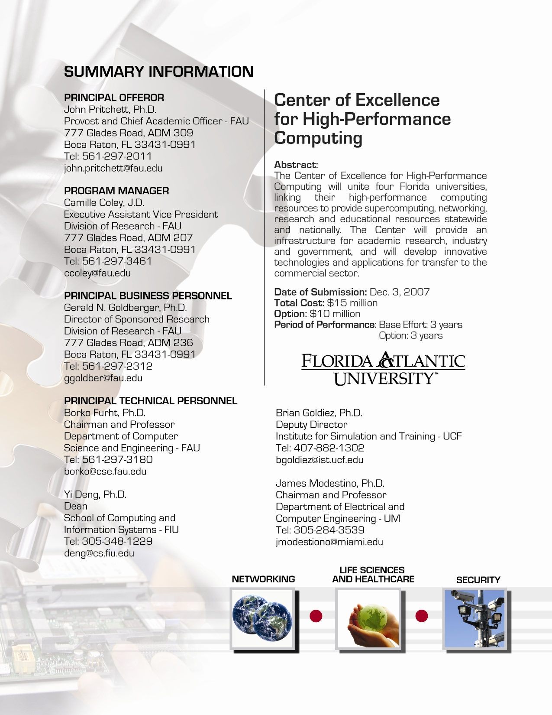
Summary Information

Table of Contents

1 Summary Information 1
2 Table of Contents 2
3 Executive Summary and Criteria Crosswalk 4
3.1 Proposed Center of Excellence 4
3.2 Industrial Needs and Outcome 5
3.3 University Capabilities 6
3.4 Plan for Self-Sufficiency 6
3.5 Organizational Plan 7
3.6 Criteria Crosswalk 9
4 Technical Proposal 12
4.1 Vision, Leadership, and Research Focus 12
4.1.1 Vision and Leadership 12
4.1.2 Research Effectiveness 12
4.1.3 Collaborative Effectiveness 14
4.1.4 Research Focus 14
4.1.4.1 Hurricane-Related Predictions and Mitigation, Disaster Recovery, and Security 16
4.1.4.2 Life Sciences and Healthcare 19
4.1.4.3 Cross-Cutting Technologies 21
4.1.4.4 HPC Enabling Technologies and Infrastructure 24
4.2 Economic Opportunity 25
4.3 Management and Infrastructure 27
4.4 Leveraging Resources and Other Collaboration 30
5 Resumes 32
6 Letters of Support 81
7 Cost Proposal 96
7.1 Base Effort Cost Proposal 96
7.2 Five-Year Funding Plan 98
7.3 Fallback Cost Proposal 98
Appendix 1. Detailed Budget, Base Effort……………………………………………..……101
Appendix 2. Detailed Fallback Budget………….………..……………….…………………107

List of Figures

Figure 1. Center of Excellence for High-Performance Computing: Research areas
Figure 2. Proposed organizational structure
Figure 3. Research areas, technologies to be developed, and participating businesses
Figure 4. Proposed distributed HPC infrastructure
Figure 5. The Florida LambdaRail infrastructure provides a statewide, dedicated optical data facility
linking major nodes throughout Florida. It will be the base for linking the HPC resources
of four universities as well as to other Florida universities and nationwide
Figure 6. Detailed organizational and management structure

List of Tables

Table 1. List of Major Competitive Grants Received by the Core Team
Table 2. Students supported in the proposed areas of research
Table 3. Hurricane Mitigation and Disaster Recovery: Summary of the Proposed Projects and
Innovative Technologies to be Developed
Table 4. Security Monitoring and Evaluation: Summary of the Proposed Projects and Innovative
Technologies to be Developed
Table 5. Life Sciences and Healthcare: Summary of the Proposed Projects and Innovative
Technologies to be Developed
Table 6. Cross-cutting Technologies: Summary of the Proposed Projects and Innovative
Technologies to be Developed
Table 7. HPC Enabling Technologies and Infrastructure: Summary of the Proposed Projects and
Innovative Technologies to be Developed
Table 8. Summary of existing programs and high-performance resources
Table 9. The distribution of the budget to four universities.
Table 10. The breakout of the budget by various categories.
Table 11. Equipment and Software to be Purchased
Table 12. Funding Plan for the Center of Excellence for High-Performance Computing
Table 13. The distribution of the budget to four universities.
Table 14. Fallback budget: the breakout of the budget by various categories.

Executive Summary and Criteria Crosswalk

Proposed Center of Excellence
We propose the creation of the Center for High-Performance Computing (HPC), which will provide supercomputing, networking, research, and educational resources to a diverse State and national community, including education, academic research, industry, federal, and state government. The Center will unite researchers from four Florida universities and link their high-performance computing resources. It will provide an infrastructure for the collaboration with a number of high-tech Florida companies, including IBM, Scripps Florida, Motorola, SAIC, LexisNexis, and others, which need high-performance computing in their research and development. Two main objectives of the Center will be: (i) to develop innovative technologies and applications that require the use of high performance computers, and transfer them to commercial sector, and (ii) to provide a high-performance computing infrastructure for academic research, industry, and government, thereby opening new research and business opportunities that will lead Florida’s knowledge economy.

The research will focus on four well-defined areas. Two are vertical application areas: (1) Hurricane Mitigation, Disaster Recovery, and Security Applications, and (2) Life Sciences and Healthcare Applications, and two are horizontal technology areas: (3) Cross-Cutting Technologies, and (4) HPC Enabling Technologies and Infrastructure, as shown in Figure #1 below. In all these four areas we have identified innovative technologies, which will be researched and developed, and then transferred to the commercial sector. The details are presented in Figure 3 in Section 4.1.
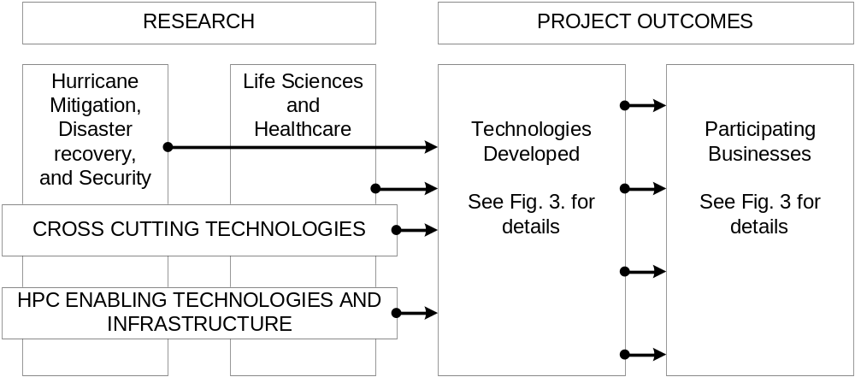

Figure 1. Center of Excellence for High-Performance Computing: Research areas.

Researchers from the four proposing universities— Florida Atlantic University, Florida International University, University of Central Florida and University of Miami—have already achieved significant research results and have received support from a number of government agencies and private corporations. The four Principal Investigators are heads of research-oriented departments from these four schools; however a number of investigators from other departments will also be involved in the Center’s projects. We focus on two application sections that are critical for the State of Florida: (1) Hurricane-Related Prediction and Mitigation, Disaster Recovery and Security; and (2) Life Sciences and Healthcare.

In summary, the Center will unite researchers in the HPC, leverage high-performance computing resources, define a research focus that will provide the greatest national and State impact, and serve as an enabler for high-tech industry, filling a gap in present infrastructure. The Center will also promote and stimulate computational research and education, and will serve as a key enabler for the State of Florida to achieve its objectives in advanced technology, information systems, and high-tech commercial enterprises.

In order to leverage resources, the high-performance computer systems from these four schools will be linked in a grid (Florida Grid) that will facilitate collaborative research on joint projects and optimize the use of resources. IBM has already committed software resources for creating this computer grid, and all four universities are already linked through the Florida LambdaRail (FLR), which is a regional research network as part of National LambdaRail, a major initiative of US research universities and technology companies.

We expect that through this Center, we will be able to create multi-sectored partnerships between these four universities and a number of private businesses. There are already preliminary discussions with IBM and Scripps Florida, which are interested in using high-performance computers for drug discovery and life science applications. Motorola is interested in using high-performance computers in simulation and rapid development of their wireless systems and products. IBM and the Barcelona Supercomputing Center are interested in techniques to more readily harness the power of computing grids to solve real-world problems such as disaster mitigation and health informatics. The Cleveland Clinic Florida is also interested in using supercomputers in complex medical imaging analysis. Additionally, discussions and interactions are underway with the organizations in the modeling, simulation, and gaming industry in Central Florida, such as SAIC, Forterra, and the U.S. Army, to address more sophisticated and cost effective simulation models that will require research and prototyping to show their utility.

Industrial Needs and Outcome
Florida has remained at the cutting edge of technology and innovation in information technology since the birth of the IBM personal computer in Boca Raton. With 20,400 companies employing more than 240,500 people, the State has reached a critical mass and remains highly competitive in this area. The talents of multiple organizations are building on each other’s unique areas of excellence to develop world-class expertise in the following important fields: modeling, simulation, and training; digital media, software and computer systems design and integration; computer products, microelectronics, precision device manufacturing, and telecommunications.

However, in this arena, there is a missing link, which the proposed Center intends to provide – the unification of researchers from universities and their resources to provide the HPC infrastructure, and to foster a strong collaboration with industries that need their resources, technologies, knowledge, and training. A number of US states have recently formed similar HPC centers; these have immediately provided vibrant, interdisciplinary partnerships between universities and industry, and significantly boosted local and state economies. Several examples include the Center for High-Performance Computing and Communications at the University of Southern California, the National Center for Supercomputing Applications at the University of Illinois, the Pittsburgh Supercomputing Center, the San Diego Supercomputer Center, and the Ohio Supercomputer Center.

University Capabilities
All four universities have already demonstrated the ability to form successful collaborative partnerships among universities and industry partners, pursue opportunities, promote research required to develop commercially promising, innovative technologies, and transfer these technologies to commercial sectors. In the last several years, FAU has received two awards for Florida Centers of Excellence, and a number of earmark projects from the federal government. Similarly, UCF has received two awards for Centers of Excellence and is currently receiving federal earmark seed funding for high performance computing research and infrastructure development.

We will briefly describe several recent successful projects in which principal investigators and other researchers from the project were involved. A number of FAU researchers participated in earmark projects on “Coastline Security Technologies,” funded by the Office for Naval Research in the total amount of $6M (2004-07) and on “Secure Communications,” funded by Department of Defense in the total amount of $3M (2004-08). These two interdisciplinary projects resulted in several innovative technologies, products, and related patents, which are currently available for use by DoD and ONR. Several FAU researchers from this project were part of the Florida Center of Excellence in Marine Biotechnology (total $10M in 2004), which resulted in several new technologies and newly-formed companies created to commercialize these technologies.

The FIU researchers are part of that university’s $4.5M National Science Foundation Center for Research Excellence in Science and Technology award, which has resulted in numerous outside collaborations, doctoral degrees, publications, and patents; this Center is eligible for a $5M extension in 2008. The latest success includes a joint FIU/FAU NSF award of $2.3M for “A Global Living Laboratory for Cyber-infrastructure Application Enablement,” to advance global partnership in information technology research, innovation, and education. This award is directly related to the proposed Center (more details are provided in Section 4).

UCF’s Institute for Simulation (IST) recently received a high level of research funding from a wide range of sources including NSF, ONR, Army Research Laboratory, Federal Aviation Administration, and the State and Federal Departments of Transportation. UCF is also expanding and integrating its science and human-centered modeling and simulation research in such diverse areas as nanotechnology, computational physics and chemistry, with civil engineering offering an essential contribution to a $5M National Oceanographic Partnership Program to develop a real-time forecasting system for winds, waves and surge.

Plan for Self-Sufficiency
The Center plans to continue beyond the three years of state funding by using the following sources to produce revenues: (1) funding from private corporations, (2) funding from government agencies, (3) revenues generated from developed technologies and products, and (4) revenues generated from education, training, and a membership program for businesses. Businesses with high-performance computing needs will join the Center’s Industrial Affiliates program, which allows them access to computing resources.

The proposed Center of Excellence is already very well positioned to acquire and leverage public and private-sector funding to provide the totality of funds to support the proposed research, which will result in commercially promising innovative technologies. Principal investigators and researchers involved in the project from all four universities have a very strong track record in acquiring funding from both government agencies and private corporations. We already have commitments from several Florida companies that will support and contribute to the Center, providing that the Center is funded. We will briefly describe these plans next; the letters of support in Section 6 give more details.

The Motorola plant in Plantation, with about 3000 employees, produces various wireless systems. Both FAU and FIU have a very successful collaboration with Motorola in terms of (1) joint research, (2) student internships at Motorola, and (3) workforce development – many FAU and FIU graduates are employed by Motorola. Motorola is very interested in establishing this Center in order to use high-performance computers in large-scale simulation and rapid development of their wireless systems and products. Motorola is committed to fund several research projects, which will result in innovative technologies and tools in the amount of more than $200,000 per year. LexisNexis is a successful company with a large plant in Boca Raton, which uses supercomputers in large data mining applications. FAU has a strong relationship with LexisNexis, and if the Center is established, they are willing to support it by funding research projects, training, and donating their own supercomputer resources.

UCF simulation oriented students have found high-wage employment in Florida in government, industry and academia. IST has strong cooperative and teaming agreements in place with simulation industry and government, and is one of the academic members of “Team Orlando” and the National Center for Simulation, both of which promote modeling and simulation on statewide and national levels. Simulation represents a growing industry sector in Florida, with average wages exceeding $60,000 per year, 50,000 direct and indirect jobs, and nearly $3B in contracts awarded annually by the federal government, with nearly $600M awarded to small business.

We also plan to acquire funding through grants and contracts from government agencies, including NSF, NIST, DoD, Army, and others. We expect that a large source of future funding will be from the developed innovative technologies and products, which will be either (a) licensed to other companies, or (b) generated from revenues from newly formed partnerships with companies that will commercialize and sell the products, or (c) generated from revenues from spin-off companies created by researchers from the Center. In Section 7 in Table 12, we present the funding plan for the next five years.

Organizational Plan
The proposed organizational structure is shown in Figure 2. The Board of Directors (BoD) will consist of four principal investigators, with the FAU representative Dr. Borko Furht as the Chairman of the Board and the other three PIs as members of the Board. The BoD will monitor the budget and the implementation schedule. The BoD will work closely with the Industry Advisory Board (IAB), which will consist of about ten executives from the key companies. The Center will hire an Executive Director, who will run day-to-day operation of the Center. The Technology Business and Commercialization Group will deal with business issues, patents, and commercialization of the developed technologies and products. The Education and Training Group will offer workshops, courses, and training seminars in the areas of HPC and parallel computing for both students and corporate clients. HPC Infrastructure and Grid Management Group will include technical support personnel from the four universities, who will install, maintain, and support the HPC resources and GRID network. Research teams are divided into four groups, each group for one of the research topics. The leaders of the groups will be the representatives from the four universities. The details and the names of responsible individuals are given in Section 4.3.

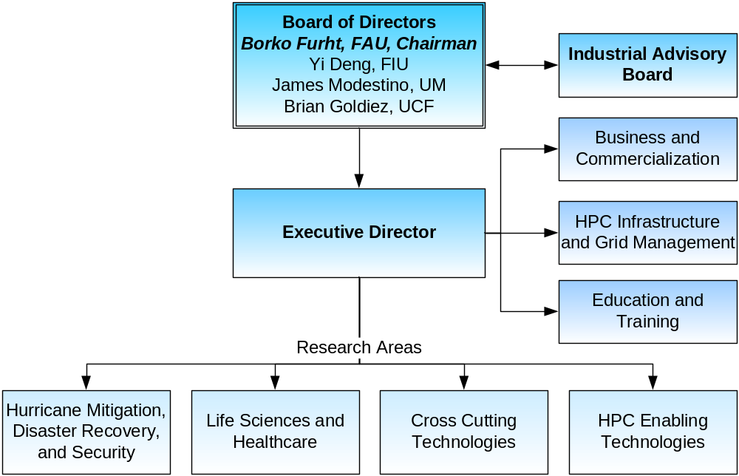

Figure 2. Proposed organizational structure.

The implementation schedule consists of three major phases over a five-year period. In the first phase (Years 1 and 2), the focus will be on research, and the innovative technologies will be defined and developed. Also, the HPC infrastructure, including the communication network and computing grid, will be completed and offered to university researchers, private corporations, and government. In the second phase (Years 3 and 4), while development of innovative technologies will continue, the focus will be on transferring developed technologies to the commercial sector by forming joint collaboration with industry and creating new companies. Also, another focus will be on leveraging the obtained research results and obtaining funding from government agencies and private corporations. In the third phase (Year 5), while activities from phases 1 and 2 will continue, the focus will be on generating additional revenues from developed technologies, the HPC infrastructure, and the training and education in HPC computing.

Criteria Crosswalk

2007  Centers of Excellence Criteria Crosswalk | Proposal  Page #(s)
Vision, Leadership, and Research Focus (clear and integrated vision and plan to assure success for developing innovative technologies and transferring them to the commercial sector; technology-centric research focus) | 4,5,12
Additional Considerations:
Evidence that the core team has a past track record of success in comparable endeavors. | 12-14
The scientific strength of the proposal (as supported by external review). | 14-16
The relevance of the research and the extent to which it is either waxing or waning. | 5, 14-25
Whether or not the research is wholly new or has been attempted before. | 14,15
An identification and analysis of the national/world competition and the extent to which it might be displaced by the proposal. | 5,6,15,16
The extent to which the research addresses any Florida specific societal issues beyond the stated goals of the legislation. | 4,5,16,19
The interpretation of “innovative technologies to include technological processes or applications as well as products. | 16,18,19,21,24
Is the investment level appropriate and sufficient to make a difference in the identified technology area, and to result in a sustainable Center? | 6,7,16
Economic Opportunity (potential for positive national and state impact, including a high-skilled, high-wage Florida workforce) | 5, 25-27
Required Criteria:
The regional economic structure and climate. | 5,25,26
The degree to which the applicant transfers advanced and emerging sciences and technologies from its laboratories to the commercial sector. | 7,26,31
The degree to which the applicant stimulates and supports the creation of new ventures. | 7,26,31
The existence of a plan to increase the likelihood of faculty and graduate students pursuing private-sector careers in the state. | 27
Additional Considerations
The extent to which Center will foster a high skilled, high wage workforce. | 26
The likelihood of new or expanded economic clusters as a result of Center. | 5,6,26
The interpretation of “economic development” to include the creation of jobs or the removal of barriers to further economic development. | 25,26
Management and Infrastructure | 7,8, 27-30
Required Criteria:
The maturity of the applicant’s existing programs relating to a proposed Center of Excellence. | 6,12-14,27,28
The ability of the applicant to provide capital facilities necessary to support research and development. | 28,29
The comprehensiveness and effectiveness of site plans relating to a proposed Center of Excellence. | 27-29
The existing amount of the applicant’s resources dedicated to activities relating to a proposed Center of Excellence. | 28,29
The presence of a comprehensive performance and accountability measurement system. | 30
Additional Considerations:
An effective management structure showing clear lines of authority and responsibility. | 8,30
Evidence that the investment level is appropriate and sufficient to make a difference in the identified technology area. | 27
Leveraging Resources and Other Collaboration (the ability to acquire public and private-sector funding; and the ability to value-add by creating multi-sectored partnerships with scholars, research center scientists and engineers, other educational institutions, and private businesses) | 30,31
Required Criteria:
The degree to which the applicant identifies and seizes opportunities to collaborate with other public or private entities for research purposes. | 4,30
The ability of the applicant to raise research funds and leverage public and private investment dollars to support advanced and emerging scientific and technological research and development projects. | 31
The existence of a plan to enhance academic curricula by improving communication between academia and industry. | 31
Additional Considerations
The extent to which the Center supports the mission of each partner. | 4,14,30,31
Existence or development of a framework to encourage long-term university/industry collaboration. | 14,30,31
The demonstration of collaborative commitment by in-kind, matching funds, or other tangible investments. | 14,31
The level of industry consensus that supports the proposed Center. | 31,81

Technical Proposal

Vision, Leadership, and Research Focus

Vision and Leadership
We propose to establish the Center of Excellence for High-Performance Computing (HPC), which will provide supercomputing, networking, research, and educational resources to a diverse state and national community, including education, academic research, industry, and state and federal government. The Center will unite researchers from four Florida universities, Florida Atlantic University, Florida International University, University of Central Florida, and University of Miami, and link their high-performance computing resources with two main objectives:
- To develop innovative technologies and applications that require HPC and transfer them to commercial sector, and
- To provide a high-performance computing infrastructure for academic research, industry, and government, which will open new business opportunities.

The proposed Center of Excellence will provide an infrastructure to engender collaboration with a number of high-tech Florida companies, including IBM, Scripps, Motorola, SAIC, LexisNexis, and others, which need high-performance computing in their research and development.

We have chosen a sector where we can truly excel and have high impact on the economy of the State. Our vision involves coupling academic goals and commercialization plans, including:
- Conducting fundamental and applied research in the proposed areas of HPC technologies and applications.
- Strategic alliances with industry leaders that will result in new inventive technologies, products, trades and spin-off companies.
- Work with industry partners to develop a streamlined research-to-market process with expeditious technology transfer and commercialization of technologies and products.
- Establish comprehensive workforce development programs, including new multidisciplinary curriculums, degrees, and certificates focusing on high-performance computing.
The core team consists of the heads of four successful computer-oriented departments and leading researchers in the field, who already have a very strong track record in acquiring funding from both government agencies and private corporations. The core team has already demonstrated abilities to form successful collaborative partnerships among universities and industry partners, pursue opportunities, promote research required to develop commercially promising, innovative technologies, and transfer these technologies to commercial sectors.

Research Effectiveness
In this section, we present a set of accountability measures for the core team, providing data on the most recent three-year performance.

- Competitive Grants Applied For and Received
Table 1 presents the list of major competitive grants applied for and received by the core team in the last three years.

Table 1. List of Major Competitive Grants Received by the Core Team.
Core Team Members | Title of the project | Time Period | Granting Institution | Total Amount
Stewart Glegg, PI  Borko Furht, Co-PI | Center for Coastline Security Technology | 2004-2007 | Office of Naval Research | $6M
Yi Deng, PI  Borko Furht, Co-PI | Global Living Laboratory for Cyber-infrastructure Application Enablement | 2007-2012 | NSF PIRE Program | $2.3M
Jie Wu, PI  Borko Furht, Co-PI | Supercluster for High-Performance Computing | 2005-2007 | NSF MRI Program Equipment Grant | $450K
Ravi Shankar, PI  Borko Furht, Co-PI | One Pass to Production | 2003-2010 | Motorola, Plantation, FL | $1.2M
Yi Deng, PI | CREST: Center for Emerging Technologies for Advanced Information Processing and High-Confidence Systems | 2003-2008 | NSF  CREST Program | $4.5M
Shu-Ching Chen,  Co-PI | Public Hurricane Loss Projection Model | 2004-2008 | Florida Office of Insurance Regulation | $2.7M
Naphtali Rishe, PI | MII: Infrastructure for Research and Training in Database Management for  Web-based Geospatial Data Visualization with Applications to Aviation | 2002-2008 | NSF  MII Program | $1.5M
Naphtali Rishe, PI | Acquisition of Research Instrumentation for Web-based Visualization of Spatio-Temporal Data | 2003-2008 | NSF  MRI Program  Equipment Grant | $400K
Tao Li, PI | CAREER: Mining Log Data for Computing System Management | 2006-2011 | NSF  Career Program | $424K
Seyed-Masoud Sadjadi, Co-PI | CI-TEAM Implementation Project: Global Cyber Bridges (GCB) | 2006-2009 | NSF CI-TEAM Program | $776K
Scott Hagen, PI | Tides and Waves for the National Weather Service River Forecast System | 2004-2008 | NOAA | $325K
R. Shumaker, PI  Brian Goldiez, co-PI | Human Robot Interaction | 2006-2007 | US Army  Research Lab | $3.6M
R. Shumaker, PI  Brian Goldiez, co-PI | Team Performance in Human Agent Collaboration | 2007-2008 | US Army  Research Lab | $1.0M
Brian Goldiez, PI  R. Shumaker, co-PI | Research for High Performance Computing for Simulation Training Systems | 2007-2008 | US Army  RDECOM | $951K
Sudipta Seal, PI  Artem Masunov, co-PI | NIRT: Engineered therapeutic  nanoparticles as catalytic antioxidants | 2007-2011 | NSF/CBET | $1M
A. Abdel-Mottaleb, PI | Automated Dental Identification | 2002-2007 | NSF & NIJ | $412K
X. Cai, PI | Cooperative Multi-Hop Wireless Communications and Networking | 2006-2009 | NSF  CNS Program | $260K
N. John, PI  A. Younis, co-PI | Hidden Markov Model Based Segmentation Framework for MR Spectroscopy Imaging | 2006-2007 | NIH/NIBIB | $291K
M. Kubat, PI  K. Premaratne, co-PI | Diagnosis and Treatment of HIV Patients using Data Mining Techniques. | 2005-2008 | NSF  SEI Program | $600K
- Total Research Expenditures
The total research expenditures from these major grants in the last three years totals approximately $38M (FAU $5M, FIU $5M, UCF $25M, and UM $3M).

- Publications in Refereed Journals from Center Research
The total number of refereed journal publications from the core team members in the last three years is over 120.

- Professional Presentations Made on Center Research
The members of the team delivered total more than 200 professional presentations on the proposed Center research at various international and national conferences.

5. Invention Disclosures Filed and Issued
The total number of disclosures filed from the proposed research is 10, with 5 disclosures issued.

Collaborative Effectiveness
Researchers on this project have already demonstrated collaboration effectiveness both with researchers from other universities and from private corporations. The best example is the establishment of LA Grid Project in 2005, where IBM jointly with the members of the core team from FIU, FAU, and UM has created an international research community and virtual computing grid enabling institutions and industry to extend beyond their individual reach to facilitate IT research, education, and workforce development. Interdisciplinary, multi-university/industry teams were formed, which perform research in the proposed areas. UCF recently was a university member (observer status) of the Standard Performance Evaluation Corporation, High Performance Computing (SPEC HPC) group. This industry lead group works to develop standard benchmark tests in the HPC area. Also, with its recent receipt of an HPC contract, UCF has established a formal memorandum of agreement with the Southern University Research Association (SURA) supporting collaboration on HPC research. Besides establishing the collaboration with IBM, researchers from the proposed Center have already established collaborations with a number of other private corporations, including Motorola, Scripps, LexisNexis, SAIC, Forterra, Citrix, and others.

The Center has not been yet formed, and therefore students have not yet been supported with Center funds. However, a number of students were supported from various grants obtained for the proposed research around which the Center will be created (See Table 2). Students who worked on these projects and graduated with various technical and scientific degrees were able to get jobs nationwide in various private corporations, and public and government institutions.

Research Focus
Two main objectives of the Center will be: (i) to develop innovative technologies and applications that require the use of high-performance computers, and transfer them to the commercial sector, and (ii) to provide a high-performance computing infrastructure for academic research, industry, and state government, thereby opening new research and business opportunities that will lead Florida’s knowledge economy.

Table 2. Students supported in the proposed areas of research.

University | Number of students supported | Students graduated (MS) | Students graduated  (PhD)
FAU | 31 | 8 | 6
FIU | 42 | 24 | 10
UCF | 26 | 9 | 5
UM | 30 | 6 | 11

The research focus will be on four well-defined areas – two vertical application areas:
- Hurricane-Related Predictions and Mitigation, Disaster Recovery, and Security Applications, and
- Life Sciences and Healthcare Applications, and two horizontal technology areas:
- Cross-Cutting Technologies, and
- HPC Enabling Technologies and Infrastructure.

In all these four areas we have identified innovative technology areas, as shown in Figure 3, which will be researched and developed, and then transferred to the commercial sector.
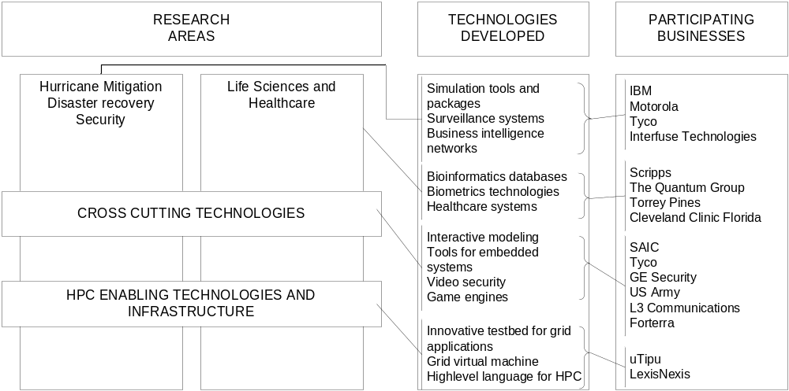

Figure 3. Research areas, technologies to be developed, and participating businesses.
A number of US states recently formed similar of HPC centers, which in turn immediately provided vibrant, interdisciplinary partnerships between universities and industry, and significantly boosted local and state economies. We identified and analyzed the following five successful Centers:

- The Center for High-Performance Computing and Communications at the University of Southern California;

- The National Center for Supercomputing Applications at University of Illinois;
- The Pittsburgh Supercomputing Center;
- The San Diego Supercomputer Center;
- The Ohio Supercomputer Center.

Each of these centers has its own research and economic focus. Our intent is not to compete with these centers. Instead, our strategy is to offer the Center with similar capabilities for specific needs of the State of Florida. Our uniqueness is that we will combine the resources from the four universities, which is not the case for other centers. In addition, the research focus of the Center will be in the areas of specific importance for Florida. It should be stressed that the majority of innovative technologies, which we propose to develop, refer to (1) innovative tools and products, and (2) new applications. We describe next the research details of the specific projects.

Hurricane-Related Predictions and Mitigation, Disaster Recovery, and Security
A. Hurricanes and Disaster Recovery
The proposed Center’s high-performance computing resources and tools will have a significant impact on applications that help government, businesses, and individuals prepare for and recover from hurricanes and other disasters, as well as other threats to homeland security. The Center will build on and combine ongoing research projects at the partner institutions; the results will be new commercializable technologies that will make our nation better prepared to face natural and man-made disasters. As this research is conducted, our students will have hands-on experience with cutting-edge homeland security applications, thus training them to become the next generation of leaders in the field and setting Florida on track to be the nation’s center of development of such applications. Table 3 summarizes the proposed projects and the innovative technologies that will be developed in the area of hurricane mitigation and disaster recovery. In this Section, we briefly describe the proposed projects.
Table 3. Hurricane Mitigation and Disaster Recovery:
Summary of the Proposed Projects and Innovative Technologies to be Developed.

Projects | Technologies to be Developed
Timely, Precise, and Zip-Code Level Hurricane Simulation | - Simulation packages for realistic distributions of damaging weather elements.  - Precision weather forecasts.
Computation of Unsteady Loadings in Urban Environments Caused By High Winds | - Computational tool to identify locations where additional structural support is needed to prevent damage during hurricanes.
High-Performance Computer Modeling of Hurricane Storm Tide Induced Bridge Pier Scour for Florida Coasts | - Innovative bridge scour modeling approach that links off-shore hydrodynamics with inland effects.
Automated Discovery of Quantitative Laws in Climatology | - The system to predict the climate system’s responses for to existing and future changes.
Business Continuity Information  Network | - Integrated and streamlined real-time business intelligence, tools for communication and coordination and support for decision making.
Topic 1.1 – Timely, Precise, and Zip-Code Level Hurricane Simulation. The NCAR Weather Research and Forecasting (WRF) model is the latest numerical program model; it has a dual use for forecasting and research and has been adopted by the National Weather Service and meteorological services world-wide as well as the U.S. military and private meteorological services. Although WRF provides support for many high-performance computational platforms, ranging from multiprocessor nodes to clustered computers, its support does not presently extend to computational platforms that cross physical and administrative boundaries. Because the simulated vortices will have realistic distributions of damaging weather elements, such as wind and flooding, ensemble members can be combined to calculate representative probability density functions, cumulative probabilities, and cumulative damage fractions at specific geographical locations. This methodology, which draws upon the methods used by windstorm underwriters for climatologically distributed weather elements, will also support event-specific estimations for such outcomes as power outages, interruption of industrial supply chains, disruption of transportation schedules, total economic loss, insurance claims, and loss of life.

Topic 1.2 – Computation of Unsteady Loadings in Urban Environments Caused By High Winds. We will determine the impact of densely packed buildings on the local unsteady wind loadings on structures with the objective of predicting severe damage during high wind events such as hurricanes. In doing so, we will develop a computational tool which can be applied to existing urban environments to assist local authorities on urban development decisions, and to identify locations where additional structural support is needed to prevent damage during hurricanes. To individually model all the structures in a relatively small area, say one square mile, is a massive computational task, requiring a boundary element solution with approximately 109 panels and a large, time consuming, computational effort; our tools will enable these engineering design decisions to be made in a timely fashion over much larger urban areas.

Topic 1.3 – High-Performance Computer Modeling of Hurricane Storm Tide Induced Bridge Pier Scour for Florida Coasts. A better capability to model hurricane storm tides and their relation to potential damages are of great interest to scientists, public and private decision-makers, and the general public. The estimation of tropical-cyclone-generated waves and surge (i.e., hurricane storm tides) in coastal waters and the nearshore zone is of critical importance to the assessment of potential damage to coastal infrastructure (namely, bridge piers) in the event that a storm makes landfall. While significant progress has been made in the theoretical ability to deterministically model bridge scour, bridge scour modeling in coastal areas is constrained due to computational limitations. The intent of the proposed work will be to develop a bridge scour modeling approach that links off-shore hydrodynamics with inland effects (e.g., bridge pier scour) for the purpose of the design and assessment of bridges along the expansive Florida coasts.

Topic 1.4 – Automated Discovery of Quantitative Laws in Climatology. Our Center’s HPC resources and tools can also help us to discover the quantitative laws that are governing climate change. We expect to derive formulas that quantify the relations among relevant variables in three major application domains from the field of ocean chemistry and climatology: CO2 fugacity, production of organic carbon in diverse areas of the ocean, and automated corrections of sea surface temperatures measured by satellite-borne devices. All of these three problems are highly topical in the application fields and their solutions are indispensable, if we want to improve our ability to predict the climate’s responses to the changes induced by natural, as well as anthropogenic causes. The essence of the solution techniques is extremely computation intensive, and methods to speed up this search are of paramount importance.
Topic 1.5 – Business Continuity Information Network for Rapid Disaster Recovery. We will develop the Business Continuity Information Network, which will link thousands of companies in the State of Florida, particularly small to medium-sized companies, and will provide them with integrated and streamlined real-time business intelligence, tools for communication and coordination, and support for sound decision-making despite chaos, which are each critical to rapid recovery after a major hurricane. This technology-enabled community network will help companies in the disaster region to quickly and accurately assess threats prior to a storm’s arrival, to assess the post-storm situation, and to enable collaboration within a company, as well as with partners in its supply chain, so as to reduce the time needed to resume their operations by days or weeks. This will result in tremendous economic impact on the scale of hundreds of millions of dollars, and help to ensure business survival.

B. Security Monitoring and Evaluation.
The computational power of high-performance computers enables applications to make use of large-scale image processing and recognition and to process vast quantities of data to find potential threats. Table 4 summarizes the projects and innovative technologies to be developed in this area of research.
Table 4. Security Monitoring and Evaluation:
Summary of the Proposed Projects and Innovative Technologies to be Developed

Projects | Technologies to be Developed
Adaptive Network Security Management and Threat Analysis | - Network security analysis and intrusion detection tools that will reduce the vulnerability of corporate and other networks.
Scalable Technologies and Tools for Processing Streaming Video | - Video processing techniques that enable correlations to be made across multiple video streams. This will enable tracking of threats via existing security monitor cameras, an emerging industry.

Topic 1.6 – Adaptive Network Security Management and Threat Analysis. Due to the importance of collected sensor network data, as well as data in more traditional corporate networks, strategies and approaches to reduce vulnerability to security threats are urgently needed. Data analysis and mining methods for automated discovery of temporal patterns in activity of interest in a given threat scenario, and automated discovery of hidden threat behavior modeling for situation/threat detection and assessment are required to allow security experts to make time-critical decisions. Intrusion prevention and detection, as part of the process of identifying and responding to malicious activities, plays an important role in security mechanisms.
The major challenge for traffic monitoring and threat analysis is the size of monitoring data and the requirement for processing speed. For example, patterns of malicious traffic must be identified while an intrusion is in progress. On the other hand, what is really useful or interesting to the network operators are the significant patterns of current bandwidth utilization, such as malicious flows consuming most of the bandwidth. We will leverage high-performance grid computing to conduct real-time data processing and analysis.

Topic 1.7 – Scalable Technologies and Tools for Processing Streaming Video. Video surveillance has become an integral part of securing the national infrastructure. Cities have a large number of video cameras deployed in places such as the street corners, on traffic lights, inside buildings, and on roads and highways. One key question concerns which cameras and what locations are the objects of interest seen over a given time period. When a large number of surveillance cameras are used, we need fast and scalable algorithms that can quickly answer this question. We will develop algorithms that enable tracking for objects of interest across a large number of cameras in real time. As the number of features to be evaluated increases, the complexity of feature analysis increases exponentially. The Center’s HPC environment will be used to partition the problem and perform feature analysis in a meaningful way.

Life Sciences and Healthcare
The rapidly increasing volume of the generated life science and healthcare data requires innovative, high-performance methods for data analysis, pattern retrieval, and visualization in supporting the understanding of the concepts and decision makings that affect healthcare, disease and the environment. The ability of enabling high performance computing for life science and healthcare data will not only provide great benefits to the researchers, but also be beneficial to the general public as well. For example, the U.S. health spending reached historically high levels (nearly 2.2 trillion, i.e., $6 billion/day) in 2006, but 16% of the population (near 47 million) was uninsured in 2005, and this trend still keeps increasing across the nation especially for the State of Florida. According to a 2005 U.S. Census Bureau Study, Florida ranks third in the nation for the highest number of uninsured population (California is ranked first followed by Texas). Using technologies, especially high-performance computing facilities to provide timely data analysis and decision support, is crucially important for delivering effective, efficient, and affordable healthcare services to our society.
The theme of our research is to fundamentally change the way domain experts view their data, by enabling immediate data management, pattern discovery, information retrieval, and risk assessment through high-end computing facilities. Table 5 summarizes projects and technologies to be developed in this area. A high-level summary of the sample projects is also outlined in this Section.
Table 5. Life Sciences and Healthcare:
Summary of the Proposed Projects and Innovative Technologies to be Developed

Projects | Technologies to be Developed
Parallel and Distributed Data Mining for Genomics and Disease Prevention | - Gene interaction database and search algorithms.  - Disease fingerprint prediction tools which consist of a large number of data mining algorithms.
High Performance Life Science and Healthcare Multimedia Data Analysis | - Healthcare multimedia (HMM)-based techniques for co-analysis of MRI and MRSI data of the brain for the purpose of detection and assessment of the progression of HIV-associated neurological abnormalities.  - A suite of software tools running in a high performance computing environment for addressing the computationally intensive requirements of MRI/MRSI co-analysis based on HMMs.  - A library of MRI/MRSI co-analysis techniques that can be utilized for HIV-associated neurological abnormalities or other neurodegenerative diseases afflicting the brain.
Integrated Large Scale Intelligent Healthcare Information Systems | - A suite of healthcare data analysis tools for the purpose of identifying individuals that are relevant to diseases, medications, risk factors, and fraud.  - A high-performance computing architecture and implementation for enabling distributed healthcare database systems.  - A workflow analysis mechanism for the decomposition and distribution of healthcare data processing tasks in a high performance computing environment.
Topic 2.1 – Parallel and Distributed Data Mining for Genomics and Disease Prevention. Existing genetic predictors of health and disease by genome-wide approaches faces at least three significant challenges: 1) effective data mining techniques need to be developed to statistically model the relationship between combinations of DNA and protein sequence variations and susceptibility to disease; 2) development of proper selection criteria for genetic features or attributes that should be included for analysis; and 3) the interpretation of gene-gene, gene-protein, and protein-protein interaction models for pathway discovery needs to be established, which can eventually lead to specific prevention and treatment strategies for many diseases. Based on our previous work on sequence pattern discovery from biological databases, rare event prediction, and gene expression data analysis, efficient data mining algorithms and gene (protein) interaction models will be developed. In addition, the dynamics of signal pathways in cancer cells and the targets that can be intervened to restore the normal function of a signaling pathway will be identified, as well as developing effective data mining solutions for prediction of rare medical diseases. All these algorithms will ensure that domain experts are able to work on large volume high dimensional biological data, through the developed high-performance computing based data analysis tools.
Searching novel DNA and protein sequences is an extremely important problem for bioinformatics research, because genes or proteins with similar sequence structures usually have similar functions, through which the domain experts can also infer evolutionary knowledge of different species. This research intends to design parallel and high performance pattern searching algorithms for HPCs to provide online and real-time biological pattern search services. We will split each user’s queries into small tasks, each of which can be effectively handled by a cluster node. We will develop a unique system architecture to leverage the resources needed across cluster nodes, such that all the search tasks are effectively processed in parallel by all cluster nodes. Consequently, our system can simultaneously and effectively support a large number of pattern search requests for large-scale biological sequences databases (possibly billions of DNA or protein letters).

Topic 2.2 – High-Performance Life Science and Healthcare Multimedia Data Analysis. The main objective of this research is the development of an artificial immune classification (AIC) technique for accurate, automated and robust MRI data analysis for the purpose of HIV-associated neurological abnormalities and multiple sclerosis (MS) lesion detection, and the quantification of regional brain atrophy. The proposed AIC technique for quantitative measurement of the effect and progression of MS disease aims to tackle current challenges in assessing MS through a generic and unified approach that relies on artificial immune functions to enable accurate identification of different tissue classes in the brain. Our preliminary research outputs from a recently funded NIH grant assert that the technique exhibited attractive accuracy, robustness and computational efficiency characteristics, based on its mathematical foundation and demonstrated from the preliminary results as compared to existing segmentation techniques.

The resulting products from the proposed project will provide basic tools for co-analysis of MRI and MRSI data of the brain, which would enable better understanding of the HIV-associated neurological disease processes, progression and varying effects on different regions of the brain. This would allow improved quality of healthcare provided to patients living with HIV, especially among minority populations prevalent in Florida. The potential economic impact also extends to the establishment of relationships with the biomedical imaging industry that would handle the licensing of the developed products to PACS as well as MRI scanners’ vendors.

Topic 2.3 – Integrated Large Scale Intelligent Healthcare Information Systems. As annual U.S. health spending reached historically high levels ($6 billion/day), healthcare provider organizations are facing a rising number of financial pressures. Administrators and physicians need timely and immediate help when making decisions, by considering the historical data and past experiences. Our research intends to deliver an integrated healthcare information platform in supporting large scale intelligent healthcare data analysis, through high performance computing enabled techniques. The key research will focus on the following two aspects: (a) identifying high-risk/high-cost patients, and (b) healthcare fraud detection.
The ability of accurate patient assessment will help healthcare providers to provide customized health plans and leverage the resources. The output of the prediction will also give nurse care coordinators a head start in foreseeing/identifying high-risk conditions so that steps can be taken to improve the patients’ quality of healthcare and to prevent health problems in the future. General patient treatment, nursing, and insurance reimbursement databases will be integrated to build a patient data warehouse, and the parallel and distributed data clustering and risk prediction algorithms will be developed. The high performance computers will be employed to analyze the data and provide the likelihood of the high-risk patients on a timely manner.

Cross-Cutting Technologies
The various research program areas proposed herein offer benefit to the other technological thrusts. These research areas, described below, are valuable research activities in their own right, but when combined with the other research work described elsewhere in this proposal provide opportunities in leveraging and integration of our collective efforts. The broad topical view of the cross cutting area of research proposed is grouped into data organization and extraction, multi-scale simulations (especially involving uncertainty), and interactivity. Each of these areas might apply directly to hurricane, disaster, security; life sciences and health care; and HPC enabling technologies. They also have applicability across these individual areas and help integrate the research programs. Each of the areas and specific research topics being proposed under the cross cutting technology area provides fundamental underpinnings relevant to many areas of technological and subsequent economic development. Table 6 summarizes projects and technologies to be developed in this area of research.
Table 6. Cross-cutting Technologies:
Summary of the Proposed Projects and Innovative Technologies to be Developed

Projects | Technologies to be Developed
Accelerated Simulation, Analysis, and Design of Mobile Embedded Systems Using HPC | - Software tools for simulation, design, and analysis of complex embedded systems.
Data Organization and Extraction | - Advanced video compression methods.  - Advanced surveillance camera systems.  - Object tracking algorithms.  - Innovative tools that implement the HPC algorithms in hardware or FPGA’s.
Multi-Scale Simulations | - Verification tools for increasing the probability of success in the development of new complex systems.
Interactive Modeling | - Game engines supporting entertainment, education, and training that are able to accommodate thousands of users simultaneously on a single image of a game.

Topic 3.1 – Accelerated Simulation, Analysis, and Design of Mobile Embedded Systems Using HPC. HPC can facilitate accelerating the design of new devices. These reductions are needed to keep Florida and our high technology industries on the leading edge of efficient product development. For example, in collaboration with Motorola, members of our team at FAU are investigating methods to accelerate the development of embedded systems. The goal is to reduce the development time of some systems from 24 months to 24 hours, a 700x reduction. Work to date shows reductions of approximately 10x. HPC provides opportunities to explore further reductions in development time. Students and faculty working in these areas will be the entrepreneurs creating new businesses or joining existing firms such as Motorola.

Topic 3.2 – Data Organization and Extraction. High performance computing approaches lend themselves to dealing with large, dense, heterogeneous data sets (e.g., medical data bases) as well as to finding inferences in sparse samples from large populations of data (e.g. fraud in transactional data bases). Our team will expand this work through several tasks strategically oriented to specific problem sets with wide applicability. Video surveillance and multimedia data are two proposed focus areas. Both deal with large amounts of data in various formats, often from sources whose locations are not precisely known. For example, a large array of cameras collecting data on crowds at airports, stadiums, public transportation sites, etc would present many problems including algorithms that efficiently process data for storage, create an integrated view of the scene, or search for an item or items of interest. Our team has experience in these two areas and will address specific solutions where HPC resources are required for timely and efficient processing. One approach to be investigated is biologically inspired search and tracking approaches that use templates of a target image(s) or that find high contrast (or specific color range or shape ) items within a larger field of interest. Another technique (related to imperfect or uncertain data) is to use abstraction methods to capture classes of items that are then subject to further processing. These and related efforts are ongoing at proposing universities and require HPC assets for efficient processing. Although the investigators are focused on specific topical areas noted above, we believe the techniques are relevant and can be extended to the health care and environmental (e.g., hurricane) fields.

Topic 3.3 – Multi-Scale Simulations. Computer simulations, by their nature, have a limited range of valid operation. Using these simulations outside of their range of operation is dangerous with respect to the validity of the results. However, it often is not known how far a simulation’s range of validity extends or the degree to which it can be used for purposes that deviate from its original purpose. By example, it is unclear if studies at a molecular level can be successively integrated to provide system level solutions or provide insights into product development that mitigates the risk of failure. High performance computing systems enable extending the range of simulations or to link disparate simulations representing different levels of granularity of a system under study but require research on validity Our proposed work is oriented to building these types of multi-scale simulations, especially in the face of uncertain or incomplete data sets. Further, our intent is to investigate underlying principles for multi-scale simulations such that simulation usage strategies can be transferred between application domains. Some specific research areas are described below.

It is critical to model material properties when development of new products relies on material characteristics. There are existing programs (e.g., Gaussian) which can be used in the study of various material characteristics including interactions between material types. Researchers build codes on top of these programs to model the specific materials and interactions of interest. Execution of these codes requires HPC assets for efficient and timely execution. We propose extending existing work in using Density Functional Theory to more efficiently study material properties and provide keener insights to developing a variety of technologies and approaches suitable for eventual commercialization. Potential eventual products include: solid oxide fuel cells, engineered nano-particles for tissue protection in radiotherapy, diagnosis of neurodegenerative diseases and others. Basically all of these applications use computational approaches to material and systems design as opposed to more traditional trial and error with expensive or specialized laboratory set ups.

Additional research in multi-scale simulation is proposed by the team in areas where uncertainty, incomplete, or sparse data exists. For example, we are proposing extensions of existing research in the area of biometric identification, wireless networks, and collaborative filtering. Our research goal is to develop mechanisms and a framework for optimizing the design of these networks using HPCs. Our research team has extensive experience with wireless sensor networks (WSN) and has investigated issues related to WSN design optimization. In this regard, our research team proposes extending existing research and collaborations in biometrics in areas such as ear models which are invariant with facial expression, collaborative filtering which facilitates adding missing or new data on users to a data base, and image recognition. Related applications in medicine and health care are expected.

Economic impact potential is large and experiencing rapid growth. For example, biometrics and wireless networks are growth areas where significant product development is expected to occur. Biometrics is currently a $3B/year industry and is expected to grow at 15% per year reaching $7.5B in the next 5 years. Likewise, the pervasive deployment of wireless sensor networks is expected to change the way we live and lead to significant growth in devices that can be used in a large variety of applications including security/defense, environmental monitoring, weather monitoring, health care, home automation, traffic control, forest fire detection, seismic detection, structural health monitoring, and industrial process control.

Topic 3.4 – Interactive Modeling. High-performance computing has typically been reserved for batch processing. Also, HPC machines are typically procured for a specific class of problem that needs specific combinations of cache, other memory, CPU cycles, or inter-processor communications. However, there are several application areas where interactive HPCs provide viable platforms for new product development. In particular, the public safety and military computer oriented training communities are seeking to conduct large, simultaneous computer exercises that comprise a single computational image on an HPC. Currently, the number of computer generated entities in these exercises is limited by the computing architecture and number of human operators to control these characters. Additionally, the cognitive and physical realism of these characters is limited. In a related area, visualization of the unfolding activity is restricted due to computing limitations in the number of freely moving entities. An analogous situation is present in the emerging market of on-line massively multi-player games.

In a related area, we also plan to focus on the use of controlled avatars that interact with users. Indeed avatars, also known as Embodied Conversational Agents (ECAs), have proven to be effective communication interface between humans and machines. One important aspect of interactive engagement, believability, and pleasantness involves the affective dimension of such artificial characters. On a more global basis, research will also be conducted on representation methods for different HPC application communities to facilitate interaction, allowing changing event sequences during runtime to facilitate free play, and strategies and tool development to aide parallelizing serial code for real time execution. This research is intended to extend to other topical areas where interactivity is required.

HPC Enabling Technologies and Infrastructure
A group of projects will focus on research in HPC enabling technologies and HPC infrastructure. Table 7 summarizes projects and technologies to be developed in this area of research.

Table 7. HPC Enabling Technologies and Infrastructure:
Summary of the Proposed Projects and Innovative Technologies to be Developed

Projects | Technologies to be Developed
Performance Realization, Evaluation, and Simulation Testbed for Applications with Grid Enablement | - The testbed for development of large-scale scientific applications—in particular, hurricane simulation and visualization applications.
Grid Enabled Communication Virtual Machine to Support Heterogeneous Research Collaboration | - A new system for developing communication-intensive applications to support collaboration.  - A software tool that can be deployed on a range of devices including PCs, PDA, and cell phones.
Data-driven Computing System Management | - An integrated data-driven framework for managing large-scale computing systems.  - A set of toolkits for on-line data management and analysis, off-line knowledge acquisition.
A High Level Language for Target Optimization Programming | - A framework for design, development, and evaluation of a new high-level program language for a portable, target-optimized, high performance software intense application.

Topic 4.1 – Performance Realization, Evaluation, and Simulation Testbed for Applications with Grid Enablement. In this project, we propose to build a high-performance testbed to evaluate and optimize the performance of large-scale scientific applications for the Grid cyberinfrastructure. This testbed is based on a highly configurable computation, communication, and data storage infrastructure that will support the emulation of large-scale Grid applications. The development of this testbed will leverage the strengths of the investigators in areas including network simulation and emulation, operating systems and virtualization, data mining, and Grid application enablement. The testbed will be used first and foremost for hurricane mitigation applications, helping improve the scalability and accuracy of large-scale and fine-grain weather forecast and visualization applications with better execution models for the Grid cyberinfrastructure.
The proposed testbed will facilitate the development of large-scale scientific applications—in particular, hurricane simulation and visualization applications—to effectively benefit from the computational and storage capacity available in a shared cyberinfrastructure, which consists of a wide range of heterogeneous resources spread across different administrative domains. The testbed will enable research in the areas of immersive network simulation, virtualization middleware, Grid network traffic monitoring and analysis, Grid application profiling and enablement, and hurricane modeling, prediction, and visualization.
Topic 4.2 – Grid Enabled Communication Virtual Machine to Support Heterogeneous Research Collaboration. The research focus of this project is the development of a Grid Enabled Communication Virtual Machine (CVM) [that provides a user-friendly, reliable and secure environment that allows researchers to retrieve and format heterogeneous data, and communicate using several media including voice, video and text. That is, if a researcher requires data sets from two different locations or needs to communicate with several researchers, then all s/he would have to do is to create a model of the communication in a user-friendly interface and the required communication will be executed by the communication engine. The CVM technology will provide a cheaper, but more effective alternative to the current approaches used to develop applications to realize communication services for collaboration. These approaches include purchasing rigid collaboration software or the development of software that could take months to complete.

Topic 4.3 – Data-driven Computing System Management. As part of this project, we have already developed techniques and tools for system monitoring, performance analysis and problem determination. We plan to evaluate, integrate and enhance existing monitoring and analyze tools and technologies into for HPC environment and reduce the HPC systems human management cost. In particular, we plan to conduct research in the following aspects: (1) Performance and workload characterization; (2) Performance diagnosis and problem determination based on monitoring data; and (3) Adaptive performance tuning.
It has been estimated that, in medium and large companies, anywhere from 30% to 70% of their information technology resources are used as administrative (maintenance) cost. The project will demonstrate and advance the capability of data mining and machine learning for autonomic problem determination. The automatic problem determination tools would be useful, in general, for detecting (unexpected) patterns in the data associated with a problem, localizing a system-wide failure to a device, identifying its root cause, assessing its impact, and predicting severe failures before they happen.
Topic 4.4 – A High Level Language for Target Optimization Programming. We propose to develop a high level language and software tools to support the development of processor-optimized software for compute-intensive, data-parallel applications. The current generation of processors such as the Pentium-4, UltraSparc, and PowerPC processors provide instruction sets that operate on data in parallel to speed up compute-intensive tasks such as video processing, visualization, and other data-parallel applications. While this SIMD capability on single processors is very useful in developing high-performance applications, the code has to be optimized specifically for each target processor and developers have to be well versed in using the low level instruction sets. Developing the same applications for a different processor with a different instruction set requires full knowledge of the instruction set and also a completely new development activity. The alternative is to describe the portions of the algorithms that need to be optimized in a high-level language and use a target specific translator to generate the optimized code. The proposed high level language will make possible platform independent development for high performance applications.

Economic Opportunity
Florida’s economic future is strongly tied to growth in the technology sector. One of the key problems facing Florida today is the wage gap among Florida’s workforce. According to the Bureau of Labor statistics, about 50% of workers in Florida have annual wages of less than $30,000 (compared to 16% for California). Uplifting the economy requires reducing this wage gap by creating more high-paying hi-tech jobs through expanding the technology base in the State. According to the Florida Chamber of Commerce New Cornerstone report, Florida ranks third in the nation in business startup rate but in the bottom 10% in net new business formation (business startups minus business failures). Some of the reasons for these low success rates are the shortage of skilled labor and problems in commercializing basic research. Small companies in the emerging technology areas such as bioinformatics and disaster mitigation lack access to large computing resources that would give them a competitive advantage.

The proposed Center for High-Performance Computing bridges super computers and high performance computing clusters to provide a standardized access to large scale computing resources. Businesses with large-scale computing needs will have access to these resources to enable better and faster product development. The students trained through this Center will have highly desirable inter-disciplinary skills that are critical to the Florida economy. In summary, the Center will foster a high skilled, high wage workforce.

The Center’s technologies will have worldwide applications as well as an important impact on the state of Florida. Specifically, two applications, (1) Hurricane Mitigation, Disaster Recovery, and Security Applications, and (2) Life Sciences and Healthcare Applications, are critical for the State of Florida. Hurricanes can cause billions of dollars of wind damage on structures in urban environments. In addition to providing high tech engineering design capabilities for local industry, which can be marketed worldwide, the construction industry would also be stimulated by the need for improved structural design.
A number of companies in Florida develop products in the area of video surveillance and will benefit tremendously from the new technologies that will be developed in this area. This will give Florida companies access to state-of-the-art video surveillance technologies, including prototypes that will allow rapid commercialization.
Data mining is critical to analyzing biological and medical databases. For example, the growing demand for bioinformatics experts is recognized in academic and industry job announcements, and has increased with need for DNA sequencing, micro arrays, and gene and protein behavior studies. The Center will foster education, training, and employment in bioinformatics and related areas. The Center will integrate methods from high performance computing, data mining, biology, and medical fields. The strategies discovered from this research will greatly augment the ability of the biotechnology industry to make discoveries and bring new medical products to market.
With a nearly 3.6 million uninsured population, about 20% of Floridians are uninsured. The proposed research in the area of integrated healthcare information systems using HPC intends to deliver a set of technical solutions to ensure timely data analysis, accurate decision making and fraud prevention, and effective resource allocation, such that effective, efficient, and affordable healthcare services can be delivered to our society. With healthcare spending reaching historically high levels, healthcare informatics is becoming crucially important for administrators, doctors, insurance companies, and patients. Our research will not only advance the existing healthcare information systems, but also provide a blueprint for the healthcare informatics framework in the next 10 years.
In the area of large-scale simulation and training, the potential economic impact is significant with direct interest from suppliers to the military and public safety training simulation communities and game platform companies. Companies with game engines are also potential outlets. Organizations that would buy or license such equipment include educational entities, training companies, entertainment venues, public safety, military, and laboratories already using HPC assets (e.g., pharmaceutical companies).
There are a large number of potential participating businesses in this project, including IBM, Motorola, Siemens, The Scripps Research Institutes, Torrey Pines Institute of Molecular Studies, LexisNexis, Science Applications International, Forterra, National Center for Simulation, Tyco, GE Security, US Army, Office of Naval Research, and many others. We have already developed strong collaborative relationships with many of these companies. We will develop a join plan with industry partners to provide opportunities for faculty and graduate students to pursue their career in the private sector.

Management and Infrastructure
The existing programs at all four universities that relate to interdisciplinary applications of high-performance computers are already very mature. Table 8 summarizes existing programs at these four universities and the HPC resources used at this time.
Table 8. Summary of existing programs and high-performance resources currently used.

University | Existing Programs | HPC Resources Used
FAU | - Life Sciences and Bioinformatics  - Security and Surveillance Applications  - Large-Scale Simulation Applications  - Data Mining Applications | - SGI Altix 370 Supercomputer  - IBM Blade Center H20  - LA Grid
FIU | - Disaster Recovery  - Hurricane Simulation  - Grid Computing and Its Applications  - Security Applications | - IBM Regatta p690+ Multiprocessor IBM Blade Center . 5 dual processor  - Dedicated 12+ node research and instructional Linux Beowulf cluster.  - LA Grid
UM | - Life Sciences and Bioinformatics  - Biomedical Imaging Analysis and Understanding  - Security and Biometric Applications | - 14 HS 20 IBM Blade Servers  - 10+ node Sun Grid  - LA Grid
UCF | - Simulation and Modeling Applications | - IBM Series X – 192 Processors  - OPCODE - 96 Processor Beowulf Cluster

The Center will provide an integrated array of high performance computing and communication systems and related services to their users, including supercomputers, software, mass storage systems, file storage areas, consulting services, and training. Figure 4 presents the proposed HPC computer/communication infrastructure, consisting of supercomputers from the four universities linked through Florida LambdaRail and connected in a grid.
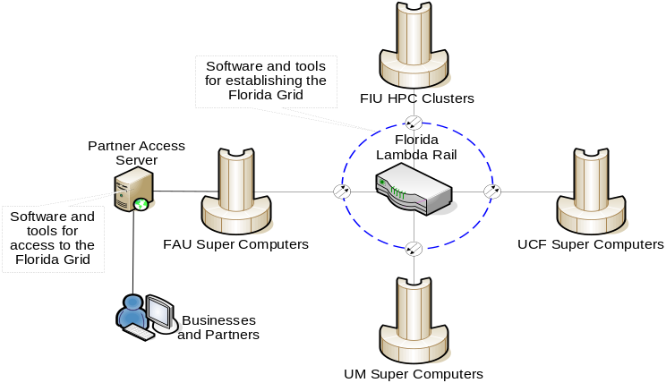

Figure 4. Proposed distributed HPC infrastructure.
The Center will leverage existing HPC resources of the four universities with minimal capital investments for additional software and hardware resources. The following HPC resources will comprise the Center:

Florida Atlantic University
- SGI Altix 3700 Supercluster
Numa-based, cache-cherent, shared-memory multiprocessor system
72 Intel Itanium 2, 1.5 GHz processors
112 GB global shared memory
64-bit environment
2 Terabyte Fibre Channel storage unit
16 Linux-based PCs as the frontend
- 10 HS 20 IBM Blade Servers
Intel Xeon EM64T 3.8 GHz/800MHz processors
2GB memory
Two Gigabit Ethernet controllers
4-port Gigabit Ethernet switch
- Florida LambdaRail Florida network

Florida International University
- IBM Regatta p690+ Multiprocessor System: 31x Power4 processors with 256GB shared RAM, 4 TB of high availability storage. SUSE Linux operating system
- IBM Blade Center . 5 dual processor Intel blades, 2 dual processor Power blades. 23+TB of IBM SANS disk storage. Linux operating system
- Dedicated 12+ node research and instructional Linux Beowulf cluster
- 120+ open lab desktop systems to run distributed processing experiments (P4 2Ghz or better)
- Gigabit connection to Internet, Internet2, Florida and National
- Florida LambdaRail, and CLARA (South American Research) networks

University of Miami
- 14 HS 20 IBM Blade Servers
9 Intel Dual Xeon EM64T 3.8 GHz/800MHz processors, 2GB memory, 1 Gigabit Ethernet
5 PowerPC dual processors, 2GB memory, 1 Gigabit Ethernet
4-port Gigabit Ethernet switch
7 TB SAN
- 10+ node Sun Grid research and instructional grid

University of Central Florida
- IBM System X – 192 Processors (Currently being procured)
3650 Management Node – Dual 2.33 Intel Quad-core processors, 8 GB Memory and GigE Ethernet ports
System X 3755 Servers – 4 units
2.8 GHz Opteron Rev F processors, 64 GB Memory per server and PCI slot support for graphics subsystems
HS21 XM Blade Servers – 24 units
Dual 2.33 GHz Intel Quad-core processors, 8 GB RAM, 73 GB Hard drive, Dual GigE ports and Cisco Infiniband interface card
DS4700 storage node with a total 13.5 TB of space
- OPCODE Beowulf Cluster (Existing System)
4 Server nodes, AMD Athlon Thunderbird 1.4Ghz Processors, RedHat Linux 7.1 with XFS filesystem, 128 Port Extreme Networks Alpine switch, 4 60GB IBM harddrives
96 Dual processor nodes, AMD Athlon Thunderbird 1.4Ghz Processors, 1 GB RAM, 20 GB hard drive each, GigE cards

Middleware Technologies and Software Packages
- Middleware technologies including Globus Toolkit, BOINC, and other Web Services toolkits.
- Biomedical databases and sequence analysis
- Various software packages: Matlab, GAMESS, AMBER, GAUSSIAN, LAPACK, SAS, Visualization/Display, MEEP, WRF
- Neural science, Material science

The heart of communications between these four universities, as well as with other universities in Florida, will be the Florida LambdaRail (FLR), as illustrated in Figure 5.

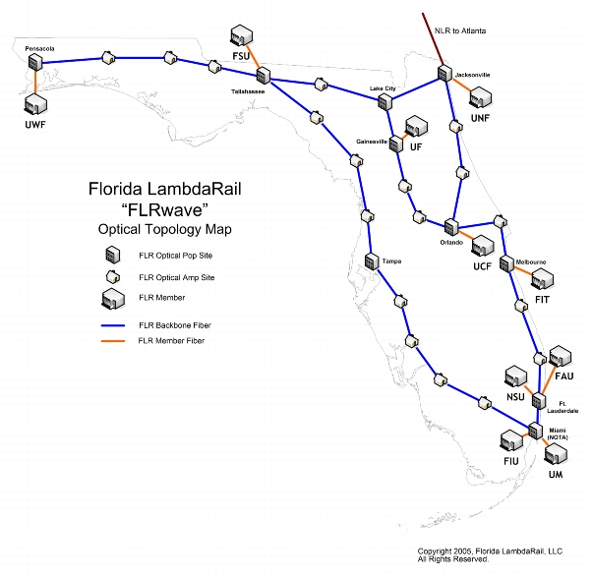
Figure 5. The Florida LambdaRail infrastructure provides a statewide, dedicated optical data facility linking major nodes throughout Florida. It will be the base for linking the HPC resources of four universities as well as to other Florida universities and nationwide.

The detailed organizational and management structure is shown in Figure 6. The Board of Directors (BoD) will consist of four principal investigators, with the FAU representative Dr. Borko Furht as the Chairman of the Board and the other three PIs as members of the Board. The BoD will monitor the budget and the implementation schedule. The BoD will work closely with the Industry Advisory Board (IAB), which will consist of about ten executives from the key companies – partners. The Center will hire an Executive Director, who will run day-to-day operation of the Center. The Technology Business and Commercialization Group, with Dr. Chandra Mishra from FAU’s College of Business and representatives from Technology Transfer Departments from the four universities will deal with business issues, patents, and commercialization of the developed technologies and products. The Education and Training Group will offer workshops, courses, and training seminars in the areas of HPC and parallel computing for both students and corporate clients. HPC Infrastructure and Grid management will include technical support personnel from the four universities, who will install, maintain, and support the HPC resources and Grid network. Research teams are divided into four groups, each group for one of the research topics. The leaders of the groups will be the representatives from the four universities, as indicated in Figure 6.
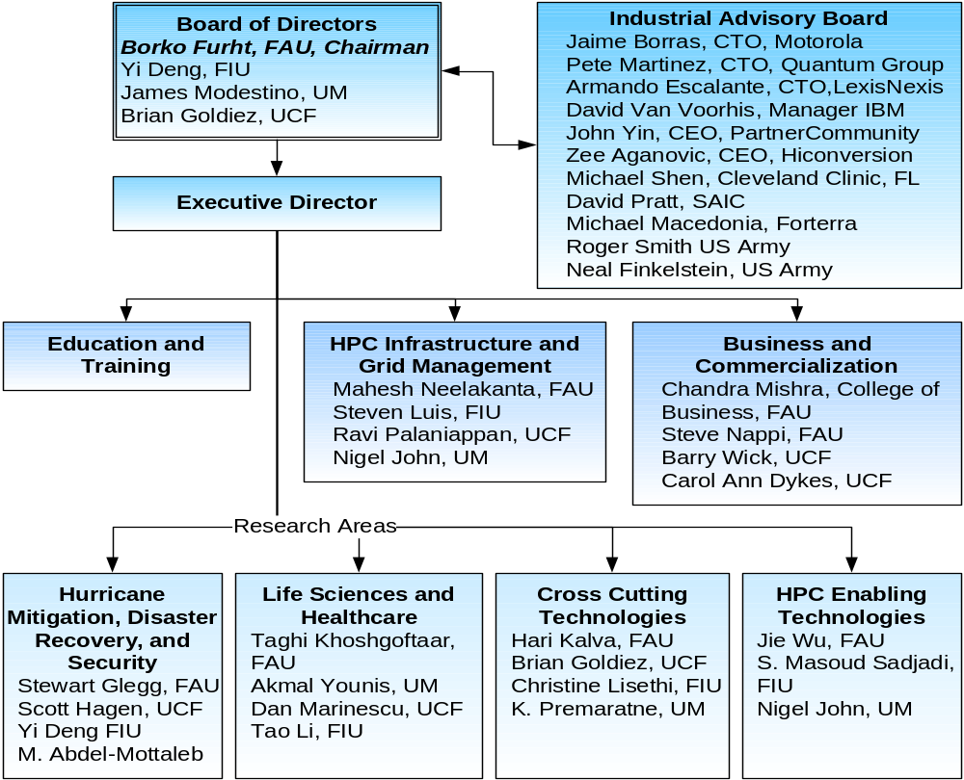

Figure 6. Detailed organizational and management structure.

The proposed organizational structure will allow the development of a comprehensive accountability measurement system with the focus on (a) research effectiveness, (b) collaboration effectiveness, and (c) economic development effectiveness.

Leveraging Resources and Other Collaboration
The proposed Center will be based on a full collaboration between researchers from the four universities with researchers from industry. The Center is will leverage the current HPC resources of the four universities including Florida LambdaRail communication facilities. The proposed Center of Excellence is already very well positioned to acquire and leverage public and private-sector funding to provide the totality of funds to support the proposed research, which will result in commercially promising innovative technologies. Principal investigators and researchers involved in the project from all four universities already have a very strong track record in acquiring funding from both government agencies and private corporations. We already have commitments from several Florida companies that will support and contribute to the Center, assuming that the Center is funded.

The Center plans to continue beyond the three years of State funding by using the following sources to produce revenues:
- Funding from private corporations,
- Funding from government agencies,
- Revenues generated from developed technologies and products,
- Revenues generated from education and training, and
- Membership program for businesses.

Businesses with high-performance computing needs will join the Center’s Industrial Affiliates program that allows them access to computing resources.

Several Florida companies have already committed to the Center, assuming that the Center is created with in-kind, matching funds, and other tangible investments (please see letters of support in Section 6). Some examples include:
- Motorola, Plantation – Matching funds for research in the area of “Large-scale simulation of wireless systems for rapid prototyping” are expected; membership in Industry Affiliates Program.
- IBM, Boca Raton, Software for Grid management, and for various HPC applications
- LexisNexis, Boca Raton – A supercomputer and software; membership in Industry Affiliates Program, research funding
- uTIPu – Free license for faculty and students for three-year period to use their service.
- SAIC – Member of Industry Affiliates
- Forterra – Member of Industry Affiliates and game software
- US Army – Member of Industry Affiliates
- L-3 Corp. – Member of Industry Affiliates

We also intend to develop a framework to encourage a long-term collaboration between the Center and industry partners. This will be done through the Corporate Affiliates Program, which will provide industrial partners the expertise and services to enhance their corporate technical and computing capabilities and to exploit high performance computing technologies.

The Center will provide a great opportunity to enhance academic curricula at the four universities. Florida students will gain exposure to the world of high-performance computing and networking. Our plan to enhance academic curricula consists of the following:

- Introduce new graduate and undergraduate courses on high-performance computing and their applications,
- Introduce new courses jointly with industry on industry applications of HPC,
- Develop and offer special certificate programs on various topics in HPC for both regular students and scientists and researchers from industry, and
- Prepare the next generation of scientists and engineers to effectively use the high-performance computers as part of the growing national cyberinfrastructure.

Resumes

Key Management Team
Borko Furht, Chairman and Professor, Dept. of Computer Science and Engineering, FAU
Yi Deng, Dean and Professor, School of Computing and Information Sciences, FIU
Brian Goldiez, Deputy Director, Institute for Simulation and Training, UCF
James Modestino, Chairman and Professor, Dept. of Electrical and Computer Engineering, UM

Industry Advisory Board
Jaime Borras, Chief Technical Officer and Vice President, Motorola
Pete Martinez, Chief Technical Officer, The Quantum Group
Armando Escalante, Chief Technical Officer, LexisNexis
David Van Voorhis, Manager, IBM
John Yin, CEO, PartnerCommunity
Zee Aganovic, CEO, Hiconversion
Michael Shen, Cleveland Clinic Florida
David Pratt, SAIC
Michael Macedonia, Forterra
Roger Smith, US Army
Neal Finkelstein, US Army

Business and Commercialization Group
Chandra Mishra, College of Business, FAU
Stephen Nappi, FAU
Barry Wick, UCF
Carol Ann Dykes, UCF
Scott Graham, FIU

HPC Infrastructure and Grid Management Group
Mahesh Neelakanta, Director, Technical Services Group, FAU
Steven Luis, Director Technical Services, FIU
Ravi Palaniappan, UCF
Nigel John, UM

Research Groups (Interdisciplinary and Multi-university)

- Hurricane Mitigation, Disaster Recovery, and Security

Research Leaders:
Yi Deng, FIU, Stewart Glegg, FAU, Scott Hagen, UCF, and Mohamed Abdel-Mottaleb, UM
Investigators:
Scott Hagen, UCF
Gour Tseh George Yeh, UCF
Yi Deng, FIU
Steven Luis, FIU
Shu-Ching Chen, FIU
Evangelos Christidis, FIU
Tao Li, FIU
Naphtali Rishe, FIU
Xiowen Liu, FIU
S.-Masoud Sadjadi, FIU
Meter Clarke, FIU
Irma Becerra Fernandez, FIU
Hugh Willoughby, FIU
Hugh Gladwin, FIU
Fang Zhao, FIU
Mohammed Hadi, FIU
William Glenn, FAU
William Rhodes, FAU
Oge Marques, FAU
Hari Kalva, FAU
Mohamed Abdel-Mottaleb, UM
Miroslav Kubat, UM
Peter Minnet, UM

- Life Sciences and Healthcare

Research Leaders:
Taghi Khoshgoftaar, FAU, Akmal Younis, UM, Dan Marinescu, UCF, and Tao Li, FIU
Investigators:
Hill Zhu, FAU
Abhi Pandya, FAU
Nigel John, UM
Mansur Kabuka, UM
Brian Bowen, UM
Pardip Patteny, UM
Xiading Cai, UM
Gabriel Tsechepenakis, UM

- Cross-Cutting Technologies

Research Leaders:
Brian Goldiez, UCF, Hari Kalva, FAU, Christine Lisetti, FIU, and Kamal Premaratne, UM
Investigators:
Jie Wu, FAU
Oge Marques, FAU
Borko Furht, FAU
Imad Mahgoub, FAU
Ionut Cardei, FAU
Artem Masunov, UCF
Gour Tseh George Yeh, UCF
Thomas Clarke, UCF
Peter Clarke, FIU
Shu-Ching Chen, FIU
Naphtali Rishe, FIU
Xiaowen Liu, FIU

- HPC Enabling Technologies and Infrastructure

Research Leaders:
Jie Wu, FAU, S.-Masoud Sadjadi, FIU, and Nigel John, UM
Investigators:
Hari Kalva, FAU
Shihong Huang, FAU
Ankur Agarwal, FAU
Abhi Pandya, FAU
Ionut Cardei, FAU
Clovis Tondo, FAU
Georgiana Hamza-Lup, FAU
Michael VanHilst, FAU
X.iaowen Liu, FIU
Tao Li, FIU
R.aju Rangaswami, FIU
Peter Clarke, FIU
Yi Deng, FIU
Evangelos Christidis, FIU

Borko Furht
Chairman and Professor, Department of Computer Science and Engineering
Senior Asst. Vice President for Engineering and Technology
Florida Atlantic University, Boca Raton, Florida 33431
Tel: 561-294-3486 Fax: 561-297-2800 Email: borko@cse.fau.edu

PROFESSIONAL PREPARATION:
Ph.D. Electrical and Computer Engineering, University of Belgrade, Yugoslavia, 1978.
M.Sc. Electrical and Computer Engineering, University of Belgrade, Yugoslavia, 1973.
BSEE (Dipl.Eng.) Electrical Engineering, University of Belgrade, Yugoslavia, 1970.

APPOINTMENTS:
1992-present Chairman (since 2002) and Professor of Computer Science and Engineering
Senior Assistant Vice President for Engineering and Technology
Florida Atlantic University, Boca Raton, Florida.
1988-1992 Senior Director of Advanced Development & Vice-President of Research
Modular Computer Systems (MODCOMP), Computer Division of Daimler Benz (Germany), Fort Lauderdale, Florida.
1982-1988 Associate Professor (since 1984) of Electrical and Computer Engineering
University of Miami, Coral Gables, Florida
1970-1982 Project Leader and Senior Scientist
Computer Systems Department, Institute “Boris Kidric”, Belgrade, Yugoslavia

SELECTED PUBLICATIONS (total over 250 publications):
- D. Culibrk, O. Marques, D. Socek, H. Kalva, and B. Furht, “Neural Network Approach to Background Modeling for Video Object Segmentation, IEEE Transactions on Neural Networks, September 2007.
- P. Sanigepalli, H. Kalva, and B. Furht, “Error Resilient Video Over Multimedia Broadcast Multicast Services (MBNS), Journal of Multimedia Tools and Applications, Special Issue on Wireless Multimedia, Vol. 28, No. 2, February 2006, pp. 187-202.
- B. Furht, Editor-in-Chief, “Encyclopedia of Multimedia,” Springer Science and Business Media, 2006.
- E. Muharemagic and B. Furht, “An Innovative Pixel Scoring Method for Watermarking of Binary Document Images,” Proceedings of the IEEE International Conference on Multimedia & Expo, Toronto, Canada, July 2006.
- H. Kalva, L. Christodoulou, L. Mayron, O. Marques, and B. Furht, “Challenges and Opportunities in Video Coding for 3D TV,” Proceedings of the IEEE International Conference on Multimedia & Expo, Toronto, Canada, July 2006.
- H. Kalva and B. Furht, Complexity Estimation of the H.264 Coded Video Bitstreams,” The Computer Journal, Oxford University Press, June 2005.
- B. Petljanski, H. Kalva, and B. Furht, “Complexity Reduction Tools for MPEG-2 to H.264 Video Transcoding,” WSEAS Transactions on Information Science and Applications, Vol. 2, Issue 3, March 2005, pp. 295-300.
- B. Furht and D. Kirovski, “Multimedia Security Handbook,” CRC Press, Boca Raton, Florida, 2005.
- B. Furht and O. Marques, “Handbook of Video Databases,” CRC Press, Boca Raton, FL, 2003.
- B. Furht, K. Gustafson, H. Huang, and O. Marques, "An Adaptive Three-Dimensional DCT Compression Based on Motion Analysis", Proc. ACM Symposium on Applied Computing, March 2003.

SYNERGISTICS ACTIVITIES:
Leadership
- Increased the Department’s sponsored research from $800,000 in 2002 to $2+ millions (in 2006-07).
- Increased the participation of the CSE faculty in sponsored research by providing leadership and motivation, from 6 faculty in 2002 to 18 faculty in 2007.
- Initiated and/or led several large department, university, and inter-university research projects.

Research (total over $7M of sponsored research)
- NSF PIRE Grant, Global Living Laboratory for Cyber-infrastructure Application Enablement, Co-PI, ($2.3M), 2007-2012.
- Federal Earmark Grant on “Center for Coastline Security”, Total $6 millions for 3 years, Co-Principal Investigator for the Project on Video and Image Processing Techniques for Coastline Security ($620,000), 2004-2007.
- Motorola Corporation, “One Pass to Production,” PI and Co-PI, ($250,000 per year, total $1.2 M) 2003-2007.
- “High Performance Computer Equipment Grant,” National Science Foundation, Co-PI, ($455,000), 2005-2007.

Partnership
- Established a strong Industry Advisory Board consisting of 25+ executives from local high-tech companies (2002-persent) with major objectives to advise the Department on educational and research issues, assist in curriculum development and improvement, and help to identify areas of opportunity for education and research.
- Established the Industry Affiliates Program (2002-present) with a goal to provide an effective partnership between the CSE Department and members of the IT industry. Received more than $200,000 in industry memberships from companies such as Motorola, Citrix, LexisNexis, Avocent, and M2sys.

Service
- Conference and program chair for several international IEEE and ACM conferences
- Editor in Chief of Springer’s Journal of Multimedia Tools and Applications (1994-present)
- Served on Board of Directors of several high-tech companies
- Principal consultant for many high-tech companies including IBM, Cisco, General Electric, Samsung, Xerox, HP, NASA, Honeywell, Cordis, RCA, and others

Education
- Led the creation of several new programs at FAU: (a) Professional weekend Master Program in Computer Science, (b) Bachelor of Information Engineering Technology, (c) Master of Information Technology and Management

COLLABORATORS & OTHER AFFILIATIONS:
- Jaime Borras, VP and CTO, Motorola, Plantation, Florida
- Ramesh Jain, University of California, Irvine
- A hmed Karmouch, University of Ottawa, Canada
- Alberto Del Bimbo, University of Firenze, Italy
- Jean-Luc Dugelay, Institut Eurocom, France
- Ken-ichi Aihara, Nagoya University, Japan
- Herman Alpert, IBM T.J. Watson Research Center
- Wolfgang Halang, Fern University, Hagen, Germany
- Dragutin Petkovic, San Francisco State University
- Wei-Ying Ma, Microsoft Research, China
- Roger Zimmerman, University of Southern California
Yi Deng
Dean and Professor
School of Computing and Information Sciences, Florida International University

PROFESSIONAL PREPARATION:
Ph.D. Computer Science, University of Pittsburgh, August 1992
M.Sc. Computer Science, University of Pittsburgh, April 1990
B.E. Computer Science and Technology, University of Science & Technology of China, 1983

APPOINTMENTS:
7/05 – present: Dean and Professor, School of Computing and Information Sciences, Florida International University – the State University of Florida at Miami.
5/02 – 6/05: Director and Professor, School of Computer Science, Florida International University.
8/00 – 5/02: Managing Director and Associate Professor of Computer Science, Embedded Software Center (ESC), School of Engineering and Computer Science, University of Texas at Dallas.
5/97 – 7/00: Director and Associate Professor, Center for Advanced Distributed System Engineering (CADSE), School of Computer Science, Florida International University.
8/92 - 5/97: Assistant Professor, School of Computer Science, Florida International University.
SELECTED PUBLICATIONS:
- J. Ding, P.J. Clarke, D. Xu, X. He, and Y. Deng, “A formal model-based approach for developing an interoperable mobile agent system”, Journal of Multiagent and Grid Systems, No. 4, Vol. 2, 2006.
- Y. Deng, J. Wang and M. Zhou, “Consistency verification in modeling of real-time systems”, IEEE Transactions on Robotics and Automation, Vol. 20, No.1, 2004, 136-144.
- Y. Deng, J. Wang, K. Beznosov and J. J.P. Tsai, “An approach for modeling and analysis of security system architectures”, IEEE Transactions on Knowledge and Data Engineering, Vol.15, No. 5, September/October 2003, 1099 – 1119.
- X. He and Y. Deng, “A Framework for Developing and Analyzing Software Architecture Specifications in SAM”, The Computer Journal, Vol. 45, No.1, 2002, 111-128.
- K. Zhang, D.Q. Zhang and Y. Deng, “Transforming multimedia XML documents using graph grammars”, Annals of Software Engineering, Vol. 12, 119-137, 2001.
- J. Ding, D. Xu, X. He and Y. Deng, “Modeling and analyzing a mobile agent-based clinical information system”, Journal of Intelligent Control and Systems, Vol. 10, No. 2, 143-151, June 2005.
- D. Xu, J. Yin, Y. Deng and J. Ding, “Architectural Modeling of Logical Agent Mobility”, IEEE Transactions on Software Engineering, Vol. 29, No. 1, January 2003.
- D. Xu, X. He and Y. Deng, “Compositional Schedulability Analysis of Real-Time Systems Using Time Petri Nets”, IEEE Transactions on Software Engineering, Vol. 28, No. 10, October 2002.
- J. Wang, Y. Deng and M. Zhou, “Compositional Time Petri Nets and Reduction Rules”, IEEE Transactions on System, Man and Cybernetics, Vol. 30, Part B, No. 4. August 2000.
- J. Wang, G. Xu and Y. Deng. "Reachability Analysis of Real Time Systems Based on Time Petri Nets", IEEE Transactions on System, Man and Cybernetics, Vol. 30, Part B, No.5, October 2000.

SYNERGISTIC ACTIVITIES:
- Leadership. As the Dean for the School of Computing and Information Sciences at FIU, Yi Deng has been responsible for overall strategic planning, management and operation of the School, as well as for coordination of university-wide computing and IT related initiatives. He is a driver at FIU in promoting computing and information as the critical enabler for multidisciplinary research and education, and has initiated and led a number of large-scale cross discipline research and education initiatives. Under his leadership, the school, in less than 4 years, doubled its Ph.D. student population, tripled Ph.D. graduation rate, and significantly increased MS and BS graduate rates. The school has also more than doubled its competitive federal research funding to $2.5M annually, and increased overall number of publications and number of top journal/conference papers by 40% and 100%, respectively.
- Diversity. Yi Deng has been a strong leader and driver for diversity in computing. Under his leadership, SCIS at FIU has increased the number of Hispanic Ph.D. students in computer science from 3 in Fall 2002 to 26 in Spring 2006. In partnership with IBM, he is a principal architect and leader of a unique and ambitious international initiative called Latin American Grid.
- Research. He is a respected leader in multidisciplinary research with 17 research grants or contracts as PI or Co-PI over $10M from agencies like NSF, NASA, USAF Office of Scientific Research, 87 peer-reviewed publications in various journals and international conferences. He founded three (3) major research centers in computer science and information technology – the Center for Advanced Distributed Systems Engineering, the NSF CREST Center of Emerging Technologies for Advanced Information Processing and High Confidence Systems, and the IBM Center for Grid and Autonomic Computing at FIU.
- Partnership. He led the development of a dynamic partnership between SCIS and industry. Such partnerships have led to a variety of collaborative research projects, education and training projects, industry grants and donations, and broader initiatives. Examples of the collaborations include: LA Grid, dedicated internship programs from IBM and Siemens, IBM Executive Mentorship Program, the IBM Center at FIU, numerous joint research/education projects with large or small companies, e.g. IBM, Motorola, Siemens, Lennar, Ultimate Software, Miami Children’s Hospital, Teges, etc.
- Service. Yi Deng has been active in servicing our professional community. For instance, he has been the conference or program chair for several conferences, e.g. the 2004 IEEE International Symposium on Multimedia Software Engineering, 2003 International Conference on Distributed Multimedia Systems. He is an editor for International Journal of Software Engineering and Knowledge Engineering, a cluster chair for NSF CISE/CNS Committee of Visitors, a member of the IEEE Computer Society Committee on Multimedia Computing, and a member of the NSF ITR Review Panels
- Education. He led the creation of 3 new degree programs and 2 international programs and developed the School into one of the largest CS/IT programs and the largest undergraduate CS/IT program among the 10 universities of the Florida State University System. He has personally supervised 7 post-doctoral research fellows, over 25 MS and Ph.D. students, and taught variety of undergraduate and graduate courses in computer science.
COLLABORATORS & OTHER AFFILIATIONS:
- Jeffrey J.P. Tsai, Tad Murata, University of Illinois at Chicago
- Konstantin Beznosov, University of British Columbia
- Mengchu Zhou, New Jersey Institute of Technology
- Farokh Bastani, Kang Zhang, I-Ling Yen, Kendra Cooper, University of Texas at Dallas
- Mark Gerken, US Air Force Academy
- Jiacun Wang, Nortel Networks, Dallas, TX
- S.K. Chang (Ph.D. Advisor), University of Pittsburgh

Brian F. Goldiez
Deputy Director, Institute for Simulation and Training
University of Central Florida, Orlando, FL 32826

PROFESSIONAL PREPARATION:
University of Kansas | Aerospace Engineering | BSAE, 1973
University of Central Florida | Computer Engineering | MS, 1979
University of Central Florida | Modeling & Simulation | Ph.D. 2004

APPOINTMENTS:
1988-Pres | Deputy Director, Institute for Simulation and Training, Assistant  Professor, Industrial Engr & Mgmt Systems (since 2006) U. Central FL
1985-1988 | Systems Engineer (Simulation), AAI Corp (Orlando), Baltimore, MD
1975-1985 | Electrical Engineer(Modeling, Software and Graphics), US  Army (now Program Executive Office, Simulation, Training,  & Instrumentation) and US Navy (now NAVAIR Orlando), Orlando
1973-1975 | Handling Qualities Aero Engineer, Sikorsky Aircraft, Stratford, CT

SELECTED PUBLICATIONS (total over 70 publications):

- Goldiez B., Rogers, R. & Woodard, P. (1999, January/February). Real-time visual simulation on PC’s. IEEE Computer Graphics & Applications, Los Alamitos, CA. pp.11-15.
- Goldiez, B., Schmorrow, D., Hofer, R., Harvey, E., & Shumaker, R. (2002, July). Integrating infrastructures and approaches for using simulation to support product development. Society for Computer Simulation Summer Conference. San Diego, CA.
- Goldiez, B. (2002, October). Critical research issues in virtual environments. Proceedings of the Workshop on Intelligent Human Augmentation & Virtual Environments. Dept. Computer Science, U. North Carolina, Chapel Hill, NC. pp. E-9.
- Goldiez, B., Sottilare, J., Yen, C., Jerome, C. (November, 2006). The current state of augmented reality and a research agenda for training. US Army Research Institute for the Behavioral and Social Sciences. Orlando, FL.
- Goldiez, B.F., Ahmad, A.M., & Hancock, P.A. (September, 2007). Effects of augmented reality display settings on human wayfinding performance. IEEE Transactions on Systems, Man, and Cybernetics: Part C: Applications and Reviews. Pages 839-845.

- Goldiez, B., Martin, G., Daly, J., Washburn, D., & Lazarus, T. (2004, October). Software infrastructure for multi-modal virtual environments. Sixth International Conference on Multimodal Interfaces. Association for Computing Machinery, Special Interest Group on Computer Human Interfaces. State College, PA, 251-257
- Goldiez, B. & Dawson, J. (2004, October). Is Presence Present in Augmented Reality? Presence 2004 Conference. Valencia, Spain.
- Goldiez, B., Ahmad, A., Stanney, K., Dawson, J., Hancock, P. (2005, July). Augmented reality as a human computer interaction device for augmented cognition. Human Computer International Conference. Las Vegas, NV
- Goldiez, B. (December 15, 2006). US military perspectives in presence and augmented reality. In G. Ruffini (Ed.), D3.1 Visions, Roadmaps, the ERA (Issue 1), Document Peach-A3.1-A3.1-VEROERA-V1.10doc, FP6 Coordinating Action No 33909. Barcelona, Spain & Brussels, Belgium. Presence Research in Action (Peach bit)
- Craighead, J., Murphy, R., Burke, J., Goldiez, B., A robot simulation classification system for HRI. The 2007 International Symposium on Collaborative Technologies and Systems. May, 2007. Orlando, FL

SYNERGISTICS ACTIVITIES:

- Created new multi-discipline graduate course in Virtual Reality
- Scientific reviewer for European Commission (European Union Equivalent of NSF)
- Facilitated securing a $50,000 Fellowship from AT&T for graduate education in simulation
- Reviewer for International Journal of Human Machine Cognition
- Reviewer for DoD SBIR Program

James W. Modestino
Victor E. Clarke Endowed Scholar
Professor and Chair
Electrical and Computer Engineering Department, University of Miami
Miami, Florida 33124
Tel: (305)284-3539 Fax: (305)284-4044 Email: jmodestino@miami.edu
_______________________________________________________________
Education:
B.S. (Electrical Engineering), Northeastern University, 1962
M.S. (Electrical Engineering), University of Pennsylvania, 1964
M.A. (Mathematics), Princeton University, 1968
Ph.D. (Electrical Engineering), Princeton University, 1969

Professional Career:
2002-Date: Victor E. Clarke Endowed Scholar, Professor and Chair, Electrical and
Computer Engineering Department, University of Miami
1992-2001: Institute Professor, Electrical, Computer and Systems Engineering
Department, Rensselaer Polytechnic Institute
1991-2001: Director, Center for Image Processing Research, Rensselaer Polytechnic
Institute
2000-2001: Associate Director, Center for Subsurface Sensing and Imaging Systems, a
Multi-University NSF-supported Engineering Research Center (ERC)
1993-1996: Co-Director, International Center for Multimedia Education, Rensselaer
Polytechnic Institute
1983-1991: Director, Image Processing Laboratory, Rensselaer Polytechnic Institute
1976-1992: Professor, Electrical, Computer and Systems Engineering Department,
Rensselaer Polytechnic Institute
1972-1976: Associate Professor, Electrical, Computer and Systems Engineering
Department, Rensselaer Polytechnic Institute
1970-1972: Assistant Professor, Electrical Engineering Department, Northeastern
University
1969-1970: Member of Technical Staff, Communications and Information Processing
Laboratory, GTE Laboratories

Society Memberships:
Eta Kappa Nu; Tau Beta Pi; Society of the Sigma Xi; Member, IEEE; Member, Institute of Mathematical Statistics; Member, New York Academy of Sciences; Member, IEEE Communications Theory Committee; Member, IEEE Communications Society Committee on Modeling and Simulation; Editor, Book Reviews, IEEE Transactions on Information Theory; Member, Commission E, International Union of Radio Science.

Honors and Awards:
IEEE Fellow; Tau Beta Pi Outstanding Teacher Award, 1977-78; Listed in Who’s Who in the East; Listed in Who’s Who in Technology Today; Listed in Who’s Who in America; Nominated for IEEE Information Theory Group Prize Paper Award, 1981-82 and 1982-83; Co-Recipient of IEEE Communications Society S.O. Rice Prize Paper Award, 1984; Recipient of Sperry Corporation Faculty Award, 1986; Recipient of GE Corporate Research and Development Center Faculty Research Fellowship, 1988; Co-Recipient of Best Paper Award at Packet Video Conference’2000.

Selected Relevant Publications:
- Y. S. Chan and J. W. Modestino, “A Joint Source Coding-Power Control Approach for Video Transmission over CDMA Networks”, IEEE Journal on Selected Areas in Communications (JSAC), vol. 21, pp. 1516-1525, December 2003.
- Y. Pei and J. W. Modestino, “Interactive Video Coding and Transmission Over Wired-to-Wireless IP Networks Using an Edge Proxy”, EURASIP Journal on Applied Signal Processing; Special Issue on Multimedia over IP and Wireless Networks, vol. 2, pp 253-264, February 2004.
- Y. S. Chan and J. W. Modestino, “A Cross-Layer Optimization Approach for Multimedia over CDMA Mobile Wireless Networks”, International Journal of Wireless and Mobile Computing (IJWMC), Special Issue on Multimedia Networking and Wireless Communications, vol. 1, No. 1, pp. 14-24, April 2005.
- Q.Qu, Y.Pei, J. W. Modestino, X. Tian and B. Wang “Cross-Layer QoS Control for Video Communications over Wireless Ad-hoc Networks”, EURASIP Journal on Wireless Communications and Networking, Special Issue on Ad Hoc Networks; Cross-Layer Issues, vol. 35, No. 5, pp. 742-756, Dec. 2005.
- Y.S. Chan, J. W. Modestino, Q. Qu and X. Fan “An End-to-End Embedded Approach for Multicast/Broadcast of Scalable Video Over Multiuser CDMA Cellular Networks”, IEEE Trans. on Multimedia, vol. 9, pp.655-667, April 2007.

Other Selected Publications:
- M. Bystrom and J. W. Modestino, “Combined Source-Channel Coding Schemes for Video Transmission over an Additive White Gaussian Noise Channel”, IEEE Jour. on Select. Topics in Communications (JSAC), vol.18, pp.880-890, June 2000.
- M. Bystrom and J. W. Modestino, “A General Scheme for Spectral Efficiency Evaluation of Direct-Sequence Spread-Spectrum Systems”, IEEE Trans. on Commun., vol. 49. pp. 1085-1094, July 2001.
- Q. Qu, Y. Pei and J.W. Modestino, “An Adaptive Motion-Based Unequal Error Protection Approach for Real-Time Video Transport over Wireless IP Networks”, IEEE Trans. on Multimedia, vol. 8, pp. 1033-1044, October 2006.
- Y.S. Chan and J.W. Modestino, “A Joint Source Coding-Power Control Approach Combined with Adaptive Channel Coding for Video Transmission over CDMA Networks”, IEEE Transactions on Communications, vol. 54, pp. 1705-1709, October 2006.
- Y. Pei and J. W. Modestino, “Cross-Layer Design for Video Transmission over Wireless Rician Slow-Fading Channels Using an Adaptive Multiresolution Modulation and Coding Scheme”, EURASIP Journal on Advances in Signal Processing, vol. 5, pp. 53-66, May 2007.

Recent Collaborators: J. Zhang, University of Wisconsin; M. Bystrom, Boston University; M. Bocko, University of Rochester; Y. Pei, Wright-State University.
Graduate Advisor: L. D. Davisson, Princeton University
Recent Graduate Students: K. Molnar, D. Langan, S. H. Cho, M. Ruf, R. Basri, V. Pathasarathy, K. Melendez, K. Park, R. Kurceren, Y Pei, Y.S. Chan, Qi Qu, Xunqi Yu.
Randall Paul Shumaker
Director, Institute for Simulation and Training, University of Central Florida, Orlando, FL 32826 and Professor of Industrial Engineering and Management Science, UCF

PROFESSIONAL PREPARATION:
INSTITUTION AND LOCATION | DEGREE | YEAR | FIELD OF STUDY
University of Pennsylvania, Philadelphia PA | Ph.D. | 1976 | Computer Science
University of Pennsylvania, Philadelphia PA | MSE | 1969 | Computer Engineering
University of Pennsylvania, Philadelphia PA | BSEE | 1967 | Electrical Engineering

APPOINTMENTS:
2002-Pres | Director, Institute for Simulation and Training, and Professor IEMS UCF
1989-2002 | Superintendent, Information Technology, Naval Research Laboratory, Washington DC
1985-1989 | Director, Navy Center for Applied Research in Artificial Intelligence, Washington DC
1979-1985 | Director, Aircraft Technology Research, Naval Air Systems Command, Arlington VA

SELECTED PUBLICATIONS (total over 65 publications):

Sims, V. K., Chin, M. G., Sushil, D. J. ,Barber, D.J., Ballion, T., Clark, B. R., Garfield, K. A., Dolezal, M. J., Shumaker, R., & Finkelstein, N., “Anthropomorphism of Robotic Forms: A Response to Affordances?”, Proceedings of the Human Factors and Ergonomics Society, 05 49 602.
Chin, M. G., Sims, V. K., Ellis, L. U., Yordon, R. E., Clark, B. R., Ballion, T., Dolezal, M. J., Shumaker, R., & Finkelstein, N. “Developing an Anthropomorphic Tendencies Scale”, Proceedings of the Human Factors and Ergonomics Society, 05 49 1266
Sims, V. K., Chin, M. G., Yordon, R. E., Sushil, D. J. ,Barber, D.J., Owens, C. W., Smith, H. S., Dolezal, M. J., Shumaker, R., & Finkelstein, N., “When Function Follows Form: Anthropomorphism of Artifact ‘Faces’ ”, Proceedings of the Human Factors and Ergonomics Society, 05 49 595.
Matthew Rhodes, Greg Tener, Annie S. Wu, Jason HandUber, Sean Luke, Keith Garfield, Randall Shumaker, Kenneth A. De Jong (2004). Evolving control for micro air vehicles in the presence of social rules, in the Proceedings of the Symposium on Artificial Multi-agent Learning in the 2004 AAAI Fall Symposium Series.
Garfield, K., Wu, A., Onal, M., Crawford, B., Campbell, A., Shumaker, R., “The Effectiveness of Transferring Multi-agent Behaviors from a Learning Environment in the Presence of Synthetic Social Features”, Proceedings of IMEC 2005, 5-11 November 2005 Orlando FL.
Campbell, A., Wu, A., Garfield, K., Shumaker, R., Luke, S., and De Jong, K. (2006). Empirical study on the effects of synthetic social structures on teams of autonomous vehicles. In the Proceedings of the IEEE International Conference on Networking, Sensing, and Control, Fort Lauderdale, FL, April 23-25, 2006.
Lum, H., Sinatra, A., Sims, V. K., Chin, M. G., Smith, H., Shumaker, R., & Finkelstein, N. Size does Matter: Automobile "Facial" Features Predict Consumer Attitudes. Proceedings of the Human Factors and Ergonomics Society, 51.
Smith, H. S., Sims, V. K., Chin, M. G., Ellis, L. U., Sushil, D. J., Velie, M. Shumaker, R., & Finkelstein, N., Evidence for the Use of Minimal Anthropomorphic Features in Attributions for Automobiles. Proceedings of the Human Factors and Ergonomics Society, 51
Drexler, J., Shumaker, R., Nicholson, D., Fidopiastis, C., Aiding Tomorrow’s Augmented Cognition Researchers through Modeling and Simulation Curricula, HCII 2007, Beijing China.
Books:

Shumaker, R. (Ed.): Virtual Reality, Second International Conference, ICVR 2007, Held as part of HCI International 2007, Beijing, China, July 22-27, 2007, Proceedings

SYNERGISTICS ACTIVITIES:

As Director of the Institute for Simulation and Training I have the frequent pleasure of dealing with researchers and students from many different disciplines. We currently have affiliates from 12 academic units within my university, and 5 other universities in research ranging from historical recreations, teacher selection, medical rehabilitation, distributed teamwork, and distributed training systems for many different applications. I am currently on the faculty of Industrial Engineering and Management Science, Electrical Engineering and Computer Science, and Modeling and Simulation.

Research Support

Current research Support

Principal Investigator
High Performance Computing for Simulation Training Systems 8/13/2007 – 9/30/2008
RDECOM-STTC (U.S. Army) $950,999

Principal Investigator
Human Agents for Training and Simulation (HATS) 2/10/2004 – 5/30/2009
RDECOM-STTC (U.S. Army) $2,246,263

Principal Investigator
Team Performance and Optimization in Human-Agent Collaboration 8/1/2006 – 12/31/2007
Army Research Laboratory (ARL) $3,642,300

Principal Investigator
Team Performance and Optimization in Human-Agent Collaboration 9/7/2007 – 9/6/2008
Army Research Laboratory (ARL) $1,001,000

Pending Research Support

Principal Investigator
Haberman STAR Classroom Management Simulation 7/1/2008 – 6/30/2011
U.S. Department of Education via Simiosys, Inc. $275,000

BIOGRAPHICAL SKETCH
Jie Wu
Distinguished Research Professor
College of Engineering & Computer Science
Florida Atlantic University
777 Glades Road
Boca Raton, Florida 33431
Tel: 561-297-3491 (office), 561-297-2800 (fax)
Email: jie@cse.fau.edu
EDUCATION/TRAINING
INSTITUTION AND LOCATION | DEGREE |  | YEAR | FIELD OF STUDY
Florida Atlantic University (FAU)  Boca Raton, FL | Ph.D. |  | 1982 | Computer Engineering
Shanghai University of Science & Technology  Shanghai, P.R. China | M.S. |  | 1985 | Computer Science
Shanghai University of Science & Technology  Shanghai, P. R. China | B.S. |  | 1982 | Computer Engineering

Professional Experience
- Distinguished Research Professor (09/07 – Present) Department of Computer Science & Engineering, FAU
- Professor; Associated Professor; Assistant Professor (08/98 – 09/07; 09/94 – 08/98; 09/89 – 08/94) Department of Computer Science & Engineering, FAU

RECENT/RELEVANT PUBLICATIONS
(Publication history: 137 journal publications; 264 refereed conference proceedings; 2 books; and 29 book chapters)
- Wu, J., Yang, S., and Dai, F., “Iterative Local Solutions for Connected Dominating Set in Ad Hoc Wireless Networks,” accepted to appear in IEEE Transactions on Computers.
- Wu, J., Yang, S., and Dai, F., “Logarithmic Store-Carry-Forward Routing in Mobile Ad-Hoc Networks,” accepted to appear in IEEE Transactions on Parallel and Distributed Systems.
- Lou, W. and Wu, J., “Towards Broadcast Reliability in Mobile Ad-Hoc Networks With Double Coverage,” IEEE Transactions on Mobile Computing, Vol. 6, No. 2, February 2007, 148-163.
- Wu, J., Lou, W., and Dai, F., “Extended Multipoint Relays to Determine Connected Dominating Sets in MANETs,” IEEE Transactions on Computers, Vol. 55, No. 3, March 2006, 334-347.
- Wu, J. and Dai, F., “Efficient Broadcasting with Guaranteed Coverage in Mobile Ad Hoc Networks,” IEEE Transactions on Mobile Computing, Vol. 4, No. 3, May/June 2005, 1-12.
- Wu, B., Wu, J., Fernandez, E.B., Ilyas, M., and Magliveras, S., “Secure and Efficient Key Management in Mobile Ad Hoc Networks,” Journal of Network and Computer Applications, 2005.
- Wu, J. and Dai, F., “A Generic Distributed Broadcast Scheme in Ad Hoc Wireless Networks,” IEEE Transactions on Computers, Vol. 15, No. 10, October 2004, 908-920.
- Wu, J., “A Fault-Tolerant and Deadlock-Free Routing Protocol in 2-D Meshes Based on Odd-Even Turn Model,” IEEE Transactions on Computers, Vol. 52, No. 9, September 2003, 1154-1169.
- Wu, J., “Fault-Tolerant Adaptive and Minimal Routing in Mesh-Connected Multicomputers Using Extended Safety Levels,” IEEE Transactions on Parallel and Distributed Systems, Vol. 11, No. 2, February 2000, 149-159.
- Wu, J., Fernandez, E.B., and Zhang, R., “Some Extensions to the Lattice Model in Multilevel Computer Security,” Computers and Security, Vol. 11, No. 4, 1992, 357-369.

Sponsored RESEARCH
- Office of Naval Research, National Science Foundation

Awards/Honors
- General Co-Chair: The 22nd IEEE International Parallel & Distributed Processing Symposium (IPDPS), 2008. The 3rd IEEE International Conference on Mobile Ad-hoc and Sensor Systems (MASS-2006).
- Chair: IEEE Technical Committee on Distributed Processing (TCDP), 12/05-present.
- Keynote Speaker: The 4th IEEE International Conference on Mobile Ad-Hoc and Sensor Systems (MASS), October 2007; The 4th Annual International Conference on Mobile and Ubiquitous Systems: Computing, Networking and Services (MOBIQUITOUS 2007), August 2007; The 1st International Workshop on Specialized Ad Hoc Networks and Systems (SAHNS 2007), in conjunction with IEEE ICDCS’07, June 2007; The 2nd International Conference on Mobile Ad-Hoc and Sensor Networks (MSN), 2006; The 6th International Workshop on Parallel and Distributed Scientific and Engineering Computing (PDSEC), 2005; The 3rd International Workshop on Mobile Distributed Computing (MDC), 2005; The 6th International Workshop on Advances in Parallel and Distributed Computational Models, 2004; International Conference on Parallel and Distributed Computing, Applications and Technologies (PDCAT), 2004; 2003 International Symposium on Parallel Processing and Applications; 1998 International Conference on Parallel and Distributed Computing and Networks.
- Program Co-Chair: The 1st IEEE International Conference on Mobile Ad-hoc and Sensor Systems (MASS-2004); The 12th ISCA International Conference on Parallel and Distributed Computing Systems (PDCS-1999).
- Program Vice-Chair: 2001 IEEE International Conference on Distributed Computing Systems (ICDCS); 2000 International Conference on Parallel Processing (ICPP).
- Co-Guest-Editor: IEEE Computer, February 2004; Journal of Parallel and Distributed Computing, December 2004; Journal of Parallel and Distributed Computing, December 2000; IEEE Transactions on Parallel and Distributed Systems, November 1999.
- Workshop Chair: 2003 IEEE International Conference on Distributed Computing Systems (ICDCS).
- Researcher of the Year: (Professor Level) Florida Atlantic University, 2001-2002 and 2006-2007; (Associate Professor Level) Florida Atlantic University, 1996-1997.
- IEEE Distinguished Visitor: Computer Society, September 1998 – August 2001.
- Associate Editor of five professional journals, including IEEE Transactions on Parallel and Distributed Systems.
Akmal A. Younis
Assistant Professor, Department of Electrical and Computer Engineering
University of Miami
Coral Gables, FL 33124

- Professional Preparation
Ain Shams University, Egypt, Electrical Engineering, B.S.E.E., 1986
University of Miami, Florida, Electrical and Computer Engineering, M.S.E.C.E., 1991
University of Miami, Florida, Electrical and Computer Engineering, Ph.D., 1998

- Appointments
2001-Present Assistant Professor, Electrical and Computer Engineering, University of Miami
1999-2001 Research Assistant Professor, Electrical and Computer Engineering, University of Miami
1998-1999 Research Associate, Electrical and Computer Engineering, University of Miami
1995-1998 Research Associate, Center for Medical Imaging & Medical Informatics, Univ. of Miami
1990-1995 Research Assistant, Electrical and Computer Engineering, University of Miami.
1988-1989 Assistant Scientist, IBM Scientific Center, IBM World Trade Corporation.

- Publications
Most Relevant Publications
- Akmal A. Younis, Mohamed O. Ibrahim, Mansur R. Kabuka, and Nigel M. John, “An Artificial Immune Activated Neural Network Applied to 3D MRI Segmentation,” Journal of Digital Imaging. (in press)
- Mohamed O. Ibrahim, Nigel M. John, Mansur R. Kabuka, and Akmal A. Younis, “Hidden Markov Models-Based 3D MRI Brain Segmentation,” Journal of Image and Vision Computing, vol. 24, no. 10, pp. 1065-1079, Oct. 2006.
- Ahmed Radwan, Akmal Younis, Mauricio Hernandez, Howard Ho, Lucian Popa, Shivkumar Shivaji, and Sawsan Khuri, “BioFederator: A Data Federation System for Bioinformatics on the Web,” Proc. AAAI Sixth Int. Workshop on Information Integration on the Web (IIWeb-07), pp. 92-97, Vancouver, Canada, July 23, 2007.
- Akmal A. Younis, Ahmed T. Soliman, and Nigel M. John, “Co-segmentation of MR and MR spectroscopy imaging using hidden Markov models,” 3rd Annual IEEE/NIH Life Science Systems & Applications Workshop (LISSA’07), Bethesda, MD, Nov. 8-9, 2007.
- Akmal A. Younis, Ahmed T. Soliman, Mansur R. Kabuka, and Nigel M. John, “MS lesion detection in MRI using grouping artificial immune networks,” IEEE 7th Int. Symposium BioInformatics and BioEngineering (BIBE’07), vol. II, pp. 1139-1146, Cambridge-Boston, MA, Oct. 14-17, 2007.

Other Publications
- Rosa Badia, Gargi Dasgupta, Liana Fong, Howard Ho, Yanbin Liu, Steve Luis, Anthony Praino, Jean-Pierre Prost, Ahmed Radwan, Masoud Sadjadi, Shivkumar Shivaji, Patrick Welsh, Akmal Younis, “Innovative Grid Technologies Applied to BioInformatics and Hurricane Mitigation through Collaborative Research,” High Performance Computing and Grids in Action, IOS Press, Amsterdam, in the Book Series Advances in Parallel Computing. (in press)
- Adel F. Iskander and Akmal A. Younis, “A Proactive Management Algorithm for Self-Healing Mobile Ad Hoc Networks,” Int. Journal of Network Management. (in press)
- Akmal A. Younis and Gamal A. Ebrahim, “Implicit Layer Coordination in Arbitrary Non-Cumulative Layered Multicasting,” Int. Journal of High Performance Computing and Networking, vol. 5, no. 6, 2007. (in press)
- Haifeng Xu, Akmal A. Younis, and Mansur R. Kabuka, “ Automatic Moving Object Extraction for Content-Based Applications,” IEEE Trans. Circuits & Systems for Video Tech., vol. 14, no. 6, pp. 796-812, Jun. 2004.
- Abeer Madbouly and Akmal A. Younis, “Cardiac Cavity Labeling in Echocardiograms using Deformable Model-Guided Splitting,” accepted for publication in Proc. Int. Conf. Image Processing (ICIP2006), pp. 1938-1941, Atlanta, GA, Oct. 8-11, 2006.

- Synergetic Activities
- Development of new courses in Database Management, Data Networks Design and Management, and Network Computing. The courses are part of the new programs in Information Technology (IT) leading to Bachelor and Master of Science degrees.
- Development of new laboratory material for new IT courses with emphasis on hands-on experience with new and emerging technologies to which the students are exposed in separate lab sessions to enrich the knowledge and technical experience gained in the courses.
- Session Chair, Multimedia Enabled E-Learning, IEEE Sixth International Symposium on Multimedia Software Engineering (ISMSE’04), Miami, Florida, Dec. 13-15, 2004.
- Session Chair, Congestion Control, IEEE International Conference on Computer Communication and Networks (ICCCN2002), Miami, Florida, Oct. 14-16, 2002.
- Panelist, NIH/NIMH Special Emphasis Panels ZMH1-DEA-M C4 and ZMH1-NRB-Q C5 for scientific merit review of NIMH proposals on 08/20/2004 and 05/09/2003, respectively.
- Supervision of multiple senior projects in network management, database systems, medical image understanding and distance learning as well as graduate students
- Design and configuration of a mission critical high-speed network for supporting a medical center’s Picture Archiving and Communications System (PACS). The network is based on an Asynchronous Transfer Mode (ATM) core and switched Ethernet/Fast Ethernet edge devices to connect the primary diagnosis and clinical review workstations.
- Led a team responsible for the design, development, and deployment of a mission critical distributed PACS system, which is based on a 3-tiered system architecture composed an image database management system, imaging data access servers, digital library archives, front-end clinical diagnosis and review applications, network interfaces to medical image acquisition equipment, and communication support components. Responsibilities included architecting the PACS system in terms of hardware and software components, planning and managing the development of the PACS system, developing testing and validation procedures, performance assessment and tuning, planning and managing the deployment of the system, and developing comprehensive technical, and user documentation.
Honors and Awards
- Senior Member of the Institute of Electrical and Electronics Engineers (IEEE), 2003.
- Eliahu I. and Joyce Jury Graduate Scholarship Award, 1992.
- Member of Electrical Engineering Honor Society, Eta Kappa Nu, 1990.
- Member of Engineering Honor Society, Tau Beta Pi, 1989.

- Collaborators and Other Affiliations
Collaborators
P. Bauer University of Notre Dame, South Bend, IN
B. Bowen, J. Jimenez, P. Pattany, P. Rusconi University of Miami School of Medicine, Miami, FL
N. John, M. Kabuka, K. Premaratne University of Miami, Coral Gables, FL
J. McManus, P. Minnett University of Miami Marine School, Key Biscayne, FL
Taylor, Thomas INFOTECH Soft, Inc.
Xu, Haifeng Motorola Corp.
All co-authors of publications listed above.
Stewart A.L. Glegg
Professor, Department of Ocean Engineering
Florida Atlantic University, Boca Raton
Tel: 561-297-2633, e-mail: glegg@oe.fau.edu

Professional Preparation
Ph.D. in Acoustics (1979), Institute of Sound & Vibration Research, Southampton University, UK
M.Sc. in Sound and Vibration (1974), Southampton University, UK
B. Sc.(Hons) in Engineering Science (l972), Southampton University, UK

Professional Engineer in the State of Florida

Appointments
1985-Present Professor, Department of Ocean Engineering, Florida Atlantic University, Boca Raton, FL 3343l, USA (Tenure awarded and promotion from Assoc. Professor, l990)
2004- Present Director of the Center for Coastline Security, Florida Atlantic University.
2003-Present Director of the Center for Acoustics and Vibration, Florida Atlantic University.
  - Chairman of the Department of Ocean Engineering, Director of SeaTech and the Institute for Ocean and Systems Engineering, Florida Atlantic University, SeaTech, Dania Beach, FL 33004, USA
1979-l985 Lecturer, Institute of Sound and Vibration Research, Southampton University, UK
l977-l979 Research Specialist, Westland Helicopters Ltd. ,Yeovil, Somerset, UK
l974-l977 Junior Research Fellow, I.S.V.R., Southampton University, UK
l969-l973 British Aircraft Corporation, Weybridge, Surrey, UK

Publications
- D. de la Riva, William J. Devenport , C. Muthanna and Stewart A.L. Glegg, " The behavior of turbulence flowing through a compressor cascade”, AIAA Journal, vol. 42, no. 7, pp. 1302-1313, July 2004
- Stewart A.L. Glegg and William J. Devenport, "Proper Orthogonal Decomposition Of Turbulent Flows For Aeroacoustic and Hydroacoustic Applications", Journal of Sound and Vibration, Vol. 239(4), pp767-784, 2001
- Devenport W J, Muthanna C and Glegg S A L, 2001, "Two-Point Descriptions of Wake Turbulence with Application to Noise Prediction", AIAA Journal, vol. 39, no. 12, pp. 2302-2307
- Stewart A.L. Glegg, Joseph M. Riley and Joseph Cichock, "Experimental Measurements of Three Dimensional Underwater Sound Propagation" Journal of Computational Acoustics, Vol 9, No. 1 (2001) pp125-132
- S.A.L. Glegg, "Airfoil Self Noise Generated in a Cascade", AIAA Jnl. Vol. 36(9), pp1575-1582, September 1998

Synergistic Activities

1) Awards

- AIAA Aeroacoustics Award for "Outstanding contributions to the understanding and reduction of fan noise in turbo machinery", May 2004
- NASA Group Achievement Award, presented to the AST Noise Reduction Broadband Noise Experiment Team, 1997
- Florida Atlantic University Researcher of the Year Award, 1995
- AIAA/AHS Best Paper award at the 13th AIAA Aeroacoustics Conference, l990

2) Professional Activities

- Chair AIAA Aeroacoustics Award Committee, 2007-Present
- Member of Editorial Board of the Journal of Sound and Vibration 2000-present
- Member of the Board of Directors of the South Florida Ocean Measurement Center 2001-2003
- Member of the Board of Governors of the Consortium for Oceanographic Research and Education, (CORE) 2001-2003
- Member of Editorial Board of the Journal of Aerospace Engineering 1998-2002
- Technical Program Chairman of the 142nd meeting of the Acoustical Society of America, Fort Lauderdale, FL ,December 2001
- Technical Program Chairman of InterNoise 99 Fort Lauderdale, FL, December 1999
- Associate Editor of the AIAA Journal 1994-1997
- Organizing Committee of 5th International Congress on Sound and Vibration, Adelaide, Australia, December 1997
- Organizing Committee of 16th AIAA Aeroacoustics Conference, Munich, Germany, July 1995
- Organizing Committee and Proceedings Editor of NOISE CON 94, Fort Lauderdale, FL, May 1994
- Member AIAA Aeroacoustics Technical Committee 1992-1994, 2007-present
- Member ASA Underwater Acoustics Technical Committee 1992-1995, 1998-2001
- Member ASA Acoustical Oceanography Technical Committee 1993-1995
- British representative at the IEA Workshop on Wind Turbine noise at FAA, Sweden, l984.
- Short course on Noise Control at Royal Institute of Technology, Sweden, l98l, l982.

Current Collaborators

- Dr. William Devenport, Aerospace and Ocean Engineering Dept., Virginia Tech and State University, Blacksburg VA
- Bruce Morin, Pratt and Whitney Aircraft, East Hartford, CN
- Dr. Brian Tester, University of Southampton, Hants, UK
Taghi M. Khoshgoftaar
Professor, Department of Computer Science & Engineering
Florida Atlantic University
Phone: (561) 297-3994 taghi@cse.fau.edu
Professional Preparation
- 1982: Ph.D. in Statistical Computing, Virginia Polytechnic Institute and State University, Blacksburg, VA USA.
- 1985: M.S. in Computer Science, North Carolina State University, Raleigh, NC USA.
- 1979: M.S. in Applied Mathematics, Massachusetts Institute of Technology, Cambridge, MA USA.
- 1977: B.S. in Statistics (major) and Computer Science (minor), College of Statistics and Information Science, Tehran, Iran.
Appointments
- 1985—Present: Professor, Department of Computer Science and Engineering, College of Engineering (and predecessor departments), Florida Atlantic University, Boca Raton, Florida USA.
- 1982-1985: Visiting Assistant Professor, Department of Mathematics and Computer Science, East Carolina University.
Publications
Research Publications Summary
116 refereed journal papers
193 refereed conference papers
35 conference papers based on refereed abstracts 20 book chapters
7 books edited
Related Publications
- Van Hulse, J., Khoshgoftaar, T.M., and Huang, H. (2007). The Pairwise Attribute Noise Detection Algorithm. Knowledge and Information Systems Journal, Special Issue on Mining Low Quality Data, Vol. 11, No. 2, pages 171-190
- Zhong, S., Khoshgoftaar, T.M., and Seliya, N. (2004). Analyzing Software Measurement Data with Clustering Techniques. IEEE Intelligent Systems. Vol. 19, No. 2, March/April 2004, pages 20-27.
- Khoshgoftaar, T.M., and Van Hulse, J. (2006). Determining Noisy Instances Relative to Attributes of Interest. Intelligent Data Analysis: An International Journal. Vol. 10, No. 3, pages 251-268.
- Khoshgoftaar, T.M., Zhong S., and Joshi V. (2005). Enhancing Software Quality Estimation Using Ensemble-Classifier Based Noise Filtering. Intelligent Data Analysis: An International Journal. Vol. 6, No. 1, pages 3-27.
5. Khoshgoftaar, T.M., Seiffert, C., and Van Hulse, J. (2006). Polishing Noise in Continuous Software Measurement Data. International Conference on Software Engineering and Knowledge Engineering (SEKE'2006), San Francisco, CA, pages 227-231.

Other Publications
- Van Hulse, J., and Khoshgoftaar, T.M. (2006). Class Noise Detection Using Frequent Itemsets. Intelligent Data Analysis: An International Journal. Vol. 10, No. 6, pages 487-507.
- Folleco, A., and Khoshgoftaar, T.M. (2006). Wavelet-Based Attribute Noise Detection. International Journal of Reliability, Quality, and Safety Engineering. Vol. 13, No. 3, pages 267-288.
- Khoshgoftaar, T.M., and Van Hulse, J. (2005) Identifying Noise in an Attribute of Interest. Proceedings of the IEEE International Conference on Machine Learning and Applications. Los Angeles, CA, pages 55-60.
- Khoshgoftaar, T.M., Seliya, N., and Gao, K. (2005). Detecting Noisy Instances with the Rule- Based Classification Model. Intelligent Data Analysis: An International Journal. Vol. 9, No. 4, pages 347-364.
5. Khoshgoftaar, T.M., Folleco, A., and Van Hulse, J., and Bullard, L. (2006). Software Quality Imputation in the Presence of Noisy Data. Proceedings of the IEEE International Conference on Information Reuse and Integration - IRI 2006. Big Island of Hawaii, pages 484-489.
Synergistic Activities
- North American Editor of Software Quality Journal (July 1995 - June 1997), and Member of the Editorial Boards of the Software Quality Journal (1992 - Present), the Empirical Software Engineering Journal (2002 - Present), and the Journal of Fuzzy Systems (2004- Present).
- Guest co-editor of IEEE Computer, special issue on the "Metrics in Software", September 1994.
- Program chair (1998) of IEEE International Conference on Software Maintenance; General chair (1999) of IEEE International Symposium on Software Reliability Engineering; (Program co-chair 1992 and 1994); and General chair (2001) of IEEE International High Assurance Systems Engineering Symposium.
- Program chair (2004) of IEEE International Conference on Tools with Artificial Intelligence and General chair (2005).
- Program chair (2005 and 2006) of the IEEE International Conference on Information Reuse and Integration.
- Program chair (2007) of the 19th International Conference on Software Engineering and Knowledge Engineering.
- Served on Technical Program Committees of various international conferences, symposia, and workshops; organized numerous technical sessions at various conferences; served on various panels; gave tutorials at conferences; and gave numerous invited talks in industry, conferences, research centers, and universities.
- Served on the NSF panels for SBIR and Software Engineering and Languages, and reviewed other proposals (via mail).
Collaborators and Other Affiliations
Recent Collaborators
North Carolina State University: Prof. B. Bhattacharya. Nortel: Rama Munikoti, Amit A. Nandi, John P. Hudepohl. IBM: Wendell D. Jones. Northrop Grumman: Ronald Flass, Robert Halstead. Harris Corporation: Gary P. Trio. Cigital: Dr. Jeffrey M. Voas, Christoph C. Michael. Telsoft Ventures: Jean Mayrand. University of Central Florida: Prof. Gary Richardson. Microsoft Corporation: K. Ganesan. Florida Atlantic University: Abhijit S. Pandya. Colorado State University: Robert B. France. Mississippi State University: Edward B. Allen. Eastern Michigan University: Matthew B. Evett. West Virginia University: Bojan Cukic. University of Alberta: Witold Pedrycz.
Scott C. Hagen
Director, Coastal Hydroscience Analysis, Modeling, & Predictive Simulations Lab
University of Central Florida, Orlando, FL 32816-2450

PROFESSIONAL PREPARATION:
University of Iowa | Civil Engineering | BSE, 1993
University of Notre Dame | Civil Engineering | Ph.D., 1998

APPOINTMENTS:
2003-Pres | Associate Prof., Civil & Environmental Engineering, UCF, Orlando, FL.
2005 | Visiting Associate Prof., Environmental Modeling Research Lab, BYU, Provo, UT.
2004 | Visiting Associate Prof., Rosenstiel School of Marine and Atm. Science, Miami, FL.
1997-2003 | Assistant Prof., Civil and Environmental Engineering, UCF, Orlando, FL.

SELECTED PUBLICATIONS (total over 60 publications):

- Salisbury, M.B. and S.C. Hagen, “The Effect of Tidal Inlets on Open Coast Storm Surge Hydrographs,” Coastal Engineering, 54 (3), 377–391 (2007).
- Dietsche, D., S.C. Hagen, and P. Bacopoulos, “Storm Surge Simulations for Hurricane Hugo (1989): On the Significance of Inundation Areas,” Journal of Waterway, Port, Coastal, and Ocean Engineering, 133 (3), 183-191 (2007)
- Parrish, D.M. and S.C. Hagen, “2D, unstructured mesh generation for oceanic and coastal tidal models from a localized truncation error analysis with complex derivatives,” International Journal of Computational Fluid Dynamics, 21 (7&8), 277–296 (August 2007).
- H.C. Graber, V.J. Cardone, R.E. Jensen, D.N. Slinn, S.C. Hagen, A.T. Cox, M.D. Powell, and C. Grassl, “Coastal Forecasts and Storm Surge Predictions for Tropical Cyclones: A Timely Partnership Program,” Oceanography, 19 (1), 130-141 (March 2006).
- DeLorme, D.E., S.C. Hagen, and I.J. Stout, “Perspectives on Prescribed Burning: Challenges and Opportunities for Environmental Campaigns," Environmental Communication Yearbook, 2, 99-114 (2005).

- Hagen, S.C., A. Zundel and S. Kojima, “Automatic, Unstructured Mesh Generation for Tidal Calculations in a Large Domain,” International Journal of Computational Fluid Dynamics, 20 (8), 593-608 (2006).
- Hagen, S.C. and D.M. Parrish, “Meshing Requirements for Tidal Modeling in the Western North Atlantic,” International Journal of Computational Fluid Dynamics, 18 (7), 585-595 (2004).
- DeLorme, D.E., S.C. Hagen, and I.J. Stout, “Consumers’ Perspectives on Water Issues: Directions for Educational Campaigns,” Journal of Environmental Education, 34 (2), 28-35 (2003).
- Hagen, S.C., O. Horstman and R.J. Bennett, “An Unstructured Mesh Generation Algorithm for Shallow Water Modeling,” International Journal of Computational Fluid Dynamics, 16, 83-91 (2002).
- Hagen, S.C., “Estimation of the Truncation Error for the Linearized, Shallow Water Momentum Equations”, Engineering With Computers, 17, 354-362 (2001).

SYNERGISTICS ACTIVITIES:

- Envisioned, designed, funded and Direct the Coastal Hydroscience Analysis, Modeling and Predictive Simulations Laboratory, which employs numerous undergraduate and graduate students.
- Principal or co-principal investigator on research grants totaling over $8.0M.
- Thesis advisor for two Ph.D. and nine Masters graduates.
- Serve on ASCE national committee and chair subcommittee on coastal and river modeling.
- Reviewer for numerous national/international journals.
- Served as PI on two funded interdisciplinary environmental education projects.
Thomas L. Clarke
Principal Mathematician, Institute for Simulation and Training
University of Central Florida, Orlando, FL 32826

PROFESSIONAL PREPARATION:
Florida International University | Mathematical Sciences | B.S. 1973
University of Virginia | Applied Mathematics | M.S. 1975
University of Miami | Applied Mathematics | Ph.D. 1985

APPOINTMENTS:
1988-Pres | Principal mathematician at Institute for Simulation and Training (IST).  Activities involve planning and developing new research projects. Areas of research with UCF faculty include the application of advanced computer architectures to problems of training simulator design and application of applied mathematics to simulation. Courtesy appointment in the Mathematics Department.
1985-1988 | 1985 – 1988. Consultant and contract researcher on various acoustical projects. Obtained SBIR grant to study optical propagation in the atmosphere doing business as General Research and Device. Consulted for several high-technology firms including Daubin Systems Corp. and General Oceanics, Inc., Miami, FL.
1975-1985 | Oceanographer at Ocean Acoustics Division of Atlantic Oceanographic and Meteorological Laboratory, U.S. Department of Commerce.  Engaged in research relating to Doppler current sensing and echo-sounding techniques using advanced signal processing techniques. Research entailed grant writing and supervision of technical personnel in both laboratory and field operations.

SELECTED PUBLICATIONS (total over 80 publications):

- Clarke, T. L., D. J. P. Swift, R. A. Young. (1982) A Numerical Model of Fine Sediment Transport On The Continental Shelf, Environ. Geol., 4, 117-129.
- Young RA, Swift DJP, Clarke TL, Harvey GR, Betzer PR, (1985) Dispersal Pathways for Particle-Associated Pollutants, Science, 229 (4712): 431-435 1985
- Clarke, T.L. (1992) “Mathematics is a Useful Guide to Brain Function.” Behavioral and Brain Sciences: 15(4), 726-727.
- Clarke, T.L..(1995) Editor, Distributed Interactive Simulation Systems for Simulation and Training in the Aerospace Environment; SPIE Press; SPIE 1995
- Clarke, T. L., G. Prasad, and R. Long. (1997) Nonintrusive HLA Interoperability Testing. Spring 1997 SISO Simulation Interoperability Workshop Paper 97F-SIW-038.
- Clarke, T.L. (2002) Complex Variables, in Encyclopedia of Optical Engineering, R. Barry Johnson and Ronald G. Driggers, eds., New York, Marcel Dekker, 2002.
- Clarke, T. L. D. K. McBride, and Douglas Reece (2003) All But War is Simulation, in Research In Philosophy And Technology. v20, Nadine Gelberg, ed., Greenwich, Conn., Jai Press.
- Clarke, T.L. (2005) Sleep is optimizing”, Brain and Behavioral Science, 28(1): 66-67.
- Clarke, T.L., Aaron Liberman, Jacqueline Cattani, Morgan Wang, Kourtney Nieves and Jennifer Sumner (2007) Epidemic Simulation for Syndromic Surveillance, Health Care Manager. 26:4, 297-302.
- Clarke, T.L., Timothy Rotarius, Aaron Liberman, Jacqueline Cattani, Kourtney Nieves Jennifer Sumner, and Ravi Palaniappan. (2008) Responding To A Bioterrorism Attack – One Scenario, Health Care Manager, in press.

PATENTS

US Patent 4070697. Augmented Passive Radiator Loudspeaker. February 28, 1976
US Patent 4623224. Anastigmatic Eyepiece. November 18,1986.
US Patent 4831874. Paradac wind measurement system. May 23, 1989
US Patent 5422715. Hybrid Orthogonal Localization and Orientation System. June 6, 1995.
US Patent 5810640. Magnetic Gel Toy and Method for Making. September 22, 1998

SYNERGISTIC ACTIVITIES:

- Created new graduate in mathematics of epidemics
- Teach core Quantitative Aspects course in Modeling and Simulation Degree Program
- Teach Certified Modeling and Simulation Professional (CMSP) Short Course
- Reviewer for NSF SBIR Program

Dan Cristian Marinescu
Provost Research Professor and Professor of Computer Science
University of Central Florida

Education
1965 M.S. Electronics and Telecommunications School, Polytechnic Institute Bucharest
1969 M.S. Electrical Engineering and Computer Science Department, U.C. Berkeley
1975 Ph.D. Electronics and Telecommunications School, Polytechnic Institute Bucharest
Professional Experience
1965-66 Researcher Institute for Atomic Physics, Bucharest, Romania
1966-68 Assistant Professor Polytechnic Institute Bucharest
1970-72 Research Associate University of California, Berkeley, CA
1972-75 Researcher Institute for Atomic Physics, Bucharest
1976-77 Senior Researcher Joint Institute for Nuclear Research, Dubna-USSR
1977-79 Senior Researcher Physics and Nuclear Engineering Institute, Bucharest
1977-80 Associate Professor Polytechnic Institute Bucharest
1980-84 Senior Researcher G.S.I. Darmstadt, Germany
1984-01 Associate, then Full Professor of Computer Sciences at Purdue University, West Lafayette, IN
2001- Professor of Computer Science and Provost Research Professor at UCF.
5 Publications Related to the Proposed Project (out of more than 200)
Marinescu, D.C., and Y. Ji (2003). A Computational framework for the 3D structure determination of viruses with unknown symmetry. Journal of Parallel and Distributed Computing, 63:738-758.
Singh, V., D.C. Marinescu, and T.S. Baker (2004). Image segmentation for automatic particle identification based on HRMF models and expectation maximization. J. Struct. Biol., 145:123-141.
Marinescu, D.C., Y. Ji, and G.M. Marinescu (2004). Computational aspects of virus structure determination at high resolution. Handbook of Nanotechnologies, American Scientific Publishers, 2004.
Bai, X., H. Yu, G. Wang, Y. Ji, G. M. Marinescu, D.C. Marinescu, L. Bölöni (2005). Coordination in intelligent grid environments. IEEE Proc., 93(3):613-630.
Zhang, X., Y. Ji, L. Zhang, M.A. Agosto, S.H. Harrison, D.C. Marinescu, M. L. Nirbert, T. S. Baker (2005). New features of reovirus outer-capsid protein μ1 revealed at 7.0Å resolution, or better by electron cryomicroscopy and image reconstruction of the virion. Structure, 13:1-13.
5 Other Publications
Ji, Y., D.C. Marinescu, L. Zhang, X. Zhang, X. Yan, T.S. Baker (2006). A model-based origin and orientation refinement algorithm for CryoTEM and its applications to the study of virus structures. J. Struct. Biol., 154(1):1-19)
Lu F., and D.C. Marinescu (2007). An R| |C_{max} quantum scheduling algorithm. Quantum Information Processing, 6(3):159-178.
Lu F., and D.C. Marinescu (2007). Quantum error correction of time-correlated errors, Quantum Information Processing, 6(4): 273-293.
Marinescu, D.C. and G.M. Marinescu (2007) Quantum information: a glimpse at the strange and intriguing future of information. The Computer Journal, 50(5):505-521.
X. Bai, D.C. Marinescu, L. Bölöni, H.J. Siegel, R.E. Daley, and I-J. Wang (2007) A macroeconomic model for resource allocation in large scale distributed systems. Journal of Parallel and Distributed Computing (in print).
Collaborators
M. J. Atallah - Purdue; A. Apostolico – GeorgiaTech; C Bajaj – Univ. of Texas at Austin; T. S. Baker - UCSD; D. Burghelea – Ohio State; J. Fortes – Univ. of Florida; Ph. Jacquet – INRIA, Paris; C. Lin - Tsinghua – University, Beijing; J. P. Morrision – University College Cork; A. Omicini – University of Bologna; J. R. Rice – Purdue; M. G. Rossmann – Purdue; H. J. Siegel – Colorado State University; W. Szpankowski – Purdue. Helmut Waldschmidt – T.U. Darmstadt; Andrew Whinston – Univ. of Texas at Austin; Will van der Aalst and Kees van Hee – T.U. Eindhoven.
Ph.D. Students (graduation year, current employer)
Marius Cornea (1994), Staff Member Intel; Mihai Sirbu (1995), Staff Member Texas Instruments; Ioana M. Martin, (1996), Staff Member IBM Research, Yorktown Heights; Kuei Yu Wang (1996), Senior Engineer IBM, Poughkeepsie; Ladislau Bölöni, (2000), Associate Professor, UCF; Kyungkoo Jun (2001), Associate Professor, Seoul, Korea; Vivek Singh (2005), Staff Member Microsoft; Han Yu (2005), Staff Member Motorola Research Divison; Xin Bai (2006), FactSet Research Inc.; Guoqiang Wang, 2007, Post Doctoral Fellow UCF, Feng Lu (2007) Citrix Co.
Post-Doctoral Fellows in Dr. Marinescu’s Group
Chuang Lin 1986-87, Ph.D. 1986, Professor and Head, Tsinghua University, Beijing; Atushita Kawabata 1987-88, Ph.D. 1986, Senior Engineer, Hitachi, Japan; Jong Dong 1988-89, Ph.D. 1987, Professor, Nanjig University; Zhongyun Zhang 1991-96, Ph.D. 1988, Staff Member, Sun Microsystems; K.C. vanZandt 1996-98, Ph.D. 1980, Lecturer, Purdue University; Hong Lin 1998-00, Ph.D. 1997, Associate Professor, Houston; Ruibing Hao 1998-99, Ph.D. 1997, now Staff Member, Bell Laboratories, Lucent; Yongchang Ji 2000-06, Ph.D. 1999, now Chief Scientist at an Oil Exploration Company; Baomin Xu 2006- Ph.D. Academia Sinica.
Research Funding (partial list):
1986 – 1992 “Advanced Parallel Systems,” ARO, $1,250,000, co-PI.
1990 – 1992 “Distributed Scientific Computing,” NATO, $13,000, PI.
1992 – 1995 “Parallel Methods for Macromolecular Structures,” NSF, $604,000, PI.
1995 – 1997 “Parallel Computing,” Intel Corporation, $ 50,000, PI.
1995 – 1998 “Scalable I/O,” NSF/ARPA/NASA - Scalable I/O Initiative, $150,000, PI.
1997 – 1998 “Support for Crystallographic Data Acquisition,” PACI, $66,000, PI.
1995 – 2002 “Parallel and Distributed Computing for Structural Biology,” NSF, $2,370,000, PI.
2000 – 2003 “Enhanced 3D Processing of Spherical Viruses at High Resolution,” NSF, $775,000, PI.
2001 – 2007 “Planning and Workflow Management for a Virtual Laboratory,” NSF, $800,000, PI.
2001 – 2006 “Middleware for Internet Workflow Management,” NSF, $400,000, PI.
2005 – 2008 “Is Resilient Quantum Computing in Solid State Possible?” NSF $300,000, co-PI
2007 – 2008 Ernest T. S. Walton Award, Science Foundation of Ireland, E 100,000, PI.
Synergistic Activities:
Dan Marinescu is the science director of the I2Lab, an interdisciplinary research organization at UCF. He introduced new courses: “Process Coordination and Grid Computing” (Purdue and UCF, 1999-2003); “Quantum Computing” (UCF, 2002-06); “Quantum Information Theory” (UCF, 2004-2006). He offered tutorials on “Grid Computing for Solving Large Structural Biology Problems” (VECPAR, Porto, Portugal, June 2002), “Process Coordination and Grid Computing” (ISCC, Taormina, Italy, July 2002,), “Quantum Parallelism” (IPDPS, Denver, Colorado, April 2005). He presented the keynote address “Quantum Parallelism and Exact Simulation of Physical Systems” at Computing Frontiers (Ischia, Italy, April 04), an invited talk at the SIAM conference (San Francisco, February 2004), as well as several talks on computational structural biology. Dan Marinescu co-organized several workshops: “Process Coordination and Ubiquitous Computing” (UCF, December 2001), HiCOMB - High Performance Computational Biology Workshop at IPDPS 2004; “NATO Advanced Research Workshop on Verification of Infinite State Systems” (Timisoara-Romania, April 2005), “Petri Nets and Process Coordination” (Miami, June 2005), “Information Beyond Shannon” (Orlando, October 2006), “Frontiers of Quantum and Biological Information Processing” (Orlando, November 2007).

Hari Kalva
Assistant Professor, Department of Computer Science and Engineering
Florida Atlantic University

- Professional Preparation
S.V. University, Tirupathi, India | Electronics and Communications Engineering | B.Tech., 1991
Florida Atlantic University | Computer Engineering | M.S.C.E., 1994
Columbia University | Electrical Engineering | M.Phil., 1999
Columbia University | Electrical Engineering | Ph.D., 2000
- Appointments
Assistant Professor, Dept. of Computer Science and Engineering, Florida Atlantic University | 8/11/03 – present
Consultant, Mitsubishi Electric Research Labs, Cambridge, MA | 11/01 – 07/03
Co-founder and V.P. of Engineering, Flavor Software Inc., NY | 01/00 – 11/01
Research Staff Associate, ADVENT Project, Columbia University | 01/95 – 08/96
- Related Publications
Publication summary: 2 books, 7 book chapters, 19 journal papers, 47 conference papers; Patents: 7 issued, 12 pending; MPEG and DAVIC contributions: 26
- G. Fernandez-Escribano, H. Kalva, P. Cuenca, and L. Orozco-Barbosa, “Very Low Complexity MPEG-2 to H.264 Transcoding Using Machine Learning,” Proceedings of the ACM Multimedia 2007, Santa Barbara, CA, October 2006, pp. 931-940.
- H. Kalva and B. Petljanski, “Exploiting the directional features in MPEG-2 for H.264 intra transcoding,” IEEE Transactions on Consumer Electronics, vol.52, no.2, May 2006, pp. 706- 711.
- H. Kalva and L. Christodoulou, “Using machine learning for fast intra MB coding in H.264,” Visual Communications and Image Processing (VCIP) 2007, IS&T/SPIE Symposium on Electronic Imaging 2007, January 2007.
- H. Kalva, R. Shankar, T. Patel, and C. Cruz, “Resource estimation methodology for multimedia applications,” Proceedings of the 14th Annual ACM/SPIE Multimedia Computing and Networking Conference (MMCN'07), San Jose, CA, Jan 2007.
- J.B. Lee and H. Kalva, “An Efficient Algorithm for VC-1 to H.264 Transcoding in Progressive Video Compression,” Proceedings of the IEEE International Conference on Multimedia & Expo (ICME) 2006, pp. 53-56.
- D. Socek, H. Kalva, S. Magliveras, O. Marques, D. Culibrk, abd B. Furht, “A Permutation-Based Correlation Preserving Encryption Method for Digital Video,” Proceedings of the International Conference on Image Analysis and Recognition ICIAR 2006, Povoa De Varzim, Portugal, September 2006.
- H. Kalva, L. Christodoulou, L. Mayron, O. Marques, and B. Furht, “Design and Evaluation of 3D Video System Based on H.264 View Coding”, International Workshop on Network and Operating Systems Support for Digital Audio and Video (NOSSDAV 2006), Newport, Rhode Island, May 22–23, 2006.
- 7. H. Kalva and B. Furht, “Complexity Estimation for the H.264 Coded Bitstreams,” The Computer Journal, Oxford University Press, Vol 48, No. 5, Sept. 2005, pp. 504-513.
- H. Kalva and B. Furht, “Hypercube Based Inter-View Prediction for Multiview Video Coding,” 2nd International Workshop On Immersive Communication And Broadcast Systems (ICOB), October 2005, Berlin, Germany.
- P. Sanigepalli, H. Kalva, and B. Furht, “An Improved Video Codec Supporting Error Resilience and Resource Adaptation,” Proceedings of the IEEE International Conference on Consumer Electronics, January 2005.
- Synergistic Activities
Workshops/Sessions Organized
- Special Session on Transcoding to H.264, International Conference on Multimedia and Expo (ICME 2006), July 2006.
- Workshop on Wireless Multimedia, Miami (12/14/04): in conjunction with the IEEE Sixth International Symposium on Multimedia Software Engineering (IEEE MSE2004, 12/13/04 - 12/15/04) at Florida International University, Miami, FL.
Editorship of Books and Journals
- Member of the Editorial Board of Recent Patents on Electrical Engineering, Bentham Science Publishers Ltd. Aug 2007 – present.
- Member of the Editorial Board of Signal Processing: Image Communication, Elsevier, Oct 2006 - present.
Recent Sponsored Research
- RealNetworks, “Real Video Decoder Design Specification”, Total of $30,000 for 2007-2008; Role: PI.
- On2 Technologies, “H.263 to VP6 Transcoding”, Total of $60,000 for 2007-2008; Role: PI.
- RealNetworks, “H.264 Video Transcoding”, Total of $55,000 for 2006-2007; Role: PI.
Contributions to International Standards Development
- MPEG-4 Standards Development (1/97 – 12/99): US delegate to the ISO (MPEG, SC29/WG11) standards committees and contributed to the development of many new interactive multimedia technologies that are now part of the MPEG-4 Systems.
- Digital Audio Visual Council (DAVIC) Standards (3/95 – 12/96): Made contributions to the DAVIC standards development with technical proposals, chairing sessions, and e-mail discussions. Participated in the Systems and Interoperability sub-group of DAVIC.
Other Professional Activities
- Workshop on Multimedia Signal Processing (MMSP 2007): Finance Co-Chair
- International Conference on Personal Wireless Communications "PWC'06" September, 2006, Albacete, Spain: Plenary talk on Adaptation and Transcoding for Mobile and Wireless Applications
- Co-Chair of the IEEE Communications Society, Palm Beach Chapter
- Collaborators and Other Affiliations
  - Collaborators
A. Basso, S.F. Chang, A. Eleftheriadis, B. Furht, O. Marques, P. Sanigepalli, R. Shankar, and A. Vetro
  - Graduate Advisors
A. Eleftheriadis, Columbia University
Shu-Ching Chen
Associate Professor
Director, Distributed Multimedia Information System Laboratory
Associate Director, The Center for Advanced Distributed System Engineering
School of Computing and Information Sciences, Florida International University, Miami, FL

PROFESSIONAL PREPARATION
Feng-Chia University Traffic & Transportation Engineering & Management B.M., 1986
(Taiwan, R.O.C.)
Purdue University Computer Sciences M.S.1992
Purdue University Electrical Engineering MSEE 1995
Purdue University Civil Engineering MSCE 1996
Purdue University Electrical & Computer Engineering Ph.D. 1998
APPOINTMENTS
- 08/04-present Associate Professor, School of Computing & Information Sciences,
Florida International University (FIU)
- 08/99-08/04 Assistant Professor, School of Computer Science, Florida
International University
- 10/98-07/99 R&D Software Engineer, Micro Data Base Systems Inc., IN, USA
RECENT PUBLICATIONS
Number of Publications: Book (1), Refereed Journals (40), Refereed Conferences (128), Refereed Presentation (2), Refereed Book Chapters (8), and Edited Volumes (6)
FIVE MOST RELEVANT PUBLICATIONS
- K. Zhang, S.-C. Chen, D. Whitman, M.-L. Shyu, J. Yan, and C. Zhang, “A Progressive Morphological Filter for Removing Non-Ground Measurements from Airborne LIDAR Data,” IEEE Transactions on Geoscience and Remote Sensing, vol. 41, Issue 4, pp. 872-882, April 2003.
- K. Zhang, S.-C. Chen, P. Singh, K. Saleem, and N. Zhao, “A 3D Visualization System for Hurricane Storm Surge Flooding,” IEEE Computer Graphics and Applications, Vol. 26, Issue 1, pp. 18-25, Jan.-Feb. 2006.
- P. A. Singh, N. Zhao, S.-C. Chen, and K. Zhang, “Tree Animation for a 3D Interactive Visualization System for Hurricane Impacts,” Proceedings of the IEEE International Conference on Multimedia & Expo (ICME), pp. 598-601, July 6-8, 2005, Amsterdam, The Netherlands.
- S.-Ch. Chen, K. Zhang, M. Chen, “A Real-Time 3D Animation Environment for Storm Surge,” Proceedings of the IEEE International Conference on Multimedia & Expo (ICME), vol. I, pp. 705-708, July 6-9, 2003, Baltimore, MD, USA.
- S.-C. Chen, R. L. Kashyap, and A. Ghafoor. Semantic Models for Multimedia Database Searching and Browsing, Kluwer Academic Publishers, September 2000.
FIVE OTHER RELEVANT PUBLICATIONS
- S.-C. Chen, M.-L. Shyu, S. Peeta, and C. Zhang, “Learning-Based Spatio-Temporal Vehicle Tracking and Indexing for Transportation Multimedia Database Systems,” IEEE Transactions on Intelligent Transportation Systems, vol. 4, no. 3, pp. 154-167, September 2003.
- S. Peeta and S.-C. Chen, “A Distributed Computing Environment for Dynamic Traffic Operations,” International Journal of Computer-Aided Civil and Infrastructure Engineering (CACAIE), Special Issue on Intelligent Transportation Systems, 14:4(1999), pp. 239-253.
- S.-C. Chen, M.-L. Shyu, S. Peeta, and C. Zhang, “Spatiotemporal Vehicle Tracking - The Use of Unsupervised Learning-Based Segmentation and Object Tracking,” IEEE Robotics and Automation Magazine, Vol. 12, No. 1, pp. 50-58, March 2005, ISSN 1070-9932.
- S.-C. Chen and R. L. Kashyap, “A Spatio-Temporal Semantic Model for Multimedia Database Systems and Multimedia Information Systems,” IEEE Transactions on Knowledge and Data Engineering, vol. 13, no. 4, pp. 607-622, July/August 2001.
- M.-L. Shyu, S.-C. Chen, and S. H. Rubin, “Stochastic Clustering for Organizing Distributed Information Source,” IEEE Transactions on Systems, Man and Cybernetics: Part B, vol. 34, no. 5, pp. 2035-2047, October, 2004.
SYNERGISTIC ACTIVITIES
- General Co-Chair: IEEE 2003, 2004, 2005, 2006 International Conference Information Reuse and Integration. (Co-Founder of this IEEE Conference)
- Program Co-Chair: IEEE MDDM’06, IEEE MIPR’06, ACM MMDB’04, ACM GIS’02 and other 8 conferences/symposium/workshops.
- Editorial Review Board: International Journal of Distance Education Technologies.
GRADUATE STUDENT TRAINING
Ph.D. Thesis Supervision: Completed (3), Current (9)
Ph.D. Thesis Committee Membership: Completed (16), Current (3)
M.Sc. Thesis Supervision: Completed (18), Current (1)
M.Sc. Thesis Committee Membership: Completed (41)
HONOR
- Best Paper Award, IEEE International Symposium on Multimedia, Dec. 11-13, 2006, San Diego, CA, USA.
- Outstanding Contribution Award, IEEE Systems, Man, and Cybernetics Society, August 2005.
- 2004 Florida International University Outstanding Faculty Research Award.
- Outstanding Faculty Research Award, School of Computer Science, FIU2002.
- Outstanding Faculty Service Award, School of Computer Science, FIU, 2004.
ADVISOR
R. L. Kashyap (IEEE Fellow), School of Electrical and Computer Engineering, Purdue University (retired).
LIST OF COLLABORATORS WITHIN LAST FIVE YEARS
All the names in the publications and Chi-Min Shu, Mark Allen Weiss, Kamal Premaratne, LiWu Chang, Arif Ghafoor, James Joshi, Yimin Zhu.
Artëm E. Masunov
Assistant Professor
University of Central Florida, Orlando, FL 32826

PROFESSIONAL PREPARATION:
Moscow State  University, Russia | Chemistry | M.S./B.S., 1988
City University of New York | Chemistry | Ph.D., 2000
City College of New York | Computational Biophysics | Post Doctoral  Research Associate,  2000-2002
Los Alamos National Lab | Theoretical Chemistry  and Molecular Physics | Post Doctoral Staff  Member 2002-2005

APPOINTMENTS:
2005-Pres | Assistant Professor, University of Central Florida, Orlando, FL
1988-1994 | Research Scientist, Organic Crystal Chemistry Lab, Moscow State University, Moscow, Russia

SELECTED PUBLICATIONS (total over 30 publications):
1. Mikhailov I.A., Tafur S., Masunov A.E. Double excitations and state-to-state transition dipoles in π-π* excited singlet states of linear polyenes: Time-dependent density-functional theory versus multiconfigurational methods. Phys. Rev. A, 2007 (accepted)
2. Toro C., Thibert A., Boni L., Masunov A. E., Hernandez F. E., Unexpected Fluorescence Emission of Disperse Red 1 in Solution at Room Temperature J. Phys. Chem. A., 2007 (accepted).
3. Kauffman J.F., Turner J.M., Alabugin I.V., Breiner B., Kovalenko S.V., Badaeva E.A., Masunov A., Tretiak, S. Two-Photon Excitation of Substituted Enediynes. J. Phys. Chem. A, 110, 241-251, 2006
4. Badaeva, E.A., Timofeeva, T.V., Masunov A., Tretiak S. Role of Donor-Acceptor and Separation on the Two-Photon Absorption Response of Cytotoxic Dyes: A TD-DFT Study. J. Phys. Chem., A, 109(32): 7276-84, 2005.
5. Masunov A., Tretiak S., Hong, J.W., Liu, B., Bazan G.C. Theoretical study of the effects of solvent environment on photophysical properties and electronic structure of paracyclophane chromophores. J. Chem. Phys., 122(22): 1-10, 2005
6. Kobko N., Masunov A., Tretiak S. Calculations of the third-order non-linear response in push-pull chromophores with time-dependent density functional theory. Chem. Phys. Lett. 392(4-6): 444-451, 2004
7. Masunov A., Tretiak, S. Prediction of two photon absorption properties of organic chromophores using the time-dependent density functional theory. J. Phys. Chem. B, 108(3): 899-907, 2004
8. Toulokhonova I.S., Stringfellow T.C., Ivanov S.A., Masunov A., West R.A. Disilapentalene and a stable diradical from the reaction of a dilithiosilole with a dichlorocyclopropene. J. Am. Chem. Soc. 125(19): 5767-73, 2003
9. Masunov A., Lazaridis T. Potentials of mean force between ionizable amino acid side chains in water. J. Am. Chem. Soc. 125(7): 1722-30, 2003
10. Mallik B., Masunov A., Lazaridis T. Distance and exposure dependent effective dielectric function. J. Comput. Chem. 23(11): 1090-9, 2002

SYNERGISTICS ACTIVITIES:
- Reviewer for Proceedings of the Symposium on Parallel Quantum Chemical Calculations, Spring 1997 ACS Natl. Meeting; Journal of the Chemical Information and Computer Science; Physical Review; Physical Review Letters; Biophysical Chemistry; Journal of American Chemical Society; Journal of Physical Chemistry; Encyclopedia of Polymer Science, 3rd Edition.
- NSTC Graduate Fellowship Committee, UCF I2Lab Graduate Fellowship Committee, Bioinformatics and Systems Biology Curriculum Committee, NSTC Education Committee, Chemistry Graduate Committee; NSTC Computing and Networking Committee; NSTC Affiliation Committee; UCF Committee on Computational Research.
- Computational awards: DOE NERSC (National Energy Research Scientific Computing); Center and NSF Teragrid Network.
- Algorithm and software development: Complete enumeration of H-bonded crystal packing patterns, 1994; AMEC (automatic analysis of molecular environment in crystals, 1990); TPSE (Theoretical Prediction of Steric Effects, 1993); L914 in Gaussian 98 (modified to simulate profiles of two-photon absorption spectra, 2003); Beta tester: ChemOffice for CambridgeSoft, 1998; ILab internet service for ACDlabs, 2002

Tao Li
Assistant Professor of Computer Science
Florida International University, Miami, Florida

a. Professional Preparation
1998 M.S. in Computer Science, Chinese Academy of Sciences, P.R. China
2000 M.S. in Mathematics, Oklahoma State University, Stillwater, OK, USA
2004 Ph.D. in Computer Science, University of Rochester, Rochester, NY, USA

b. Appointments
Fall 2004- Assistant Professor of Computer Science, Florida International University, Miami,FL
Summer 2003, Summer 2004 Research Internship at IBM Research
Summer 2001, Summer 2002 Research Internship at Xerox Research

c. Five Most Relevant Publications
- Tao Li. A General Model for Clustering Binary Data. In Proceedings of The Eleventh ACM SIGKDD International Conference on Knowledge Discovery and Data Mining (SIGKDD 2005).
- Tao Li, Feng Liang, Sheng Ma, and Wei Peng. An Integrated Framework on Mining Logs Files for Computing System Management. In Proceedings of The Eleventh ACM SIGKDD International Conference on Knowledge Discovery and Data Mining (SIGKDD 2005).
- Tao Li, Sheng Ma and Mitsunori Ogihara. Entropy-Based Criterion in Categorical Clustering. In Proceedings of The 2004 IEEE International Conference on Machine Learning (ICML 2004).
- Chris Ding, Tao Li and Wei Peng. Orthogonal Nonnegative Matrix Tri-factorizations for Clustering, In Proceedings of The Twelfth ACM SIGKDD International Conference on Knowledge Discovery and Data Mining (SIGKDD 2006).
- Zhiyuan Chen and Tao Li. Addressing Diverse User Preferences in SQL-Query-Result Navigation. In Proceeding of the ACM SIGMOD 2007 International Conference, 2007.

d. Other Related Publications
- Chris Ding, Rong Jin, Tao Li, and Horst D. Simon. A Learning Framework using Green’s Function and Kernel Regularization with Application for Recommender System. In Proceedings of ACM Int’l Conf. on Knowledge Discovery and Data Mining (SIGKDD 2007), to appear.
- Tao Li, Sheng Ma and Mitsunori Ogihara. Document Clustering via Adaptive Subspace Iteration. In Proceedings of The Twenty-Seventh Annual International ACM SIGIR Conference on Research and Development in Information Retrieval (SIGIR 2004).
- Tao Li. A Unified View on Clustering Binary Data. Machine Learning, Volume 62, Issue 3, Pages 199 - 215, 2006.
- Chris Ding, Tao Li and Wei Peng. NMF and PLSI: Equivalence and A Hybrid Method. In Proceedings of AAAI-06: Twenty-First National Conference on Artificial Intelligence.
- Tao Li and Mitsunori Ogihara. Semi-supervised Learning from Different Information Sources. Knowledge and Information Systems Journal, Volume 7, Number 3, Pages 289-309, 2005.

e. Synergistic Activities
- Conference Chair: ICMLA 2006, ICMLA 2007
- Program Committee Member: SIGKDD 2007, BIBM 2007, WI 2007, ICTAI 2007, SIAM Data Mining 2007, PAKDD 2007, FLAIRS 20, SEKE 2007, ICDM 2006, WI 2006, ICTAI 2006, SIGKDD 2006, SIAM Data Mining 2006, PAKDD 2006, Web Intelligence 2005, SIGIR 2005, CIKM 2005, CIKM 2004.
- Workshop Co-chair, ICDM 2004, ICDM 2005 and KDD 2006 Workshops on Temporal Data Mining: Algorithms, Theory and Applications.
- Guest Co-editor: A Special Issue on Temporal Data Mining with DMKD (Data Mining and Knowledge Discovery) Journal
- Journal Referee: ACM Transactions on Information Systems, Bioinformatics, Computational Statistics and Data Analysis, Data and Knowledge Engineering, Data Mining and Knowledge Discovery, IEEE Transactions on Audio, Speech, and Language Processing, IEEE Transactions on Knowledge and Data Engineering, IEEE Transactions on Multimedia, IEEE Transactions on Systems, Man and Cybernetics, Information Processing and Management, Information Systems, Journal of Systems and Software, Machine Learning Journal, Pattern Recognition Letters, Theoretical Computer Science, VLDB Journal

f. Collaborators and Other Affiliations
- Collaborators (The following list consists of collaborators over the past 48 months from institutions other than Florida International University.): Zhiyuan Chen (UMBC), Yinhe Cheng (IBM), Chris Ding (LLBL), Qi Li (U. Delaware), Feng Liang(Duke U.), Michale I. Jordan (UC Berkeley), Sheng Ma (IBM Research), Tong Sun (Xerox Research), George Tzanetakis (U. Victoria), Jieping Ye (Arizona State), Shenghuo Zhu (NEC Lab), Li Zhang (IBM China Lab)
- Graduate and Post Doctoral Advisors
  - Graduate Advisor: Mitsunori Ogihara, University of Rochester, Rochester, NY, USA.
  - Postdoctoral Advisors: None.
- Thesis Advisors and Postgraduate-Scholar Sponsor
  - Thesis advisees: none
  - Postgraduate advisees: none

Ravi Shankar
Director, Center for Systems Integration
Professor, Computer Science and Engineering
Florida Atlantic University

PROFESSIONAL PREPARATION:
MBA College of Business, Florida Atlantic University (FAU) , May 2000
Ph.D Elect. and Comp. Eng., Univ. of Wisconsin, Madison, WI, 1982
MS Elect. and Comp. Eng., Univ. of Wisconsin, Madison, WI, 1997
BS Telecom Eng., Karnataka University, Dharwar, India, 1971
Other Professional Engineer, State of Florida (1984 - present);
Fellow, American Heart Association; and Senior Member, IEEE.

APPOINTMENTS:
8/91 – Present: Professor, Computer Science and Engineering, FAU
8/94 – Present: Director, Center for Systems Integration, College
of Engineering and Computer Science, FAU
1/01- 8/03: Technical Account Manager, Cadence Design Systems, on Leave
8/92 – 7/93 Director, R&D, Vasocor Inc., Technology Transfer of my patents
8/91 – 8/02 Consultant, Vasocor and Motorola
8/86- 8/91 Associate Professor, Elect & Comp Eng., FAU
8/82 – 8/86 Assistant Professor, Elect & Comp Eng., FAu
8/77- 5/82 Teaching & Research Assist., Univ. of Wisconsin, Madison, WI
5/71- 12/73 Technical Officer I, Analog Group, ECIL, Hyderabad, India

SYNERGISTIC PUBLICATIONS: See www.csi.fau.edu for Journal Publications.
- Shankar, R., and Borras, J., “Radical Productivity Improvement with One Pass to Production (OPP),” Ist IEEE Systems Conference, Hawaii, April 2007. Mr. Borras is VP and CTO, iDEN, Motorola. Motorola has funded our center for the past 5 years ($1.06 M). Goal: To reduce engineering development time for cell phones from 24 months (2003 metric) to 24 hours. Relevancy: Accelerate our OPP methodology with supercomputing; and use our technical know-how to help improve supercomputing and to commercialize supercomputing applications.
- Shankar, R., “High Speed Scaleable Multiplier,” US Patent No 7080114, Granted April 2006, http://patft.uspto.gov/netahtml/PTO/search-bool.html. Three other patents filed; two more to be filed. These will be useful for building portable multicore systems that need high performance at low power dissipation. Relevancy: Port supercomputer applications to mobile systems.
- Shankar, R., and Barrett, Jr., R.L., “On building a long-term university-industry collaboration,” IEMC 2005, Canada, August 2005. This details our efforts in building a self-sufficient multi-disciplinary college level center. After initial success, funding deteriorated. Obtaining an MBA and proactively seeking industry issues changed it all. Result: 5 year consistent industry funding. Relevancy: We can help build mutually beneficial industry-university partnerships.
- Shankar, R., and Jayadevappa, S., “A New SystemC-based Foundation for the CE Curriculum,” European Workshop on Microelectronics Education (EWME), April 2004. This laid out our plans to develop a systems integration curriculum to address the needs of the changing face of the technology – multicore, concurrent programming, sophisticated applications, and complex systems. Relevancy: Build a pipeline of new graduates with the right background and expertise.
- Shankar, R., and Fernandez, E., VLSI and Computer Architecture, 490 pages, Academic Press, Inc., August 1989. Co-authoring this book helped appreciate the big picture of EDA (engineering design automation). This helped establish our center in 1993, first with VLSI and EDA focus, and now with focus on systems integration, advantageously utilizing EDA concepts.

OTHER PUBLICATIONS: FAU has received $1 M in royalties from relevant commercialization.
- Shankar, R., "Apparatus for Detecting the onset and relative degree of atherosclerosis in humans," USA Patent No. 5,343,867, September 6, 1994; "Method for Detecting Atherosclerosis while excluding motion artifacts," USA Patent No. 5,297,556, March 29, 1994; Shankar, R., " Early and Noninvasive Detection of Atherosclerosis," USA Patent No. 5,241,963, Sept. 7, 1993. http://patft.uspto.gov/netahtml/PTO/search-bool.html
- Shankar, R., and Webster, J.G., "Noninvasive Measurement of Compliance of Human Leg Arteries," IEEE Trans. Biomed Eng., Vol. 38, No. 1, pp. 62-67, January 1991.
- Shankar, R., and Bond, M.G., "Correlation of Noninvasive Arterial Compliance with Anatomic Pathology of Atherosclerotic Nonhuman Primates, " Atherosclerosis, Vol. 85, pp. 37-46, December 1990
- Shankar, T.M.R., Webster, J.G. and Shao, S.Y., "The Contribution of Vessel Volume Change and Blood Resistivity Change to the Electrical Impedance Pulse," IEEE Trans. Biomed. Eng., Vol. BME-32, No. 3, pp. 192-198, March 1985.
- Shankar, T.M.R., and Webster, J.G., "Contribution of Different Sized Vessels in the Extremities to the Arterial Pulse Waveform as Recorded by Electrical Impedance and Volume Plethysmography," Med. Biol. Eng. Comput., Vol. 23, pp. 155-164, March 1985.

SYNERGISTIC ACTIVITIES:
- Technology Transfer: My biomedical patents were the result of pilot studies on human and monkey subjects (see above). The patents were licensed to Vasocor Inc. I led a 30+ technical group during my sabbatical leave (592-5/93) in developing Vasogram I; it was used in the first set of clinical validation studies that provided FDA approval. Vasogram II was then built and used in a multi-center clinical validation study. Excellent results were obtained by the clinical researchers involved (Herrington et al., Circulation, Vol. 110, July 27 2004, pp. 432-437).
- Multi-disciplinary Collaboration: I have led groups of 20+ computer science, computer and electrical engineering faculty members & students (Co PIs: Furht and Agarwal) on a major Motorola project (see above: OPP). The group changed substantially during the 5 years as new goals were addressed. Our efforts have been recognized by Motorola and FAU with Awards.
- Industry Research and Development: I worked as a senior manager at Cadence and supported all system and chip design activities at Motorola. A perceived problem of technical managers in picking the right combination of tools from various vendors (these tools have unit costs of $50K to $300K) led to an US patent (Shankar, R., “Concurrent Language For Capturing Chip Design Flow,” US Patent Application No. 20050010598, Published January 2005).
- Undergraduate (UG) Curriculum: I chair the computer engineering (CE) UG committee. We have revamped the CE curriculum and are automating the ABET data collection process. I have developed 3 state-of-the-art undergraduate courses and 4 graduate courses in CE since 2003.
- Biologically Inspired Architectures: This is a recent effort that combines my various backgrounds in biomedical, electrical, and computer engineering, computer science and management, to evolve biologically inspired architectures and implementations. Result: multi-faculty proposals planned/submitted, to NIH, NSF and DARPA.

COLLABORATORS & OTHER AFFILIATIONS:
- Jaime Borras, VP and CTO, iDEN, Motorola, Plantation, FL
- Ray Barrett, Principal Engineer, Allegro Inc., NH
- John G Webster, Professor Emeritus, University of Wisconsin, Madison, WI
- M. G. Bond, Professor Emeritus, Bowman Gray School of Medicine, Winston-Salem, NC
- Peter Tarjan, Professor, Biomedical Engineering, University of Miami, Miami, FL

Christine Lisetti
Associate Professor
School of Computing and Information Sciences
Florida International University, Miami, Florida

RELEVANT EXPERIENCE:
Affective computing; building humane information and communication technologies for the future; human-centered design; cognitive and social informatics

PROFESSIONAL PREPARATION:
- Post-Doctoral Computer Science and Psychology, Stanford University, Stanford, CA, 1998
- Ph.D. Computer Science, Florida International University, Miami, FL, 1995
- MS Computer Science, Florida International University, Miami, FL, 1992
- BS Computer Science, Florida International University, Miami, FL, 1988

APPOINTMENTS:
- 2007 – Present: Associate Professor, School of Computing and Information Sciences, Florida International University
- 2003 – 2007: Professor, Department of Multimedia Communications, Institut Eurecom, Sophia Antipolis, Alpes Maritimes, France
- 2003 – 2007: Visiting Research Professor, Department of Computer Science, School of Electrical Engineering and Computer Science, University of Central Florida, Orlando, FL
- 2001 – 2003: Assistant Professor, Department of Computer Science, School of Electrical Engineering and Computer Science, University of Central Florida, Orlando, FL
- 1996 – 1998: Post-Doctoral Research Associate, Department of Computer Science and Department of Psychology, Stanford University, Stanford, CA
- 1996 – 1998: Computer Science Research Consultant, Interval Research Corporation, Palo Alto, CA and Intel Corporation, San Jose, CA
- 1996: Visiting Scholar, Economics and Cognition Program, Santa Fe Institute, Santa Fe, NM
- 1989 – 1995: Research and Teaching Assistant, School of Computer Science, Florida International University, Miami, FL
- 1988 – 1989: Computer Programmer, Office of the Director, National Oceanographic and Atmospheric Administration, Miami, FL

PUBLICATIONS:
FIVE RELEVANT PUBLICATIONS:
- F. Nasoz and C.L. Lisetti (2006). Visualizing Interpretation of User’s Emotions using Expressive Embodied Conversational Agents. Journal of Visual Languages and Computing – Special Issue on Context and Emotion Aware Visual Interaction.
- C. LeRouge and C.L. Lisetti (2005). Triangulating Design Science, Behavioral Science, and Practice for Technological Advancement in Tele-Home Health. International Journal of Healthcare and Technology and Management.
- C.L. Lisetti, F. Nasoz (2004). Using Noninvasive Wearable Computers to Recognize Human Emotions from Physiological Signals. EURASIP Journal on Applied Signal Processing – Special Issue on Multimedia Human-Computer Interface, 2004:11, 1672-1687.
- C.L. Lisetti, S. Brown, K. Alvarez, A. Marpaung (2004). A Social Informatics Approach to Human-Robot Interaction with an Office Robot. IEEE Transactions on Systems, Man, and Cybernetics –Special Issue on Human-Robot Interaction, Vol. 34(2), 195-209.
- F. Nasoz, K. Alvarez, C.L. Lisetti, and N. Finkelstein (2003). Emotion Recognition from Physiological Signals Using Wireless Sensors for Presence Technologies. International Journal of Cognition, Technology and Work – Special Issue on Presence: Design and Technology Challenges for Cooperative Activities in Virtual or Remote Environments, Springer, Vol. 6, 4114.

OTHER SIGNIFICANT PUBLICATIONS:
- C.L. Lisetti, F. Nasoz, C. LeRouge, O. Ozyer, and K. Alvarez (2003). Developing Intelligent Affective Interfaces for Telemedicine. International Journal of Human-Computer Studies and Knowledge Acquisition, Vol. 59, 245-255.

SYNERGISTIC ACTIVITIES:
1. Published in Marquis Edition of Who’s Who in America, 2003
2. Published in the International Who’s Who of Women in Information Technology, 1999
3. Published in International Who’s Who of Professionals, 1997.
4. Member, Association for Computing Machinery
5. Member, American Association for Artificial Intelligence
6. Member, Institute of Electrical and Electronics Engineers Computer Society
7. Member, IEEE Society on Social Implications of Technology
8. Co-chair at scientific international conferences
9. Invited expert for international granting institutions
Seyed-Masoud Sadjadi
Assistant Professor, School of Computing and Information Sciences
Florida International University, Miami, Florida

(a) Professional Preparation
University of Tehran | Computer Hardware Engineering | B.S. (1995)
Tehran Azad University | Computer Software Engineering | M.S. (1999)
Michigan State University | Computer Science | Ph.D. (2004)

(b) Appointments
2004-present | Assistant Professor of Computer Science, School of Computing and Information Sciences, Florida International University.
2000-2004 | Graduate Assistant, Department of Computer Science and Engineering, East Lansing, Michigan.
1996-1999 | Project Manager, Iran University Press, Tehran, Iran.
1992-1995 | Software Developer, Tebb Va Rayaneh Corporation, Tehran, Iran

(c) Publications
(i) Five most closely relevant to the proposed project
- S. Masoud Sadjadi and Philip K. McKinley. Autonomic Computing: Concepts, Infrastructure, and Applications, chapter Transparent Autonomization in Composite Systems. Taylor and Francis Books, 6000 Broken Sound Parkway, NW, Boca Raton, FL 33487, 2006. To appear.
- S. M. Sadjadi, Philip K. McKinley, Eric P. Kasten, and Zhinan Zhou. Metasockets: Design and operation of run-time reconfigurable communication services. Software: Practice and Experience (SP&E). Special Issue: Experiences with Auto-adaptive and Reconfigurable Systems., 36:1157-1178, 2006.
- S. Masoud Sadjadi, Philip K. McKinley, and Betty H.C. Cheng. Transparent shaping of existing software to support pervasive and autonomic computing. In Proceedings of the first Workshop on the Design and Evolution of Autonomic Application Software 2005 (DEAS'05), in conjunction with ICSE 2005, St. Louis, Missouri, May 2005.
- S. Masoud Sadjadi and P. K. McKinley. Using transparent shaping and web services to support self-management of composite systems. In Proceedings of the International Conference on Autonomic Computing (ICAC'05), Seattle, Washington, June 2005.
- S. M. Sadjadi, Philip K. McKinley, Betty H.C. Cheng, and R.E. Kurt Stirewalt. TRAP/J: Transparent generation of adaptable Java programs. To appear in Proceedings of the International Symposium on Distributed Objects and Applications (DOA'04), Agia Napa, Cyprus, October 2004.
(ii) Five other significant publications
- S. M. Sadjadi, P. K. McKinley, “Transparent Self-Optimization in Existing CORBA Applications,'' In Proceedings of the International Conference on Autonomic Computing (ICAC-04), pp. 88-95, New York, NY, May 2004.
- S. M. Sadjadi and P. K. McKinley. “ACT: An adaptive CORBA template to support unanticipated adaptation,'' In Proceedings of the 24th IEEE International Conference on Distributed Computing Systems (ICDCS-24), Tokyo, Japan, March 2004.
- Yi Deng, S. Masoud Sadjadi, Peter J. Clarke, Chi Zhang, Vagelis Hristidis, Raju Rangaswami, and Nagarajan Prabakar. A communication virtual machine. In Proceedings of the 30th Annual International Computer Software and Applications Conference (COMPSAC 2006), Chicago, U.S.A., September 2006.
- Philip K. McKinley, S. M. Sadjadi, Eric P. Kasten, and Betty H. C. Cheng. Composing adaptive software. IEEE Computer, pp. 56-64, July 2004.
- P. K. McKinley, U. I. Padmanabhan, N. Ancha and S. M. Sadjadi, “Composable Proxy Services to Support Collaboration on the Mobile Internet,'' IEEE Transactions on Computers (Special Issue on Wireless Internet), pp. 713-726, June 2003.
(d) Synergistic Activities
- Development of new research tools for Transparent Shaping: TRAP.NET, TRAP/J, TRAP.BEPL, ACT/J, MetaSockets, and ASA, used by many researchers.
- Development of a new curriculum courses, such as the graduate course, “Autonomic Grid Computing”, undergraduate course, “Component-Based Software Development”, and introduction of underrepresented Hispanic undergraduate students to research through teaching the Software Project course at FIU.
- Serving as the Registrations Chair for IEEE ICNSC’06 and Program Committee Member for ICSE-SEAM-06, ATC-06, CSICC-06, ACS/IEEE AICCSA’06.
- Serving in organization committee, program committee, and referee and reviewer for a number of journal transactions, international conferences and workshops including: Middleware’06, ATC’06, ICNSC’06, AICCSA’06, CSICC’06, ICSE-SEAMS’06, TSE’05, SPE’05, SEKE’05, ICAC’05, ICDCS’05, SoutheastCon’05, PerCom’04, FTDCS’04, HICSS-37.
(e) Collaborators & Other Affiliations

Collaborators and Co-Editors: Rosa Badia (Barcelona Supercomputing Center, Spain), Martine Ceberio (University of Texas at El Paso), B. H.C. Cheng (Michigan State University), Julita Corbalan (BSC), Gargi B Dasgupta (IBM India), Yi Deng (Florida International University), Liana Fong (IBM Research), E. P. Kasten (MSU), P. K. McKinley (MSU), U. I. Padmanabhan (Microsoft Corporation in Redmond), Jean-Pierre Prost (IBM France), Farshad Samimi (MSU), R. E. K. Stirewalt (MSU).

Graduate Students: PhD: Onyeka Ezenwoye, Selim Kalayci, Juan Carlos Martinez, and David Villegas; MS: Fernando Trigoso; UG: Tatiana Soldo, Luis Atencio, and German Moran.

Thesis Advisor: Professor Philip K. McKinley (Michigan State University).

Imadeldin Mahgoub
Professor, Computer Science and Engineering
Florida Atlantic University (FAU), Boca Raton, Florida 33431
Email: imad@cse.fau.edu; Tel: (561) 297-34548; Fax: (561) 297-2800

Professional Preparation
University of Khartoum, Khartoum Electrical Engineering B.S. 1978
N.C. State University, Raleigh, N.C. Applied Mathematics M.S. 1983
N.C. State University, Raleigh, N.C. Electrical & Computer Engineering M.S. 1986
The Pennsylvania State University, UP, PA Computer Engineering Ph.D. 1989

Appointments
1999 – present Professor, Dept. of Computer Science & Eng., FAU
1994 – 1999 Associate Professor, Dept. of Computer Science & Eng., FAU
1989 - 1994 Assistant Professor, Dept. of Computer Science & Eng., FAU
1978 – 1981 Electrical and Electronics Engineer, SSL Company

Selected Publications (recent 3 years)

- Badi, A., and Mahgoub, I., “Wireless Sensor Networks: Optimization of the OSI Network Stack”, in press, the Encyclopedia of Wireless and Mobile Communications, CRC Press, 2007.
- Ibriq, J., and Mahgoub, I., “Key Management Schemes in Wireless Sensor Networks”, in press, the Encyclopedia of Wireless and Mobile Communications, CRC Press, 2007.
- Slavik, M., Mahgoub, I., Badi, A., and Sibai, F., “A Functional Component Based Framework for Cross-Layer Design”, Proceedings of the IEEE Conference on Innovations in Information Technologies (IIT 2007), Dubai, UAE, November 18-20, 2007.
- Ibriq, J., and Mahgoub, I., “A Hierarchical Key Establishment Scheme for Wireless Sensor Networks,” Proceedings of the IEEE 21st International Conference on Advanced Information Networking and Applications (AINA-07), Niagara Falls, Canada, May 21-23, 2007.
- Tippanagoudar, V., Mahgoub, I., and Badi, A., “Implementation of the Sensor-MAC Protocol for the JiST/SWANS Simulator”, Proceedings of the International IEEE AICCSA 2007, Amman, Jordan, May 13-16, 2007, pp. 225-232.
- Ibriq, J., and Mahgoub, I., “A Secure Hierarchical Routing Protocol for Wireless Sensor Networks,” Proceedings of the Tenth IEEE International Conference on Communication Systems (ICCS), Singapore, Oct 30 - Nov 2, 2006, pp. 1-6.
- Asaduzzaman, A., and Mahgoub, I., “Cache Modeling and optimization for Portable Devices Running MPEG-4 Video Decoder”, the Journal of Multimedia Tools and Applications (2006) 28:239-256.
- Mahgoub, I., and Ilyas, M., Eds., Sensor Network Protocols, CRC Press, 2006.
- Mahgoub, I., and Ilyas, M., Eds., Smart Dust: Sensor Network Applications, Architecture, and Design, CRC Press, 2006.
- Ilyas, M., and Mahgoub, I., Eds., Handbook of Mobile Computing, CRC Press, 2005.
- Ilyas, M., and Mahgoub, I., Eds., Handbook of Sensor Networks, CRC Press, 2005.

Sponsored Research
- DOD through Pragmatics September 2004 – August 2008 Secure Telecomm
The goal of this project is to develop secure routing protocols for wireless sensor networks.
Role: Investigator
- Motorola, Plantation, Florida January 2003 – December 2005
One Pass to Production
The goal of this project was to develop new methodologies to optimize the time to market for cell phones.
Role: Investigator
- National Science Foundation June 1999 – June 2003
Infrastructure for Research in Mobile Computing
The goal of this project was to provide infrastructure for research in mobile computing.
Role: PI
- Xpoint Technology , Boca Raton, FL. June 1998 – August 2001
Intelligent Network I/O
The goal of this project was to develop and evaluate schemes for data management and protection in mobile computing environments.
Role: PI

Synergistic Activities
- Dr. Mahgoub carried out a major restructuring of the Computer Engineering curriculum at the American University at Sharjah, UAE (2000-2001).
- He has been serving as a member of the HBCU-UP NSF Advisory Board for the new Computer Engineering Program at Bethune-Cookman College in Daytona Beach funded by the National Science Foundation (2003-present).
- Dr. Mahgoub and his graduate students have enhanced the JiST/SWANS wireless network simulator by developing and integrating new components to facilitate research in large scale wireless networks.
- He served as Vice Chair, Publicity Chair, Poster Chair and member of the technical program committees of several international conferences.
- He has served as editor of the Encyclopedia of Wireless and Mobile Communications and the International Journal of Computers and Applications.
Kamal Premaratne
Professor, Department of Electrical and Computer Engineering
University of Miami, Coral Gables

(a) Professional Preparation
- University of Moratuwa, Colombo, Sri Lanka; Electronics and Telecommunication Engineering; BSc (Eng) 1982.
- University of Miami, Coral Gables, Florida; Electrical and Computer Engineering; MSECE 1984.
- University of Miami, Coral Gables, Florida; Electrical and Computer Engineering; PhD 1988.

(b) Appointments
- University of Miami, Coral Gables, Florida; Department of Electrical and Computer Engineering; Professor: June 2004-present; Associate Professor: June 1995-May 2004; Assistant Professor: August 1989-May 1995; Research Assistant Professor: August 1988-August 1989.
- University of Notre Dame, Notre Dame, Indiana; Department of Electrical Engineering; Visiting Associate Professor; January 1997-May 1997.
- University of Peradeniya, Peradeniya, Sri Lanka; Department of Electrical and Electronic Engineering; Visiting Lecturer; June-July 1996.
- University of Miami, Coral Gables, Florida; Department of Electrical and Computer Engineering; Teaching/Research Assistant; August 1983-May 1988.
- Airport and Aviation Services, Limited, Colombo, Sri Lanka; Electronics Engineer; April 1983-July 1983.
- Ceylon Institute of Scientific and Industrial Research, Colombo, Sri Lanka; In-Plant Trainee; July 1981-January 1982.

(c) Publications

Most closely related to proposed project:
[1] Dewasurendra DA, Bauer PH, Premaratne K (2007). Evidence filtering. IEEE Trans on Sig Proc, DOI 10.1109/TSP.2007.900759, to appear.
[2] Hewawasam KKRGK, Premaratne K, Shyu M-L (2007). Rule mining and classification in a situation assessment application: a belief theoretic approach for handling data imperfections. IEEE Trans on Syst, Man and Cyber, Pt B, 37(6) 1446, DOI 10.1109/TSMCB.2007.903536, to appear.
[3] Premaratne K, Dewasurendra DA, Bauer PH (2007). Evidence updating in an environment with heterogeneous sources. IEEE Trans on Syst, Man and Cyber, Pt A, 37(3) 298.
[4] Hewawasam KKRGK, Premaratne K (2007). Dependency based reasoning in a Dempster-Shafer theoretic framework. Int Conf on Inf Fusion (ICIF'07) (Quebec, Canada).
[5] Hewawasam KKRGK, Premaratne K (2007). Learning Bayesian networks from imperfect data: Improvements to the EM algorithm. In Intelligent Computing: Theory and Applications V, Eds: Priddy KL, Emre E, Proc of the SPIE, 6560, 65600E.

Other significant publications:
[6] Dewasurendra DA, Bauer PH, Premaratne K (2006). Distributed evidence filtering: the recursive case. IEEE ISCAS'06 (Kos, Greece), 4731.
[7] Dewasurendra DA, Bauer PH, Scheutz M, Premaratne K (2006). Evidence based navigation in swarms. IEEE CDC'06 (San Diego, CA), 5078.
[8] Hewawasam KKRGK, Premaratne K, Subasingha SP, Shyu M-L (2005). Rule mining and classification in imperfect databases. Int Conf on Inf Fusion (ICIF'05) (Philadelphia, PA), 1 661.
[9] Dewasundra DA, Bauer PH, Premaratne K (2006). Distributed evidence filtering in networked embedded systems. In Networked Embedded Sensing and Control, Eds: Antsaklis PJ, Tabuada P, Lecture Notes in Control and Information Sciences (Springer), 331 183.
[10] Kulasekere EC, Premaratne K, Dewasurendra DA, Shyu M-L, Bauer PH (2004). Conditioning and updating evidence. Int J of Approx Reasoning, 36 75.

(d) Synergistic Activities

Research Contributions:
- Recipient of Mather (1994) and Heaviside (2002) Premiums from IEE (London, UK) --- Touset S (Hispanic-American, female) is a co-recipient of the latter.
- Best Paper Award (1991) ASEE SE Section.

Recent Externally Funded Research Projects:
[1] NeTS-NBD: Illuminating congestion control: analytical guidance and practical implementations. Murthi MN (PI), Premaratne K (Co-PI). National Science Foundation (NSF). $400,000. Sep 2005 - Aug 2008.
[2] SEI: Diagnosis and treatment of HIV patients using data mining techniques: making inferences from imperfect data. Kubat M (PI), Jayaweera DT (Co-PI: Internal Medicine, Division of Infectious Diseases, Miller School of Medicine, University of Miami), Premaratne K (Co-PI). National Science Foundation (NSF). $595,598. Aug 2005 - Jul 2008.
[3] Combining model-based reasoning with knowledge discovery techniques for level 2 and 3 fusion. Das S (Team Leader: Charles River Analytics, Inc, Boston, MA). Subcontract: Dempster-Shafer modeling for level 2 and 3 fusion. Premaratne K (PI). The Department of Defense (DoD) Navy STTR Program. $21,000. Aug 2005 - May 2006.
[4] ITR Collaborative Research: Distributed information fusion networks for threat detection and assessment. Premaratne K (Co-PI), Shyu M-L (Co-PI). National Science Foundation (NSF) ITR Medium (Group) Grant. $399,647. Aug 2003 - Jul 2007.
[5] Development of a “real 3-D” GPR system for geoscientific imaging. Grasmueck M (PI: Marine Geology and Geophysics, Rosenstiel School of Marine and Atmospheric Sciences, University of Miami), Premaratne K (Co-PI). National Science Foundation (NSF). $271,284. Jan 2004 - Dec 2005.

Service to Scientific and Engineering Community:
- Associate Editor of J of the Frankl Inst (1993-2005) and IEEE Trans on Sig Proc (1994-1996). Vice-Chairman (1992-1993) and Chairman (1993-1994) of Research Unit of American Society for Engineering Education (ASEE), Southeastern Section.

Broadening Participation of Under-Represented Groups:
- Journal publication coauthored with a three undergraduate students one of whom is Hispanic: Premaratne K, Salvi R, Habib NR, Le Gall JP (1994). Delta-operator formulated discrete-time approximations of continuous-time systems. IEEE Trans on Auto Cont, 39 581:585.
- Supervised 03 Hispanic graduate students: Muriel H (BS/MS'94), Panebianco F (MS'03), Touset S (MS'99) who is a female.
- Supervised 02 female students participating in NSF REU: Babier R (African-American), Boujarwah F (Hispanic-American) (Summer'04).

Training of High-School Students:
- Supervised high-school students from Miami-Dade County Public School System --- Advanced Academic Internship Program in work related to NSF grants.

International Student Collaborations:
- Supervised the Diplome Thesis of an undergraduate Fulbright Scholar from University of Hannover, Hannover, Germany.

Nigel M. John
Research Assistant Professor
Department of Electrical and Computer Engineering
University of Miami
Coral Gables, FL 33124

- Professional Preparation
Undergraduate Institution
University of Miami, Florida Computer Engineering B.S.E.E. 1989
Graduate Institutions
University of Miami, Florida Electrical and Computer Engineering M.S.E.C.E. 1993
University of Miami, Florida Electrical and Computer Engineering Ph.D. 1999

- Appointments
2007-Present Lecturer, Electrical and Computer Engineering, University of Miami
1999-2005 Research Assistant Professor, Electrical and Computer Engineering, University of Miami
2001-2003 Network Services Director, College of Engineering, University of Miami
1995-1999 Research Associate, Center for Medical Imaging & Medical Informatics, Univ. of Miami

- Publications
Most Relevant Publications
- A. A. Younis, A. T. Soliman and N. M. John, “Co-Segmentation of MR and MR Spectroscopy Imaging Using Hidden Markov Models ,” submitted to IEEE-NIH LIfe Science Systems and Applications (LISSA'07), Bethesda, MD, Nov. 8-9, pp. 243-246, November 2007.
- A. Younis, A. Soliman, M. R. Kabuka and N. M. John, “MS Lesions Detection in MRI Using Grouping Artificial Immune Networks,” IEEE 7th International Symposium on Bioinformatics and Biomedical Engineering, Cambridge-Boston, MA, Oct. 14-17, October 2007. (in press)
- M O. Ibrahim, N. M. John, A. A. Younis, and M. R. Kabuka, “Hidden Markov Models-Based 3D MRI Brain Segmentation,” Journal of Image and Vision Computing, vol. 24, no. 10, pp. 1065-1079, Oct. 2006.
- N. John, M.R. Kabuka, M.O. Ibrahim,“Multivariate Statistical Model for 3D Image Segmentation with Applications to Medical Images,” Journal of Digital Imaging, vol. 17, no. 4, pp. 365-377, April 2004.
- A. S. Madbouly, Nigel John, A. A. Younis, and M. R. Kabuka, “Efficient Content-Based Video Retrieval using Fuzzy Spatial Relations,” Ninth Int. Conf. Distributed Multimedia Systems (DMS’2003), Sep. 24-26, 2003.

Other Publications
- T. J. Taylor, M. R. Kabuka, E. P. Shironoshita, M. T. Ryan, A. A. Younis, N. M. John, J. R. McQuaid, M. H. Trivedi, G. W. Currier, R. A. McKinney, B. D. Grannemann, C. Claassen, “Viability of Mental Health Assessment Software in Diverse Settings,” 45th Annual NCDEU (New Clinical Drug Evaluation Unit), Boca Raton, Florida, June 6-9, 2005.
- X. Li, N. John, Akmal Younis, M.R. Kabuka, "A Statistical Approach to the Segmentation of MR Brain Images," Proceedings Society of Magnetic Resonance, San Francisco, 1994.
- N. John, X. Li, A. Younis, M.R. Kabuka, "Towards Automatic Segmentation of MR Brain Images," SPIE Conference on Medical Imaging: Image Processing, Newport Beach, 1994.
- S. Bhide, N. John, M.R. Kabuka, "A Boolean Neural Network Approach for the TSP," IEEE Transactions on Computer, Vol. 42 No. 10, October 1993.
- N. John, S. Bhide, M.R. Kabuka, "A Real-Time Solution for the TSP using Boolean Neural Networks," IEEE International Conference on Neural Networks, 1993.

- Synergetic Activities
- Development of new courses for Internet/Intranet Security, Internet Programming I&II, Client-Server Programming, Software Architecture, Software Testing and Quality Assurance
- Developed laboratories and training material for Internet/Intranet Security emphasizing hands-on training in use of software tools for security and practical use of course material in real-world settings.
- Principal Investigator in NIH sponsored projects for the development of an electronic system for design, development and administration of electronic system for clinical trials and for the development of a technique of co-analysis of Magnetic Resonance Images and Magnetic Resonance Spectrographic Images.
- Projects Manager: Picture Archiving and Communication System Design and Development, Manage development Staff, Oversee all development projects (PACS, Distributed Medical Database, Multimedia Diagnosis Workstation, DICOM library, Clinical Imaging Workstation, Advanced Imaging Management System), Interface with users for specifications, System Administrator, Database Administrator. Improve performance aspects of projects, Maximize I/O through put on RAID with Sun SS1000, Maximize client/server throughput using multi-threading, implement enhancements, resulted in 20%-30% improvement in overall performance.
- Consultant: design and development of security related software modules for medical applications. Responsible for the design and development of a generic security subsystem providing authentication, authorization, confidentiality, integrity, auditability, and electronic signature support for use in software systems in a medical environment.

- Collaborators and Other Affiliations

Collaborators
Bowen, Brian University of Miami School of Medicine, Miami, FL
Bradley, Walter University of Miami School of Medicine, Miami, FL
Brooks, William M. University of Kansas Medical Center, Kansas City, KS
Davidson, Mayer D. Charles R. Drew University, CA
Ibrahim, Mohamed Fidelis Security Systems, Bethesda, MD
Kabuka, Mansur University of Miami, Coral Gables, FL
New, Pamela Baylor College of Medicine, TX
Pattany, Pradip University of Miami School of Medicine, Miami, FL
Rha, Peter University of Miami, Coral Gables, FL
Taylor, Thomas INFOTECH Soft, Inc.
Younis, Akmal University of Miami, Coral Gables, FL
All co-authors of publications listed above.

Graduate and Postdoctoral Advisors
Liu, Philip University of Miami, Coral Gables, FL M.S.E.C.E Advisor
Kabuka, Mansur University of Miami, Coral Gables, FL Ph.D. Advisor

Xingquan Zhu
Assistant Professor, Department of Computer Science & Engineering
Florida Atlantic University
Phone: 561-297-3168 Email: xqzhu@cse.fau.edu
Professional Preparation
- Xidian University, China, Communication Engineering, B.Eng., 1995
- Xidian University, China, Communication & Electronic Systems, M.Eng., 1998
- Fudan University, China, Computer Science, PhD, 2001
Appointments
- August 2006 – Date, Assistant Professor, Department of Computer Science & Engineering, Florida Atlantic University, Boca Raton, FL 33431
- August 2003 – July 2006, Research Assistant Professor, Department of Computer Science, University of Vermont, Burlington, VT 05405
- October 2002 – July 2003, Postdoctoral Associate, Department of Computer Science, University of Vermont, Burlington, VT 05405
- February 2001 - October 2002, Postdoctoral Associate, Department of Computer Science, Purdue University, West Lafayette, IN 47907

Publications

- Up to 5 publications most closely related to the proposed project
- Xingquan Zhu and Xindong Wu, “Mining Complex Patterns across Sequences with Gap Requirements”, in Proceedings of the Twentieth International Joint Conference on Artificial Intelligence (IJCAI-07) , Hyderabad, India, January 6-12, 2007.
- Dan He, Xindong Wu, and Xingquan Zhu, “SAIL-APPROX: An Efficient On-line Algorithm for Approximate Pattern Matching with Wildcards and Length Constraints”, in Proc. of the 2007 IEEE International Conference on Bioinformatics and Biomedicine (BIBM), CA, November 2007.
- Yu He, Xindong Wu, Xingquan Zhu, and Abdulla N. Arslan, “Mining Frequent Patterns with Wildcards from Biological Sequences”, in Proc. of the 2007 IEEE International Conference on Information Reuse and Integration (IRI), Las Vegas, August 2007, USA
- Xingquan Zhu, Xindong Wu, Ahmed K. Elmagarmid, Zhe Feng, and Lide Wu "Video Data Mining: Semantic indexing and event detection from the association perspective", IEEE Trans. on Knowledge and Data Engineering (TKDE), vol.17, no.5, pp.665-677, May 2005.
- Xingquan Zhu, Walid G. Aref, Jianping Fan, Ann C. Catlin, Ahmed K. Elmagarmid, "Medical video mining for efficient database indexing, management and access", In Proc. of 19th IEEE International Conference on Data Engineering (ICDE 2003), India, March, 2003

Up to 5 other significant publications
- Xingquan Zhu and Xindong Wu, "Class Noise Handing for Effective Cost-Sensitive Learning by Cost-Guided Iterative Classification Filtering", IEEE Transactions on Knowledge and Data Engineering (TKDE) , vol.18, no.10, pp.1435-1440, 2006.
- Xingquan Zhu and Xindong Wu, "Bridging Local and Global Data Cleansing: Identifying Class Noise in Large, Distributed Data Datasets", Data Mining and Knowledge Discovery (DMKD), vol.12, no.2, pp.275-308, 2006
- Xingquan Zhu and Xindong Wu, "Cost-Constrained Data Acquisition for Intelligent Data Preparation", IEEE Trans. on Knowledge and Data Engineering (TKDE), vol.17, no.11, November, 2005.
- Xingquan Zhu, Ahmed K. Elmagarmid, Xiangyang Xue, Lide Wu, Ann C. Catlin, "InsightVideo: Towards hierarchical video content organization for efficient browsing, summarization and retrieval", IEEE Trans. on Multimedia, vol.7, no.4, 2005.
- Xingquan Zhu, Jianping Fan, Ahmed K. Elmagarmid, Xindong Wu "Hierarchical video summarization and content description joint semantic and visual similarity", ACM/Springer Multimedia Systems Journal, vol.9, No.1, pp.31-53, 2003
Synergistic Activities (Up 5 Examples)
- Book Editor: Knowledge Discovery and Data Mining: Challenges and Realities with Real World data, Idea Group Reference, ISBN: 978-1-59904-252-7, February 2007.
- Associate Editor: Knowledge and Information Systems Journal (KAIS) 2004 - Date.
- Program Committee: The 13th ACM SIGKDD International Conference on Knowledge Discovery and Data Mining (KDD 2007), San Jose, CA.
- Program Committee: The 11th Pacific-Asia Conference on Knowledge Discovery and Data Mining (PAKDD 2007), Nanjing, China.
- Program Committee: The 6th IEEE International Conference on Data Mining (ICDM 2006), Hong Kong.
Collaborators
- Xindong Wu (University of Vermont)
- Ian Davidson (SUNY Albany)
- Ahmed K. Elmagarmid (Purdue University)
- Walid G. Aref (Purdue University)
- Hongjiang Zhang (Microsoft Research Asia)
- Jianping Fan (University of North Carolina)
- Mohand-Said Hacid, LISI, France
- Qiang Yang (Hong Kong U. of S&T)

Letters of Support
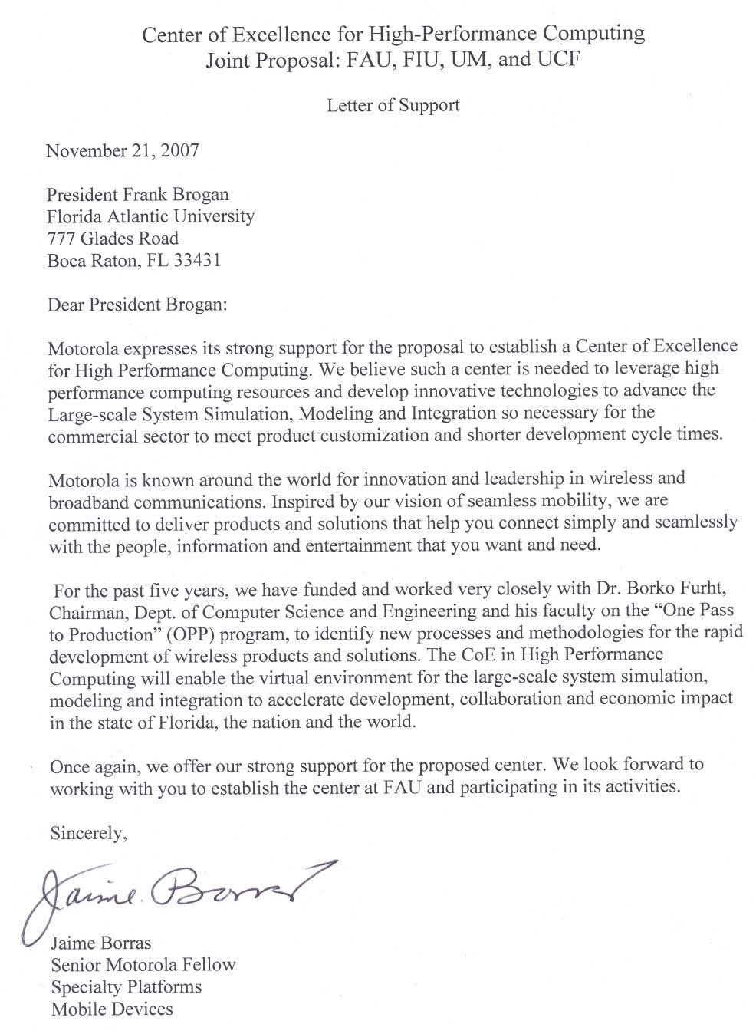
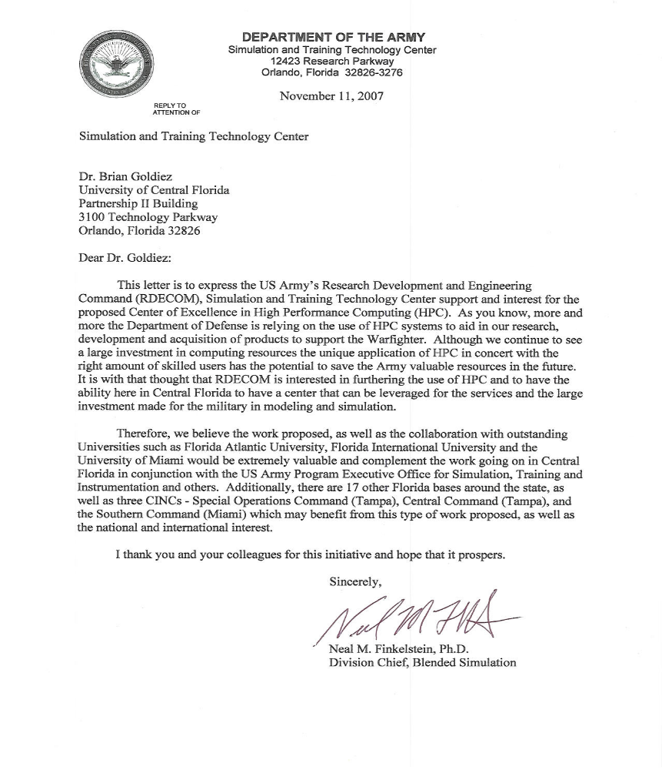

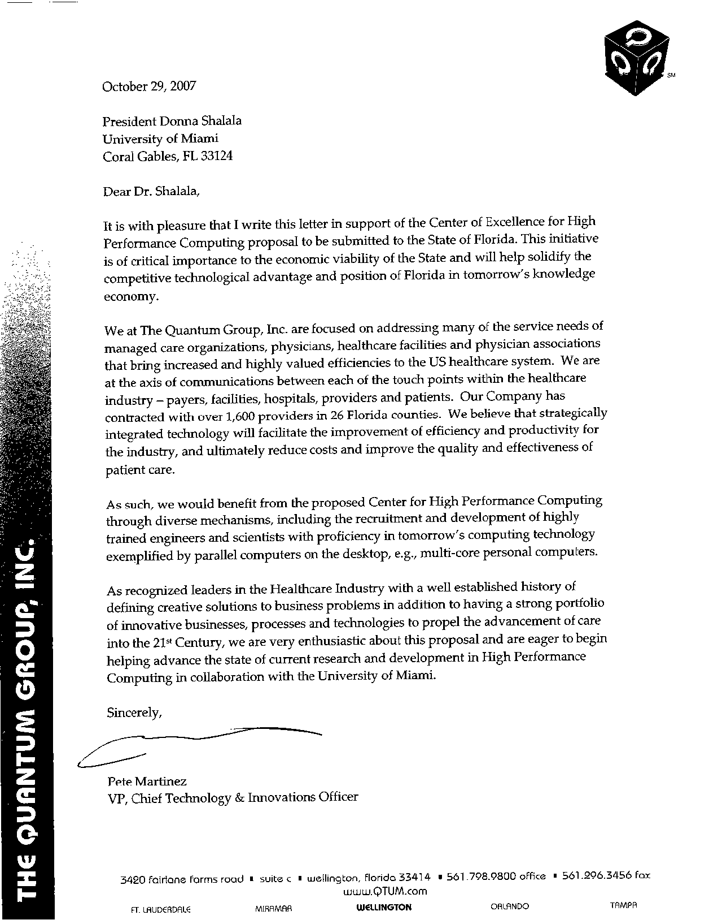
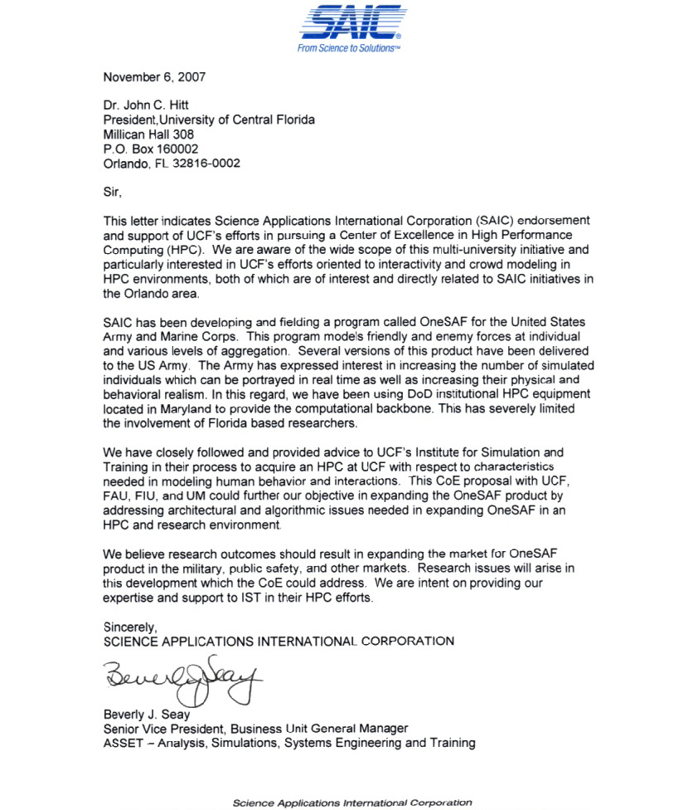

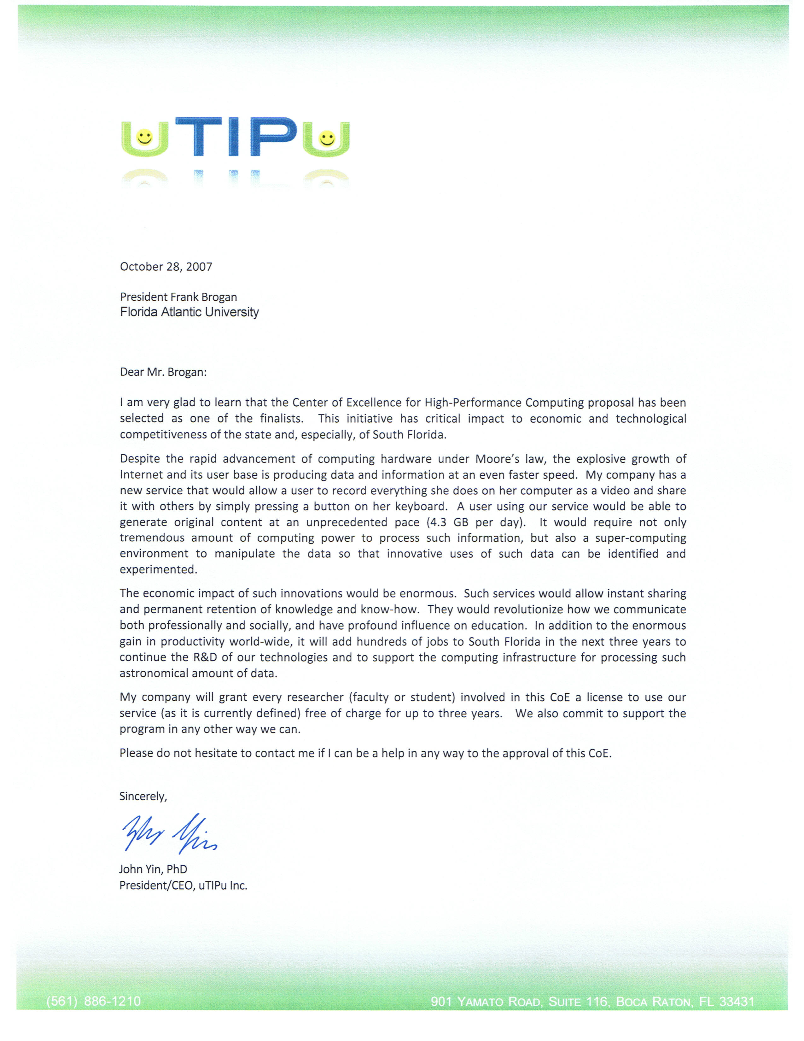

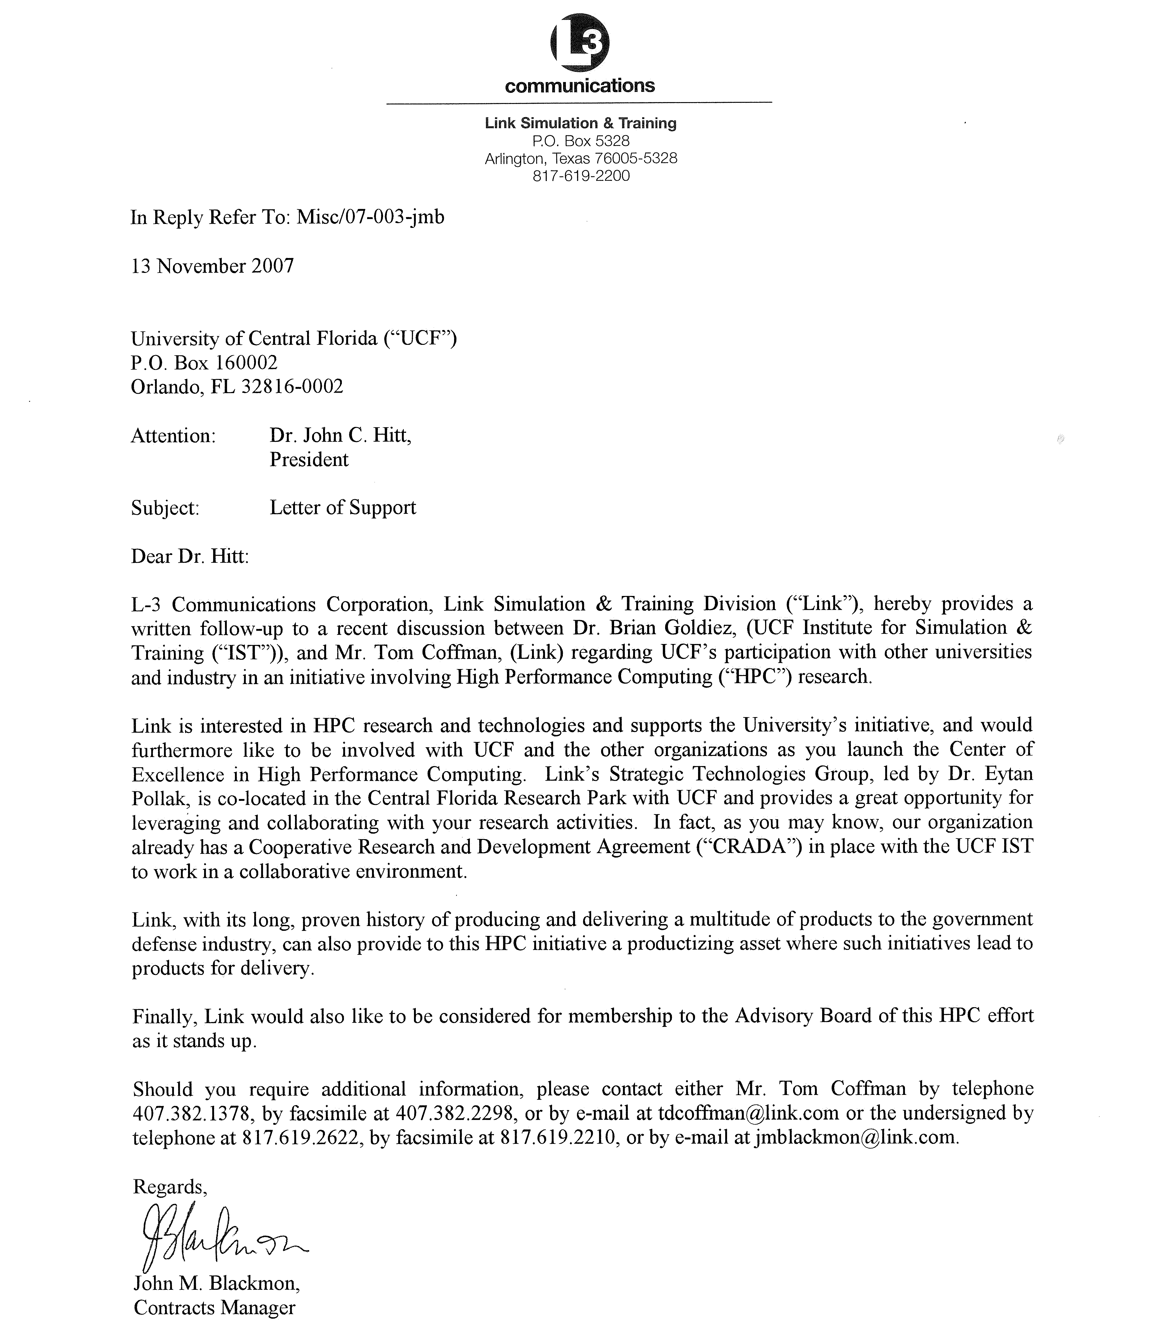

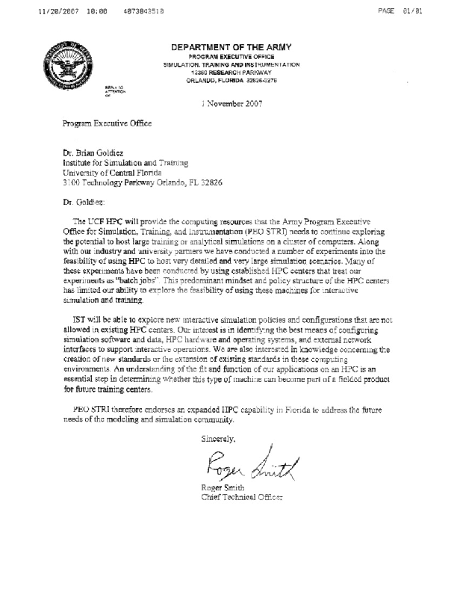

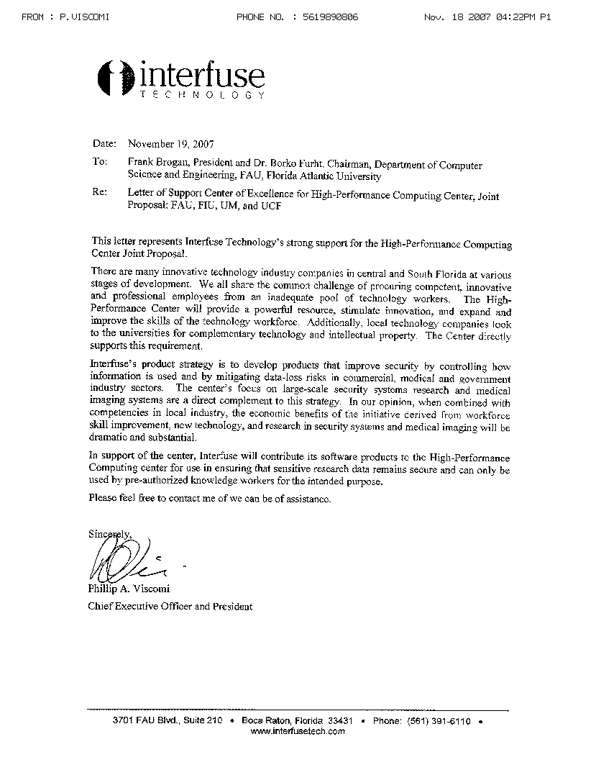

FDRTERRA
SYSltMS INC
'<~'~"-'::';'
Dr. John Hitt
President, University of Central Florida 3100 Technology, Room 315
Orlando, FL 32826
November 16, 2007
Dear Dr. Hitt,
This letter is in reference to the proposal submitted by the University of Central Florida Institute for Simulation and Training and Florida Atlantic University for the State of Florida for a Center of Excellence in High Performance Computing.
As a professional working in High Performance Computing over 20 years, I consider myself to be an expert in this area. I am also the former Simulation Research Lead for the Department of Defense High Performance Computing Management Office. My current work involves the development of massive multiplayer online virtual worlds for education and medical training.
I see the confluence of gaming and HPC environments as a compelling platform upon which to excite and stimulate our university and secondary-level students towards greater interest and achievements, and ultimately careers, in these increasingly important areas. Many exciting innovations and products are sure to emerge in our marketplace by modeling complex interactions on HPC platforms. Moreover, HPC is an essential tool in academic research today ranging from understanding the quantum world to exploring the human genome.
Many researchers and educators are working on creating new "onscreen" virtual experiences and environments. This proposal will enable the groundswell of interest in "serious games" by looking holistically at not only the content and delivery system, but at the entire social classroom environment on a massive scale as "the interface". This approach (which has precedents in socalled Mixed and Augmented Realities as extensions of screen-based Virtual Reality) is ripe for research and development in an HPC environment. This project will provide a much-needed transformation of the physical and social environment where young people spend a significant amount of their formative years. Our students and researchers deserve access to the same level of technological sophistication in their laboratories and classrooms as they now have in their homes and mobile phones.
This proposal addresses this serious gap by teaming major Florida universities with leading edge companies such as Forterra Systems Inc. I appreciate the opportunity to express my support for this project, and look forward to advising the team on its research efforts and looking for technology tr,ansfer oppo.rtunities for Forterra once the grant is awarded.
, ,
Sincerely,

Michael R. Macedonia, Vice President Forterra Systems Inc.

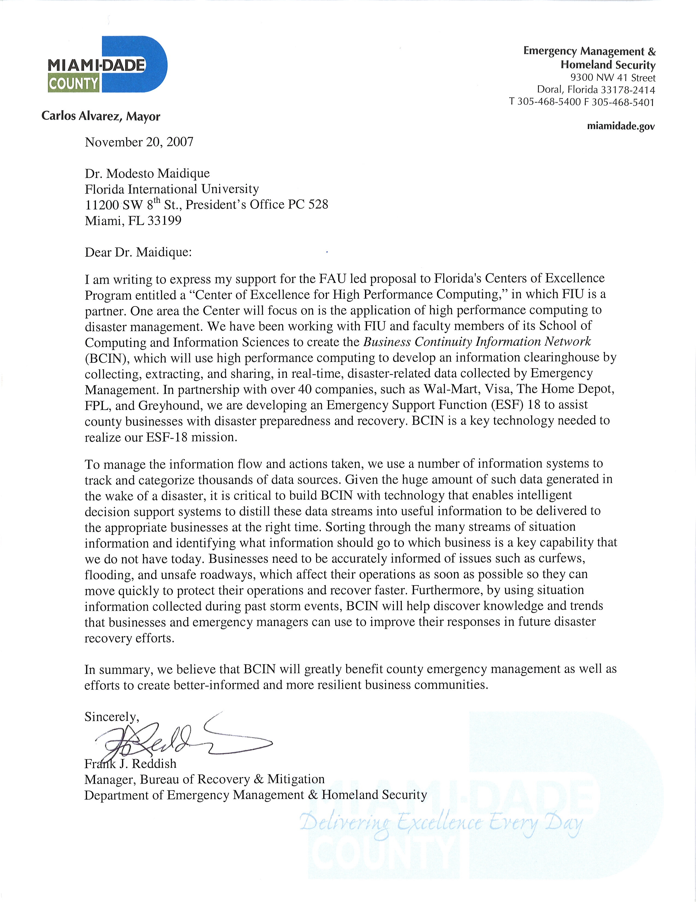

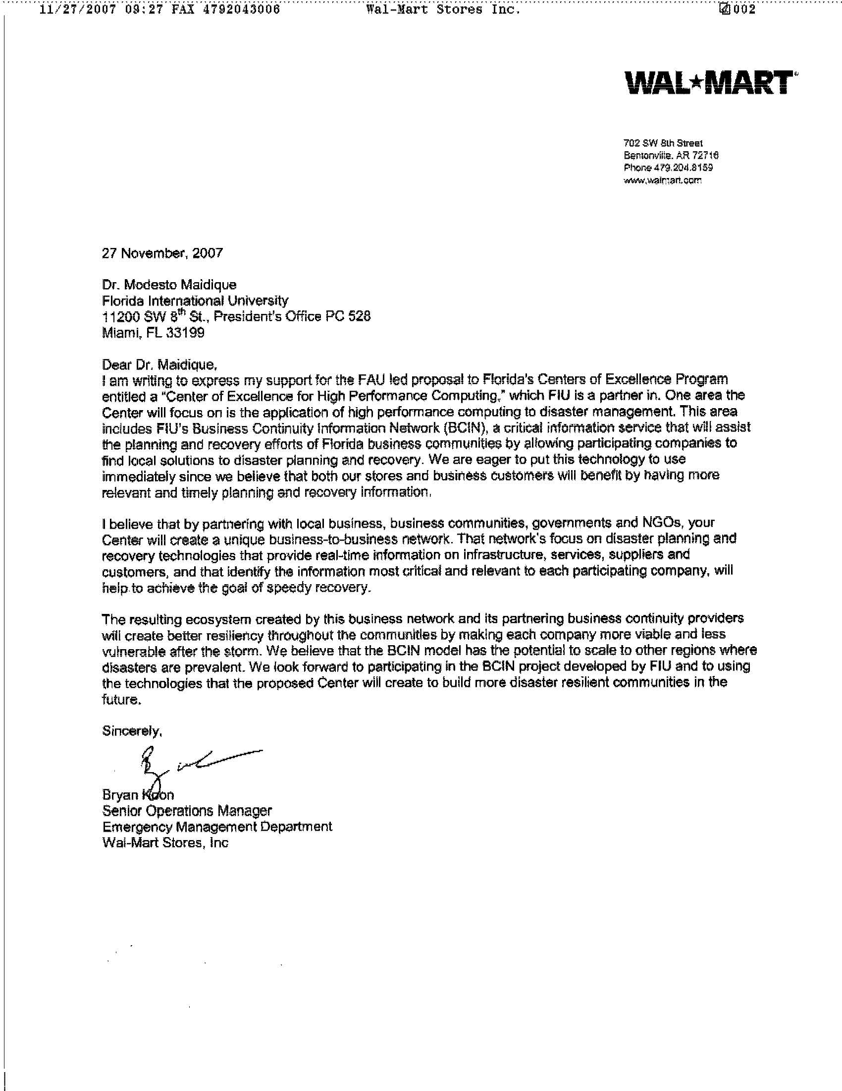

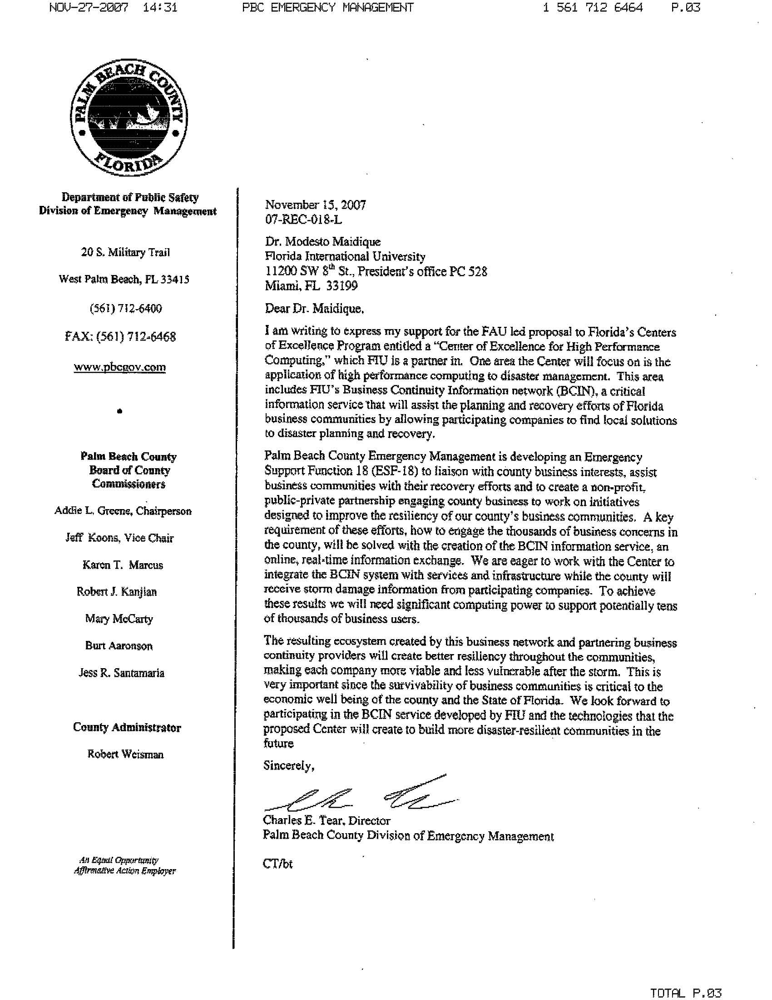
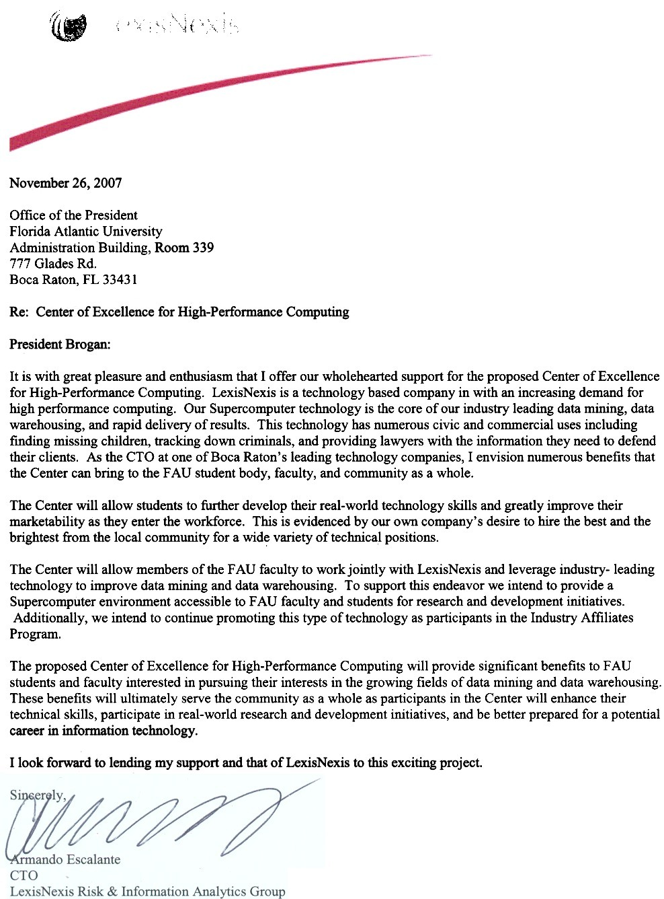

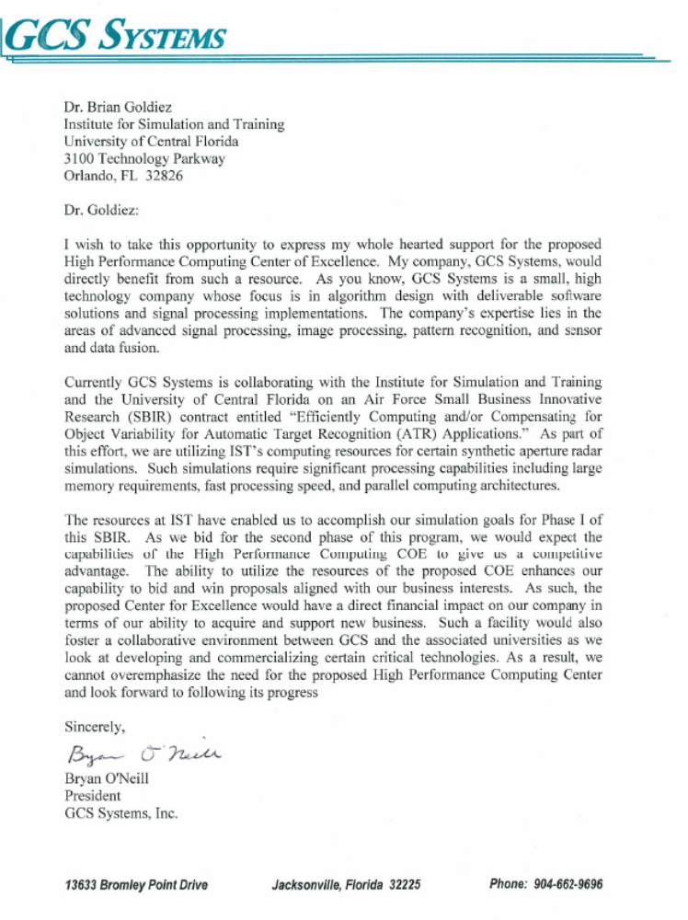

Cost Proposal
In this Section we present the cost proposal for the base effort of $15M and for the fallback budget of $10M. We also present the funding plan for the next five years from FY2008-FY2012, which demonstrates the ability to continue the proposed Center without additional state funding. We also included the justification for the budget as well as for capital expenditure.

Base Effort Cost Proposal

The base effort cost of $15M for the 3-year period is distributed to four universities as shown in Table 9.
Table 9. The distribution of the budget to four universities.

 | FY2008 [$M] | FY2009 [$M] | FY2010 [$M] | TOTAL [$M]
FAU | 1.8 | 1.5 | 1.15 | 4.45
FIU | 1.4 | 1.2 | 0.95 | 3.55
UCF | 1.4 | 1.2 | 0.95 | 3.55
UM | 1.4 | 1.2 | 0.95 | 3.55
TOTAL | 6 | 5 | 4 | 15

The breakout by year is given in Appendix 1, which includes faculty labor, staff and support labor, student labor, tuition and fees, all overhead, capital expenditures, and travel.

The approximate budget breakout by various categories and research topics is shown in Table 10. The amounts are rounded.

Table 10. The breakout of the budget by various categories.

BASE EFFORT | FY2008 [$] | FY2009 [$] | FY2010 [$] | TOTAL [$]
Project Management | 480,000 | 450,000 | 420,000 | 1,350,000
Business  and Commercialization | 50,000 | 70,000 | 90,000 | 210,000
HPC Infrastructure,  Grid Management and Staff | 350,000 | 320,000 | 270,000 | 940,000
Research Topic 1 | 1,000,000 | 960,000 | 800,000 | 2,760,000
Research Topic 2 | 970,000 | 900,000 | 750,000 | 2,620,000
Research Topic 3 | 940,000 | 880,000 | 730,000 | 2,550,000
Research Topic 4 | 810,000 | 770,000 | 620,000 | 2,200,000
Travel | 200,000 | 200,000 | 170,000 | 570,000
Capital Expenditure | 1,200,000 | 450,000 | 150,000 | 1,800,000
TOTAL | 6,000,000 | 5,000,000 | 4,000,000 | 15,000,000
Budget Explanation
- Senior Personnel:
- Academic year – The Fall semester begins in August; the Spring Semester begins in January; the Summer terms begin in May.
- Salary raises were budgeted at 3% per year.

- Graduate Students:
- Ph.D. student Research Assistant –Two for year 1, 1 for year 2, and 1 for ½ yr 3: Salary of $22,000 per annum. 1 Master’s student Yr.1, .5 Master’s Yr.2, none in Yr. 3.

- Fringe Benefits:
- Faculty and Senior Research Associate – The fringe benefits rate of 30% of salary is set by the Florida Atlantic University policy.
- Graduate students – There are no fringe benefit costs.

- Equipment and Capital Expenditure:
In this project, we intend to spend a minimal amount on capital expenditure. This will include equipment and software needed to improve current HPC infrastructure at four universities, including extending the HPC computing facilities, communication switches needed for faster communications, and application software packages. Table 11 presents the planned equipment, computer and software, which will be purchased as part of the project.

Table 11. Equipment and Software to be Purchased

University | Amount | Equipment and Justification
FAU | $439,467 | - Adding an IBM HPC Cluster ($354,467)  - MATLAB software (bioinformatics) ($35,000)  - Communication switch for fast link to LambdaRail ($50,000)
FIU | $492,472 | - Adding a Dell HPC Cluster – 36 processors, 576 GB Ram, 107 TB disk storage, tape library ($406,700)  - Software licenses, maintenance, installation ($55,772) Communication switch and router for fast link to LambdaRail ($42,000)
UCF | $378,000 | - Routers and interconnects (e.g. LambdaRail and SURA)  - Scheduling and remote login software  - Hardware and interactivity (e.g. video wall, haptics, audio)
UM | $489,649 | - Adding an IBM HPC Cluster ($343,609)  - Adding SAN storage ($108,040)  - Communication switch for Internet2/LambdaRail ($38,000)

- Travel:
- Domestic – Travel to domestic technical conferences to present research results from this project.
- Foreign – Travel to international technical conferences to present research results from this project. We plan to submit papers to major technical conferences in the software engineering and soft computing fields, such as those sponsored by IEEE and ACM. These are frequently held at international locations.

- Other Direct Costs:
- Tuition – For each graduate student research assistant: tuition for 12 credits $879.87 per credit, (includes anticipated 5% increase in Yrs 1 & 2). Graduate research assistants are required to enroll as full time students, namely, 9 credits each semester, and 6 credits each summer for a total of 24 credits per year.

Five-Year Funding Plan

As already indicated in Section 3.4, the Center plans to continue beyond the three years of State funding by using various sources to produce revenues.

- Acquiring funding from private corporations,
- Acquiring funding from government agencies,
- Revenues generated from developed technologies and products,
- Revenues generated from education, and training
- Membership program for businesses to use HPC infrastructure, computing resources, and faculty expertise and knowledge.

Table 12 presents a funding plan for the next five years based on the assumption that the Center will be funded at the level of the base effort ($15M).

Table 12. Funding Plan for the Center of Excellence for High-Performance Computing

SOURCE OF FUNDING | FY2008 | FY2009 | FY2010 | FY2011 | FY2012
State of Florida | 6,000,000 | 5,000,000 | 4,000,000 | 0 | 0
Private  corporations | 300,000 | 500,000 | 1,000,000 | 1,200,000 | 1,300,000
Government  agencies | 200,000 | 500,000 | 1,000,000 | 1,600,000 | 1,800,000
Revenues generated from developed technologies | 0 | 0 | 0 | 1,200,000 | 2,000,000
Revenues generated from computing infrastructure and training | 0 | 200,000 | 400,000 | 1,000,000 | 1,500,000
TOTAL BUDGET | $6,500,000 | $6,200,000 | $6,400,000 | $5,000,000 | $6,600,000

Fallback Cost Proposal
Table 13 shows the distribution of funds to four universities based on fallback cost proposal of $10M.
Table 13. The distribution of the budget to four universities.

 | FY2008 [$M] | FY2009 [$M] | FY2010 [$M] | TOTAL [$M]
FAU | 1.15 | 0.9 | 0.9 | 2.95
FIU | 0.95 | 0.7 | 0.7 | 2.35
UCF | 0.95 | 0.7 | 0.7 | 2.35
UM | 0.95 | 0.7 | 0.7 | 2.35
TOTAL | 4 | 3 | 3 | 10

The budget breakout by various categories and research topics is shown in Table 14.

Table 14. Fallback budget: the breakout of the budget by various categories.

FALLBACK BUDGET | FY2008 [$] | FY2009 [$] | FY2010 [$] | TOTAL [$]
Project Management | 400,000 | 370,000 | 350,000 | 1,120,000
Business  and Commercialization | 30,000 | 50,000 | 70,000 | 150,000
HPC Infrastructure and  Grid Management and Support | 260,000 | 200,000 | 200,000 | 660,000
Research Topic 1 | 680,000 | 540,000 | 580,000 | 1,800,000
Research Topic 2 | 610,000 | 520,000 | 550,000 | 1,680,000
Research Topic 3 | 590,000 | 510,000 | 540,000 | 1,640,000
Research Topic 4 | 450,000 | 390,000 | 425,000 | 1,265,000
Travel | 180,000 | 180,000 | 170,000 | 530,000
Capital Expenditure | 800,000 | 240,000 | 115,000 | 1,155,000
TOTAL | 4,000,000 | 3,000,000 | 3,000,000 | 10,000,000

Compared to the base effort cost proposal, the following significant reductions were made:

- The Project management budget has been reduced from total $1.35M to $1.12M.
- Budget for all four research topics has been reduced for approximately for 30-35%. This means that not all projects will be completed. The Board of Directors will carefully select the projects, which will have a better chance for success and fund those projects.
- Capital expenditure has been reduced from $1.8M to $1.155M.

Appendix 1. Detailed Budget, Base Effort

FAU, Base Effort | Yr. 1 | Yr. 2 | Yr. 3 | Total
 | 2008 | 2009 | 2010
 | 1,800K | 1,500K | 1,150K | 4,450K
PI
Borko Furht 30/25/15 | 49,529 | 41,274 | 33,019 | 123,822
Sr. Researchers
Taghi Khoshgoftaar | 16,447 | 16,447 | 16,447 | 49,341
Ravi Shankar | 14,553 | 14,553 | 14,553 | 43,659
Jie Wu | 9,958 | 9,958 | 9,958 | 29,873
Hari Kalva | 12,225 | 12,225 | 12,225 | 36,674
Oge Marques | 13,124 | 13,124 | 13,124 | 39,373
Ankur Agarwal | 10,860 | 10,860 | 10,860 | 32,579
Xingquan "Hill" Zhu | 10,875 | 10,875 | 10,875 | 32,625
Abhijit Pandya | 12,716 | 12,716 | 12,716 | 38,147
Imadeldin Mahgoub | 14,779 | 14,779 | 14,779 | 44,338
Ionut Cardei | 9,304 | 9,304 | 9,304 | 27,911
Mihaela Cardei | 8,150 | 8,150 | 8,150 | 24,449
Shihong Huang | 9,304 | 9,304 | 9,304 | 27,911
Hanqi Zhuang | 8,664 | 8,664 | 8,664 | 25,992
Stewart Glegg | 12,098 | 12,098 | 12,098 | 36,294
Bill Glenn | 14,741 | 14,741 | 14,741 | 44,223
Bill Rhodes | 11,425 | 11,425 | 11,425 | 34,274
 | 238,750 | 230,495 | 222,241 | 691,486
Benefits 30% | 71,625 | 69,149 | 66,672 | 207,446
Total Faculty Salaries & Benefits: | 310,375 | 299,644 | 288,913 | 898,932
AMP
Executive Director 1.0 FTE | 100,000 | 100,000 | 100,000 | 300,000
AMP Benefits 32.5% : | 32,500 | 32,500 | 32,500 | 97,500
Total AMP Costs: | 132,500 | 132,500 | 132,500 | 397,500
SP
Support Staff -Sect | 27,000 | 27,000 | 27,000 | 81,000
Support Staff-Prog. Coordinator | 19,000 | 19,000 | 19,000 | 57,000
Sub-total: | 46,000 | 46,000 | 46,000 | 138,000
SP Benefits 41% | 18,860 | 18,860 | 18,860 | 56,580
Total SP Costs: | 64,860 | 64,860 | 64,860 | 194,580
OPS
15 PhD's-20 hrs/wk | 331,209 | 331,209 | 220,806 | 883,224
15 Masters 20 hrs/wk | 256,041 | 256,041 | 204,833 | 716,915
Total OPS: | 587,250 | 587,250 | 425,639 | 1,600,139
Travel
Foreign - $2000 / faculty | 34,000 | 34,000 | 23,800 | 91,800
Domestic - $1600/ faculty | 27,200 | 27,200 | 18,700 | 73,100
Total Travel: | 61,200 | 61,200 | 42,500 | 164,900
Total Direct Costs: | 1,156,185 | 1,145,454 | 954,411 | 3,256,051
Tuition (25non-res/5res.) | 277,229 | 284,160 | 193,093 | 754,482
Equipment | 366,586 | 70,386 | 2,495 | 439,467
Total: | 1,800,000 | 1,500,000 | 1,150,000 | 4,450,000

FIU, Base Effort |  | Yr. 1 |  | Yr. 2 |  | Yr. 3 |  | Total
 |  | 2008 |  | 2009 |  | 2010
 |  | 1.4M |  | 1.2M |  | 0.95M |  | 3.55M
FIU PI
Yi Deng |  | 38,512 |  | 39,668 |  | 40,858 |  | 119,038
Sr. Researchers
Chen, Shu-Ching - L |  | 21,297 |  | 14,624 |  | 11,297 |  | 47,218
Christidis, Evangelos - L |  | 15,308 |  | 10,512 |  | 8,120 |  | 33,940
Clarke, Peter |  | 9,975 |  | 5,137 |  | 5,291 |  | 20,404
Li, Tao - L |  | 16,244 |  | 11,159 |  | 8,620 |  | 36,022
Lisetti, Christine - L |  | 18,025 |  | 12,377 |  | 9,561 |  | 39,964
Liu, Xiaowen (Jason) - L |  | 15,107 |  | 10,373 |  | 8,013 |  | 33,493
Luis, Steven |  | 11,884 |  | 6,120 |  | 6,304 |  | 24,307
Rangaswami, Raju |  | 9,770 |  | 5,031 |  | 5,182 |  | 19,983
Rishe, Naphtali |  | 19,823 |  | 10,209 |  | 10,515 |  | 40,546
Sadjadi, S.-Masoud - L |  | 15,079 |  | 10,354 |  | 7,999 |  | 33,432
 |  | 191,023 |  | 135,564 |  | 121,761 |  | 448,348
Benefits 27.5% |  | 52,531 |  | 37,280 |  | 33,484 |  | 123,296
Total Faculty Salaries & Benefits: |  | 243,555 |  | 172,844 |  | 155,245 |  | 571,644
Staff
Coordinator (1.0 FTE) |  | 60,000 |  | 61,800 |  | 63,654 |  | 185,454
Post Docs |  | 80,000 |  | 82,400 |  | 42,436 |  | 204,836
Support Staff -Sect (0.5 FTE) |  | 13,500 |  | 13,905 |  | 14,322 |  | 41,727
Support Staff-Technical Support |  | 40,000 |  | 20,600 |  | 21,218 |  | 81,818
Sub-total: |  | 193,500 |  | 178,705 |  | 141,630 |  | 513,835
Staff Benefits 27.5% |  | 53,213 |  | 49,144 |  | 38,948 |  | 141,305
Total Staff Costs: |  | 246,713 |  | 227,849 |  | 180,578 |  | 655,140
Student Assistants
20 GA's in Yrs 1, 2, & 3 |  | 360,000 |  | 360,000 |  | 360,000 |  | 1,080,000
10 Undergrad Asst in Yrs 1, 2, & 3 |  | 50,000 |  | 50,000 |  | 50,000 |  | 150,000
Sub-total: |  | 410,000 |  | 410,000 |  | 410,000 |  | 1,230,000
OPS Benefits 7.65% |  | 31,365 |  | 31,365 |  | 31,365 |  | 94,095
GA Tuition |  | 117,320 |  | 123,186 |  | 129,345 |  | 369,851
Total OPS: |  | 558,685 |  | 564,551 |  | 570,710 |  | 1,693,946
Travel
Foreign - $2000 / Faculty & Post Doc / Yr. |  | 26,000 |  | 26,000 |  | 24,000 |  | 76,000
Domestic - $1200 / Faculty & Post Doc / Yr. |  | 20,666 |  | 20,666 |  | 19,466 |  | 60,798
Total Travel: |  | 46,666 |  | 46,666 |  | 43,466 |  | 136,798
Equipment |  | 304,382 |  | 188,090 |  | 0 |  | 492,472
Total: |  | 1,400,000 |  | 1,200,000 |  | 950,000 |  | 3,550,000
UM, Base Effort | Yr. 1 |  | Yr. 2 |  | Yr. 3 |  | Total
 | 2008 |  | 2009 |  | 2010
 | 1,400K |  | 1,200K |  | 950K |  | 3,550K
PIs
James Modestino | 16,680 |  | 17,513 |  | 18,389 |  | 52,582
Akmal Younis | 31,245 |  | 32,805 |  | 22,964 |  | 87,014
Sr. Researchers
Mohamed Abdel-Mottaleb | 28,216 |  | 29,626 |  | 15,554 |  | 73,396
Xiadong Cai | 21,164 |  | 22,222 |  | 11,666 |  | 55,052
Nigel John | 12,805 |  | 13,445 |  | 14,119 |  | 40,369
Kamal Premaratne | 26,782 |  | 28,120 |  | 14,763 |  | 69,665
Miroslav Kubat | 22,778 |  | 23,918 |  | 12,557 |  | 59,253
Gavriil Tsechpenakis | 17,388 |  | 18,258 |  | 9,585 |  | 45,231
 | 177,058 |  | 185,907 |  | 119,597 |  | 482,562
Benefits 28.2% | 49,930 |  | 53,354 |  | 34,923 |  | 138,207
Total Faculty Salaries & Benefits: | 226,988 |  | 239,261 |  | 154,520 |  | 620,769
SP
Support Staff | 40,000 |  | 40,000 |  | 40,000 |  | 120,000
SP Benefits 33.7% | 13,500 |  | 13,500 |  | 13,500 |  | 40,500
Total SP Costs: | 53,500 |  | 53,500 |  | 53,500 |  | 160,500
OPS
16 PhD's-20 hrs/wk | 364,800 |  | 364,800 |  | 364,800 |  | 1,094,400
Benefits 550(600/650)/student | 8,800 |  | 9,600 |  | 10,400 |  | 28,800
Total OPS Costs: | 373,600 |  | 374,400 |  | 375,200 |  | 1,123,200
Travel
Foreign – $2625/faculty | 21,000 |  | 21,000 |  | 21,000 |  | 63,000
Domestic – $3000/faculty | 24,000 |  | 24,000 |  | 24,000 |  | 72,000
Total Travel: | 45,000 |  | 45,000 |  | 45,000 |  | 135,000
Miscellaneous
Publication Costs | 3,500 |  | 3,500 |  | 3,604 |  | 10,604
Materials & Supplies | 3,000 |  | 3,000 |  | 3,000 |  | 9,000
Total Miscellaneous Costs: | 6,500 |  | 6,500 |  | 6,604 |  | 19,604
Total Direct Costs: | 705,588 |  | 718,661 |  | 634,824 |  | 2,059,073
Tuition (42 credits/student) | 294,944 |  | 391,158 |  | 315,176 |  | 1,001,278
Equipment | 399,468 |  | 90,181 |  | 0 |  | 489,649
Total: | 1,400,000 |  | 1,200,000 |  | 950,000 |  | 3,550,000

UCF, Base Effort | Year 1 | Year 2 | Year 3 | TOTAL
 | 2008 | 2009 | 2010
 | 1.4M | 1.2M | 0.95M | 3.55M
Goldiez, Brian, PI | $ 100,049 | $ 9,160 | $ 7,862 | $ 117,071
Shumaker, Co-PI | $ 7,098 | $ 7,310 | $ 7,530 | $ 21,938
Clarke, Co-PI | $ 43,760 | $ 23,888 | $ 3,714 | $ 71,362
Kaup, Co-PI | $ 21,879 | $ 17,721 | $ 8,440 | $ 48,040
Hagen, Co-PI | $ 19,088 | $ 19,664 | $ 20,251 | $ 59,003
Yeh, Co-PI | $ 15,315 | $ 15,774 | $ 16,247 | $ 47,336
Marinescu, Co-PI | $ 70,277 | $ 43,320 | $ 22,592 | $ 136,189
Masunov, Co-PI | $ 7,880 | $ 8,117 | $ 8,361 | $ 24,358
Wiegand | $ 45,049 | $ 25,397 | $ 5,031 | $ 75,477
TBD | $ 98,634 | $ 101,590 | $ 104,645 | $ 304,869
TBD | $ 98,634 | $ 101,590 | $ 104,645 | $ 304,869
Davis | $ 35,863 | $ 20,218 | $ 4,005 | $ 60,086
TBD | $ 61,651 | $ 63,496 | $ 65,416 | $ 190,563
Palaniappan | $ 58,822 | $ 60,590 | $ 62,400 | $ 181,812
TBD-Goldiez | $ 107,900 | $ 111,156 | $ 45,781 | $ 264,837
TBD-Masunov | $ 43,160 | $ 44,463 | $ 45,781 | $ 133,404
TOTAL Faculty Salaries | $ 835,059 | $ 673,454 | $ 532,701 | $ 2,041,214
Benefits 28.15% | $ 204,694 | $ 161,004 | $ 134,426 | $ 500,124
Total Faculty S & B | $ 1,039,753 | $ 834,458 | $ 667,127 | $ 2,541,338
Adm. Personnel | $ 24,305 | $ 39,082 | $ 8,694 | $ 72,081
Benefits 28.15% | $ 6,842 | $ 11,002 | $ 2,447 | $ 20,291
Total A & P | $ 31,147 | $ 50,084 | $ 11,141 | $ 92,372
TBD | $ 9,690 | $ 10,126 | $ 10,281 | $ 30,097
TBD-Hagen | $ 29,994 | $ 30,898 | $ 31,824 | $ 92,716
TBD-Goldiez | $ 23,120 | $ 23,901 | $ 9,020 | $ 56,041
TBD-Clarke | $ 27,276 | $ 16,346 | $ 8,175 | $ 51,797
TBD-Marinescu | $ 18,720 | $ 18,720 | $ 18,720 | $ 56,160
TBD-Masunov | $ 19,999 | $ 20,602 | $ 21,216 | $ 61,817
TBD-Masunov | $ 3,000 | $ 3,000 | $ 3,000 | $ 9,000
 | $ 131,799 | $ 123,593 | $ 102,236 | $ 357,628
Total benefits | $ 141 | $ 147 | $ 149 | $ 437
Total OPS | $ 131,940 | $ 123,740 | $ 102,385 | $ 358,065
TOTAL LABOR | $ 1,202,840 | $ 1,008,282 | $ 780,653 | $ 2,991,775
Travel
Foreign | $ 8,986 | $ 9,435 | $ 9,907 | $ 28,328
Domestic | $ 26,176 | $ 26,900 | $ 25,968 | $ 79,044
Misc Materail and Supply | $ 19,469 | $ 14,628 | $ 9,479 | $ 43,576
Other direct costs | $ 54,631 | $ 50,963 | $ 45,354 | $ 150,948
TOTAL DIRECT COTS | $ 1,257,471 | $ 1,059,245 | $ 826,007 | $ 3,142,723
INDIRECT COST | $ 0 | $ 0 | $ 0 | $ 0
Tuition Fees | $ 9,529 | $ 9,755 | $ 9,993 | $ 29,277
Equipment | $ 133,000 | $ 131,000 | $ 114,000 | $ 378,000
TOTAL COST | $ 1,400,000 | $ 1,200,000 | $ 950,000 | $ 3,550,000

Appendix 2. Detailed Fallback Budget

FAU, Fallback budget | Yr. 1 | Yr. 2 | Yr. 3 | Total
 | 2008 | 2009 | 2010
 | 1000K | 900K | 900K | 2,800K
PI
Borko Furht 30/25/15 | 49,529 | 41,274 | 24,764 | 115,567
Sr. Researchers
Taghi Khoshgoftaar | 13,158 | 13,158 | 10,965 | 37,280
Ravi Shankar | 11,643 | 11,643 | 9,702 | 32,987
Jie Wu | 5,532 | 5,532 | 5,532 | 16,596
Hari Kalva | 9,780 | 9,780 | 8,150 | 27,709
Oge Marques | 9,375 | 9,375 | 7,500 | 26,249
Ankur Agarwal | 8,688 | 8,688 | 7,240 | 24,615
Xingquan "Hill" Zhu | 8,700 | 8,700 | 7,250 | 24,650
Abhijit Pandya | 9,781 | 9,781 | 10,124 | 29,686
Imadeldin Mahgoub | 11,823 | 11,823 | 9,853 | 33,500
Ionut Cardei | 6,203 | 6,203 | 5,427 | 17,832
Mihaela Cardei | 4,890 | 4,890 | 4,075 | 13,854
Shihong Huang | 6,203 | 6,203 | 4,652 | 17,057
Hanqi Zhuang | 5,776 | 5,776 | 3,851 | 15,402
Stewart Glegg | 8,065 | 6,721 | 4,033 | 18,819
Bill Glenn | 9,827 | 8,190 | 6,552 | 24,569
Bill Rhodes | 7,617 | 6,347 | 3,808 | 17,772
 | 186,588 | 174,081 | 133,476 | 494,145
Benefits 30% | 55,976 | 52,224 | 40,043 | 148,243
Total Faculty Salaries & Benefits: | 242,564 | 226,306 | 173,519 | 642,388
Executive Director 1.0 FTE | 100,000 | 100,000 | 100,000 | 300,000
Benefits 32.5% | 32,500 | 32,500 | 32,500 | 97,500
Total AMP | 132,500 | 132,500 | 132,500 | 397,500
Support Staff -Sect. | 23,000 | 23,000 | 23,000 | 69,000
Support Staff- Prog. Coord. | 11000 | 11000 | 11000 | 33,000
Subtotal: | 34,000 | 34,000 | 34,000 | 102,000
Benefits 41% | 13,940 | 13,940 | 13,940 | 41,820
Total USPS: | 47,940 | 47,940 | 47,940 | 143,820
Total AMP/SP & Benefits: | 180,440 | 180,440 | 180,440 | 541,320
OPS
8PhD's-20 hrs/wk | 176,645 | 176,645 | 220,806 | 574,096
8Masters 20 hrs/wk | 136,555 | 136,555 | 136,555 | 409,666
Total OPS: | 313,200 | 313,200 | 357,361 | 983,761
Travel
Foreign - $1300/faculty | 22,100 | 25,500 | 28,900 | 76,500
Domestic -approx $1330faculty | 22,587 | 23,633 | 28,900 | 75,120
Total Travel: | 44,687 | 49,133 | 57,800 | 151,621
Total Direct Costs: | 780,891 | 769,079 | 769,120 | 2,319,090
Tuition 8 non-res/8res | 113,602 | 105,697 | 111,004 | 330,302
Equipment | 105,508 | 25,225 | 19,874 | 150,607
Total: | 1,000,000 | 900,000 | 900,000 | 2,800,000

FIU, Fallback Budget |  | Yr. 1 |  | Yr. 2 |  | Yr. 3 |  | Total
 |  | 2008 |  | 2009 |  | 2010
 |  | 950K |  | 700K |  | 700K |  | 2,350K
FIU Co-PI
Yi Deng |  | 28,884 |  | 29,751 |  | 30,643 |  | 89,279
Sr. Researchers
Chen, Shu-Ching - L |  | 14,198 |  | 10,968 |  | 11,297 |  | 36,463
Christidis, Evangelos - L |  | 10,206 |  | 7,884 |  | 8,120 |  | 26,210
Clarke, Peter |  | 7,481 |  | 5,137 |  | 5,291 |  | 17,910
Li, Tao - L |  | 10,829 |  | 8,369 |  | 8,620 |  | 27,818
Lisetti, Christine - L |  | 12,017 |  | 9,283 |  | 9,561 |  | 30,861
Liu, Xiaowen (Jason) - L |  | 10,071 |  | 7,780 |  | 8,013 |  | 25,864
Luis, Steven |  | 8,913 |  | 6,120 |  | 6,304 |  | 21,337
Rangaswami, Raju |  | 7,327 |  | 5,031 |  | 5,182 |  | 17,541
Rishe, Naphtali |  | 14,867 |  | 10,209 |  | 10,515 |  | 35,591
Sadjadi, S.-Masoud - L |  | 10,053 |  | 7,766 |  | 7,999 |  | 25,817
 |  | 134,846 |  | 108,298 |  | 111,546 |  | 354,690
Academic Year Benefits 27.5% |  | 37,083 |  | 29,782 |  | 30,675 |  | 97,540
Total Faculty Salaries & Benefits: |  | 171,928 |  | 138,079 |  | 142,222 |  | 452,229
Staff
Coordinator (0.75 FTE) |  | 45,000 |  | 46,350 |  | 47,741 |  | 139,091
Post Doc (1.0 FTE) |  | 40,000 |  | 41,200 |  | 42,436 |  | 123,636
Support Staff -Sec. (0.25 FTE) |  | 6,750 |  | 6,953 |  | 7,161 |  | 20,864
Support Staff-Technical Support (0.1 FTE) |  | 8,000 |  | 8,240 |  | 8,487 |  | 24,727
Sub-total: |  | 99,750 |  | 102,743 |  | 105,825 |  | 308,317
Staff Benefits 27.5% |  | 27,431 |  | 28,254 |  | 29,102 |  | 84,787
Total Staff Costs: |  | 127,181 |  | 130,997 |  | 134,927 |  | 393,105
Student Assistants
12 GA's in Yrs 1,2,&3 |  | 216,000 |  | 216,000 |  | 216,000 |  | 648,000
5 Undergrad Asst in Yrs 1,2&3 |  | 25,000 |  | 25,000 |  | 25,000 |  | 75,000
Sub-total: |  | 241,000 |  | 241,000 |  | 241,000 |  | 723,000
OPS Benefits 7.65% |  | 18,437 |  | 18,437 |  | 18,437 |  | 55,310
GA Tuition |  | 70,392 |  | 73,912 |  | 77,607 |  | 221,911
Total OPS: |  | 329,829 |  | 333,348 |  | 337,044 |  | 1,000,220
Travel
Foreign - $2000 / Faculty |  | 30,000 |  | 30,000 |  | 30,000 |  | 90,000
Domestic - $1200 / Faculty |  | 18,000 |  | 18,000 |  | 18,000 |  | 54,000
Total Travel: |  | 48,000 |  | 48,000 |  | 48,000 |  | 144,000
Equipment |  | 273,062 |  | 49,576 |  | 37,808 |  | 360,446
Total: |  | 950,000 |  | 700,000 |  | 700,000 |  | 2,350,000
UM, Fallback Budget | Yr. 1 |  | Yr. 2 |  | Yr. 3 |  | Total
 | 2008 |  | 2009 |  | 2010
 | 950K |  | 700K |  | 700K |  | 2,350K
PIs
James Modestino | 11,676 |  | 12,259 |  | 12,872 |  | 36,807
Akmal Younis | 19,793 |  | 20,781 |  | 16,075 |  | 56,649
Sr. Researchers
Mohamed Abdel-Mottaleb | 16,936 |  | 17,781 |  | 10,888 |  | 45,605
Xiadong Cai | 12,702 |  | 13,338 |  | 8,166 |  | 34,206
Nigel John | 8,967 |  | 9,415 |  | 9,887 |  | 28,269
Kamal Premaratne | 16,075 |  | 16,878 |  | 10,334 |  | 43,287
Miroslav Kubat | 13,671 |  | 14,355 |  | 8,790 |  | 36,816
Gavriil Tsechpenakis | 10,436 |  | 10,958 |  | 6,710 |  | 28,104
 | 110,256 |  | 115,765 |  | 83,722 |  | 309,743
Benefits 28.2% | 31,093 |  | 33,223 |  | 24,447 |  | 88,763
Total Faculty Salaries & Benefits: | 141,349 |  | 148,988 |  | 108,169 |  | 398,506
SP
Support Staff | 40,000 |  | 40,000 |  | 40,000 |  | 120,000
SP Benefits 33.7% | 13,500 |  | 13,500 |  | 13,500 |  | 40,500
Total SP Costs: | 53,500 |  | 53,500 |  | 53,500 |  | 160,500
OPS
10 PhD's-20 hrs/wk | 228,000 |  | 228,000 |  | 228,000 |  | 684,000
Benefits 550(600/650)/student | 5,500 |  | 6,000 |  | 6,500 |  | 18,000
Total OPS Costs: | 233,500 |  | 234,000 |  | 234,500 |  | 702,000
Travel
Foreign – $2625/faculty | 21,000 |  | 21,000 |  | 21,000 |  | 63,000
Domestic – $1750/faculty | 14,000 |  | 14,000 |  | 14,000 |  | 42,000
Total Travel: | 35,000 |  | 35,000 |  | 35,000 |  | 105,000
Miscellaneous
Publication Costs | 0 |  | 1,600 |  | 2,196 |  | 3,796
Materials & Supplies | 1,311 |  | 1,355 |  | 1,500 |  | 4,166
Total Miscellaneous Costs: | 1,311 |  | 2,955 |  | 3,696 |  | 7,962
Total Direct Costs: | 464,660 |  | 474,443 |  | 434,865 |  | 1,373,968
Tuition (42 credits/student) | 184,340 |  | 193,557 |  | 250,135 |  | 628,032
Equipment | 301,000 |  | 32,000 |  | 15,000 |  | 348,000
Total: | 950,000 |  | 700,000 |  | 700,000 |  | 2,350,000

UCF, Fallback Budget | Year 1 | Year 2 | Year 3 | TOTAL
 | 2008 | 2009 | 2010
 | 950K | 700K | 700K | 2,350K
Goldiez, Brian, PI | $ 100,790 | $ 7,633 | $ 7,862 | $ 116,285
Shumaker | $ - | $ - | $ - | $ -
Clarke | $ 43,760 | $ 9,014 | $ 9,284 | $ 62,058
Kaup | $ 26,653 | $ 10,243 | $ 10,550 | $ 47,446
Hagen | $ 19,088 | $ 19,661 | $ 20,251 | $ 59,000
Yeh | $ 15,315 | $ 15,774 | $ 16,247 | $ 47,336
Marinescu | $ 37,268 | $ 32,901 | $ 33,888 | $ 104,057
Masunov | $ 7,880 | $ 8,117 | $ 8,361 | $ 24,358
Wiegand | $ - | $ - | $ - | $ -
TBD | $ - | $ - | $ - | $ -
TBD | $ - | $ - | $ - | $ -
Davis | $ - | $ - | $ - | $ -
TBD | $ 61,651 | $ 63,502 | $ 65,416 | $ 190,569
Palaniappan | $ 58,822 | $ 60,590 | $ 62,400 | $ 181,812
TBD-Goldiez | $ 43,160 | $ 44,450 | $ 45,781 | $ 133,391
TBD-Masunov | $ 43,160 | $ 44,450 | $ 45,781 | $ 133,391
Total Faculty Salaries | $ 457,547 | $ 316,335 | $ 325,821 | $ 1,099,703
Total Benefits 28.15% | $ 114,772 | $ 74,602 | $ 76,840 | $ 266,214
Total Faculty S& B | $ 572,319 | $ 390,937 | $ 402,661 | $ 1,365,917
Adm. Personnel | $ 33,387 | $ 9,043 | $ 12,631 | $ 55,061
Benefits 28.15% | $ 9,398 | $ 2,546 | $ 3,556 | $ 15,500
Total A & P | $ 42,785 | $ 11,589 | $ 16,187 | $ 70,561
OPS
TBD | $ 9,690 | $ 9,980 | $ 10,281 | $ 29,951
TBD-Hagen | $ 29,994 | $ 30,898 | $ 31,824 | $ 92,716
TBD-Goldiez | $ 39,100 | $ 8,755 | $ 9,020 | $ 56,875
TBD-Clarke | $ 18,492 | $ 14,283 | $ 14,715 | $ 47,490
TBD-Marinescu | $ 18,720 | $ 18,720 | $ 18,720 | $ 56,160
TBD-Masunov | $ 19,999 | $ 20,602 | $ 21,216 | $ 61,817
TBD-Masunov | $ 3,000 | $ 3,000 | $ 3,000 | $ 9,000
 | $ 138,995 | $ 106,238 | $ 108,776 | $ 354,009
Total Benefits | $ 141 | $ 145 | $ 149 | $ 435
Total OPS | $ 139,136 | $ 106,383 | $ 108,925 | $ 354,444
TOTAL LABOR | $ 754,240 | $ 508,909 | $ 527,773 | $ 1,790,922
Travel
Foreign | $ 8,986 | $ 9,435 | $ 9,907 | $ 28,328
Domestic | $ 26,176 | $ 26,900 | $ 25,968 | $ 79,044
Misc. Material & Supp | $ 18,675 | $ 14,637 | $ 13,027 | $ 46,339
Other direct costs | $ 53,837 | $ 50,972 | $ 48,902 | $ 153,711
TOTAL DIRECT COSTS | $ 808,077 | $ 559,881 | $ 576,675 | $ 1,944,633
INDIRECT COST | $ - | $ - | $ - | $ -
Tuition Fees | $ 8,923 | $ 9,119 | $ 9,325 | $ 27,367
Equipment | $ 133,000 | $ 131,000 | $ 114,000 | $ 378,000
TOTAL COST | $ 950,000 | $ 700,000 | $ 700,000 | $ 2,350,000

